# Section 1

#### Component

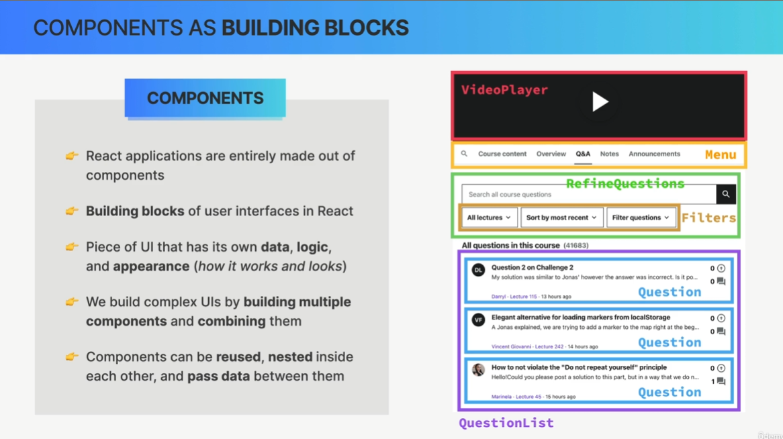

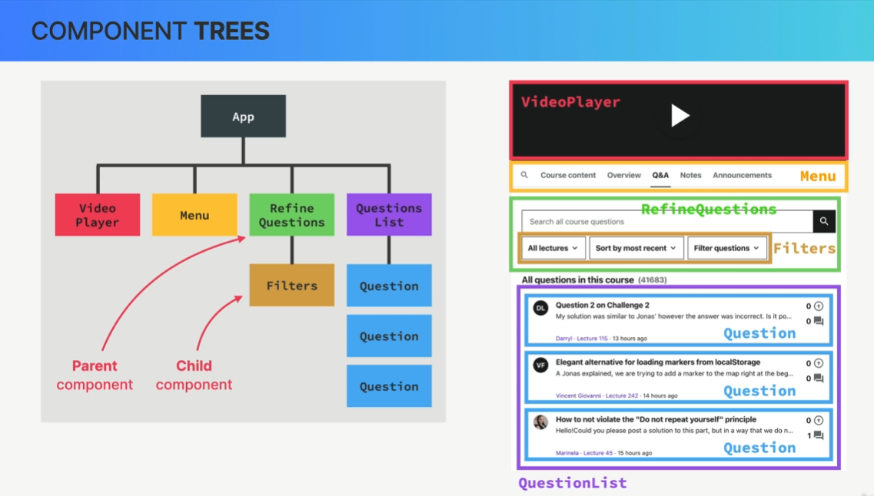

in React is just a function. Now, these functions in React, so these components can return something called JSX, which is a syntax that looks like HTML and describes what we can see on the screen.

##### JSX

It is basically just like HTML, but we can add some JavaScript to it.  
  
- Declarative syntax to describe what components look like and how they work

So when we try to build UIs using vanilla JavaScript, we will by default use an imperative approach. This means that we manually select elements, traverse the DOM, and attach event handlers to elements. Then each time something happens in the app like a click on the button, we give the browser step-by-step instructions on how to mutate those thumb elements until we reach the desired updated UI. So in the imperative approach, we basically tell the browser exactly how to do things.

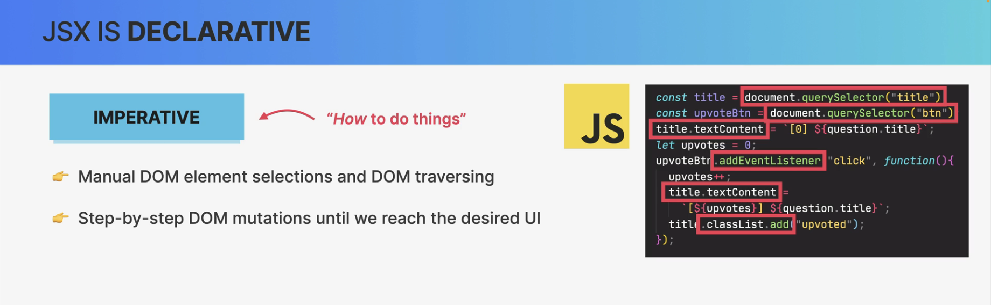

So, a declarative approach is to simply describe what the UI should look like at all times,

always based on the current data that's in the component.

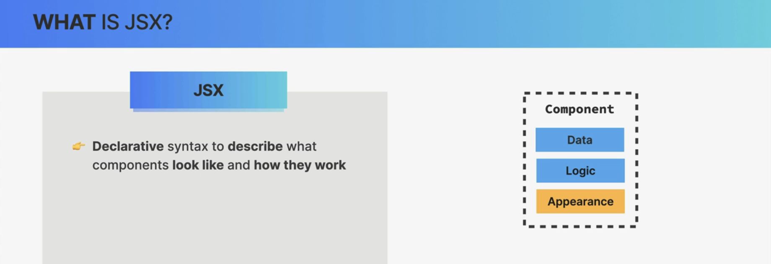

* Components must return a block of JSX

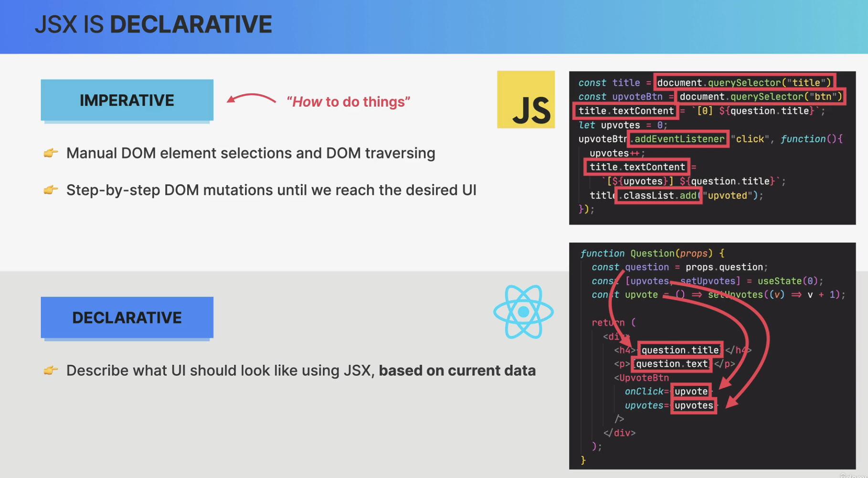

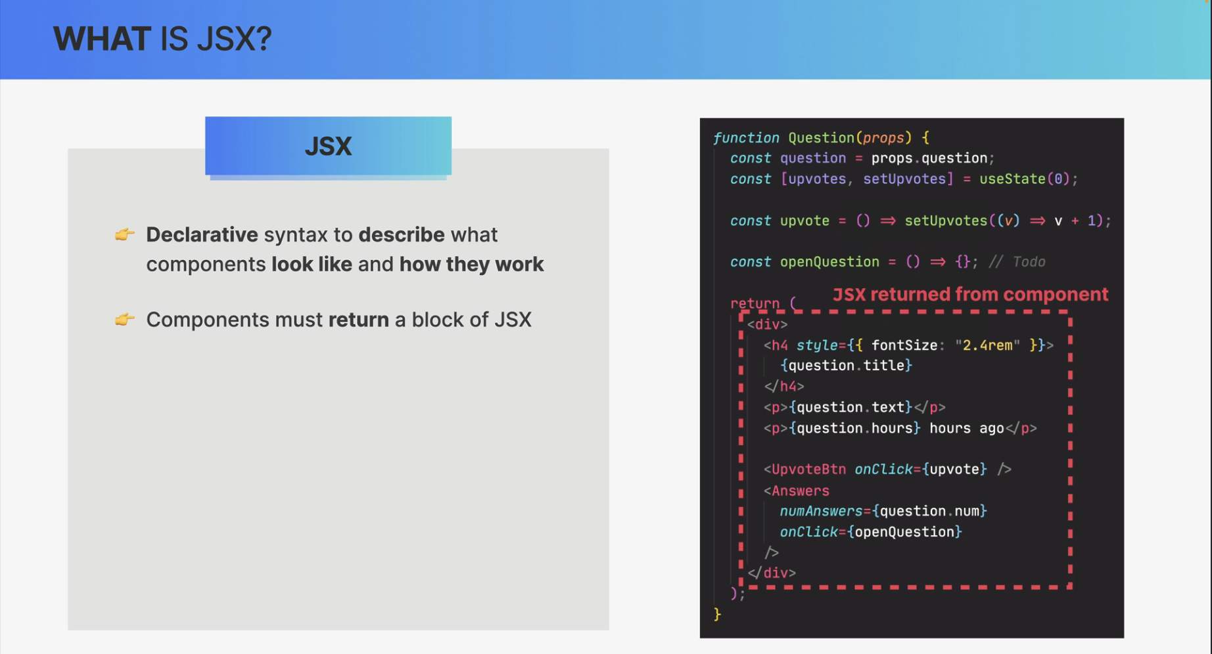

* Extension of JavaScript that allows us to embed JavaScript, CSS, and React components into HTML

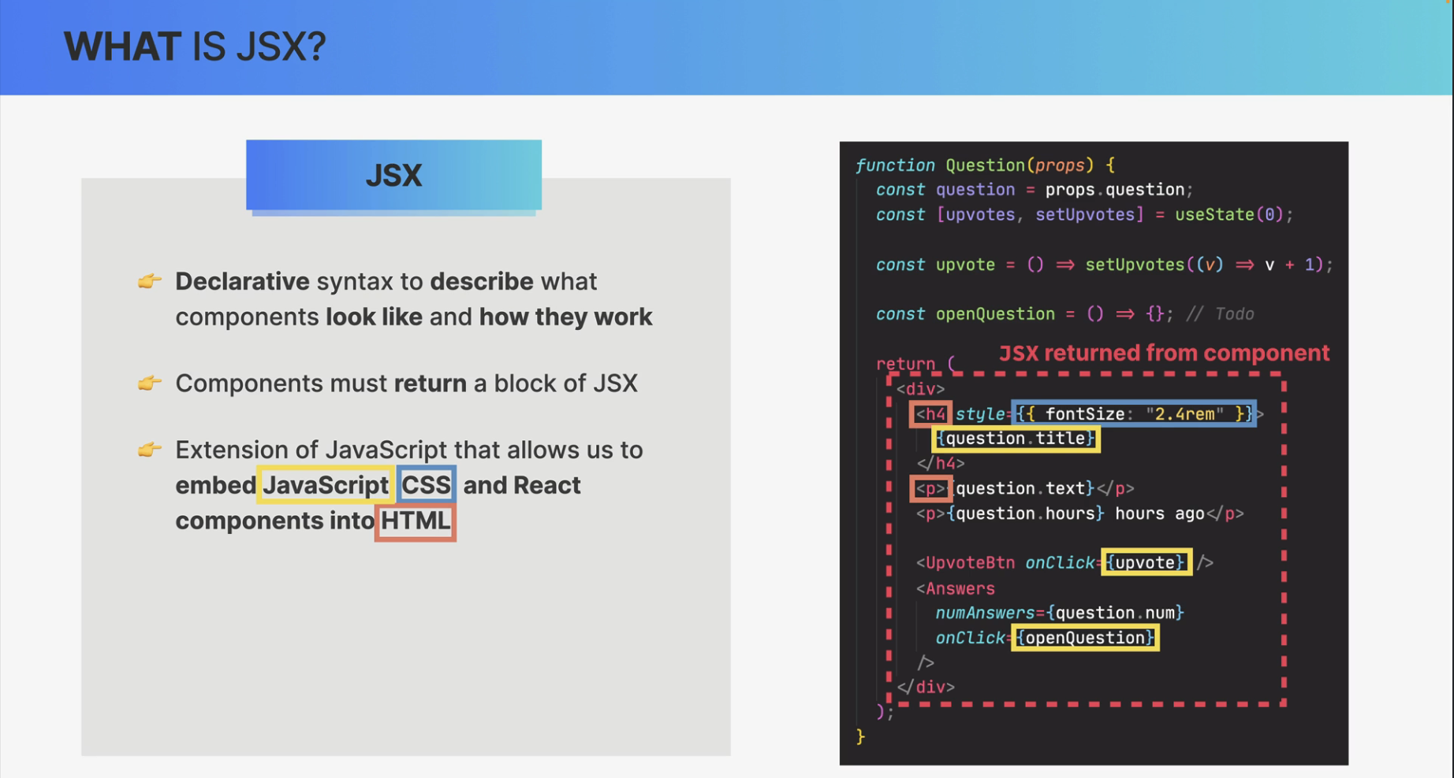

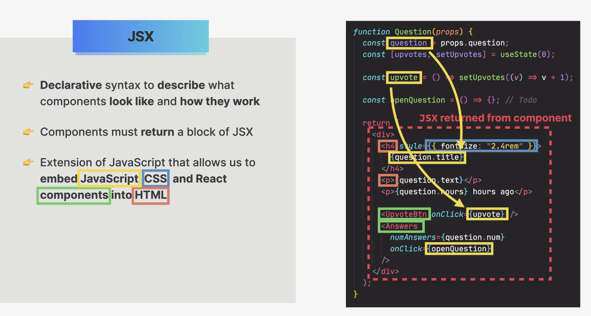

* Each JSX element is converted to a React.createElement function call

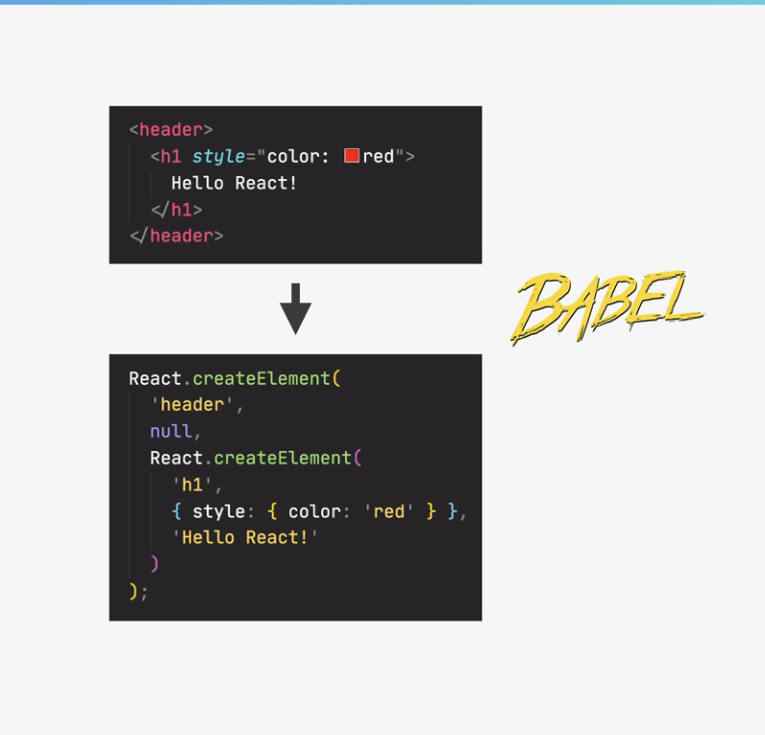

But anyway, this conversion is necessary because browsers of course, do not understand JSX.

They only understand HTML. So behind the scenes, all the JSX that we write is converted into many nested React.createElement function calls. And these function calls are what in the end, create the HTML elements that we see on the screen.

Now, what this means is that we could actually use React without JSX at all.

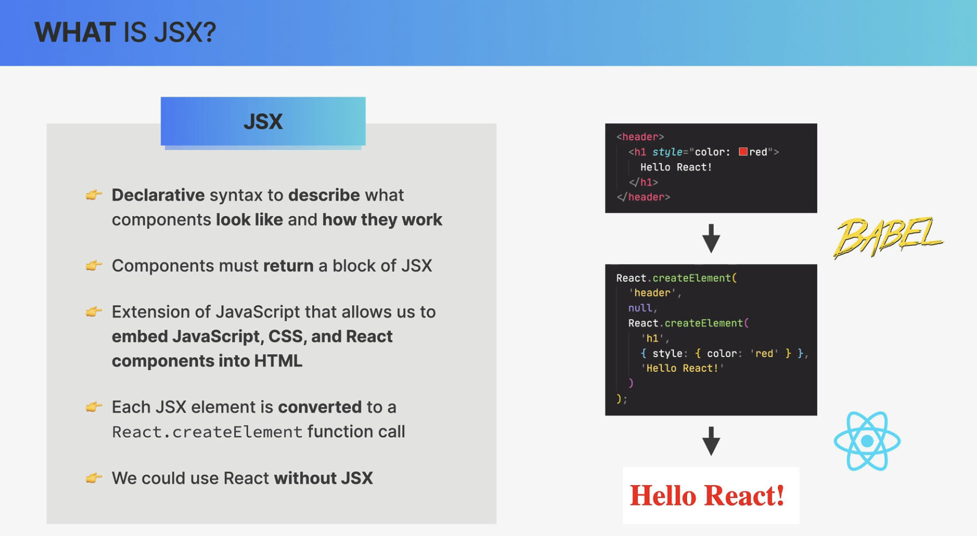

And so again, basically, we use JSX to describe the UI based on props and state. So the data that's currently in the component and all that happens without any DOM manipulation at all.

So, there are no Query selectors, no ad event listeners, no class list, and no text content properties anywhere to be seen here because, in fact, React is basically a huge abstraction away from the DOM, so we, developers never have to touch the DOM directly.

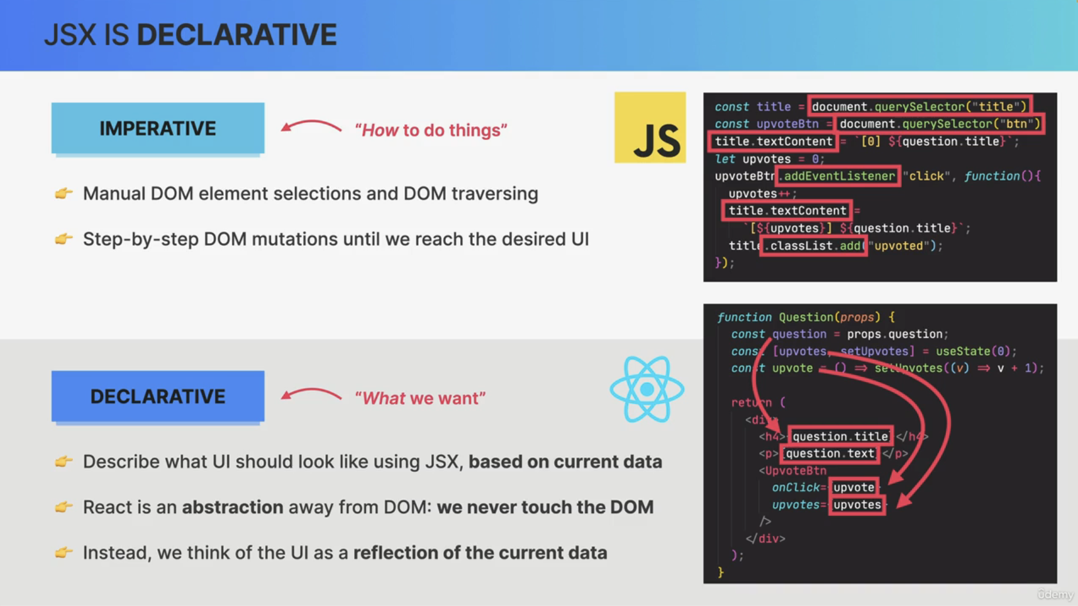

###### Rules of JSX

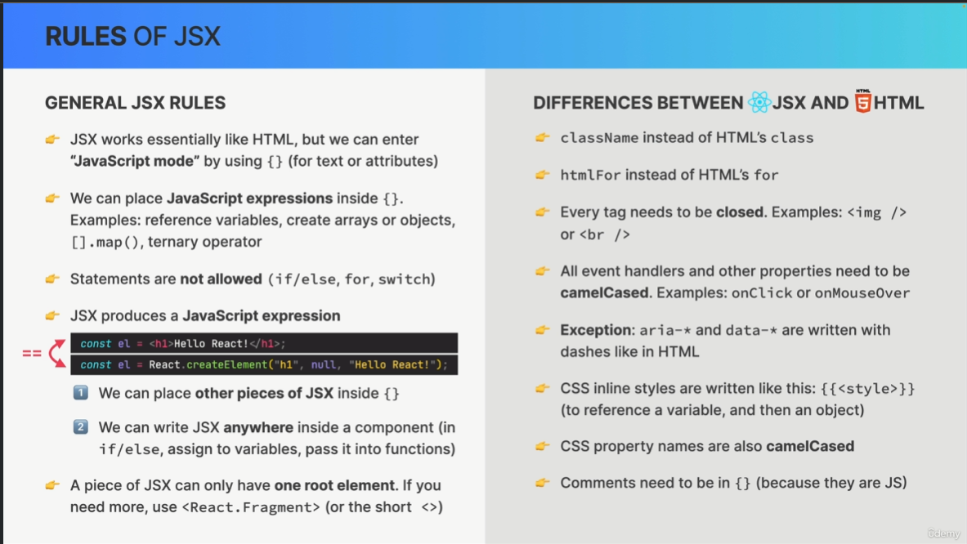

GENERAL JSX RULES

JSX works essentially like HTML, but we can enter

“JavaScript mode” by using {} (for text or attributes)

👉 We can place JavaScript expressions inside {}.

Examples: reference variables, create arrays or objects, [].map(), ternary operator

👉 Statements are not allowed (if/else, for, switch)

👉 JSX produces a JavaScript expression

1⃣ We can place other pieces of JSX inside {}

2⃣ We can write JSX anywhere inside a component (in

if/else, assign to variables, pass it into functions)

==

👉 A piece of JSX can only have one root element. If you

need more, use <React.Fragment> (or the short <>)

DIFFERENCES BETWEEN JSX AND HTML

👉 className instead of HTML’s class

👉 htmlFor instead of HTML’s for

👉 Every tag needs to be closed. Examples: <img />

or <br />

👉 All event handlers and other properties need to be

camelCased. Examples: onClick or onMouseOver

👉 Exception: aria-* and data-* are written with

dashes like in HTML

👉 CSS inline styles are written like this: {{<style>}}

(to reference a variable, and then an object)

👉 CSS property names are also camelCased

👉 Comments need to be in {} (because they are JS)

##### Props

And the prop is basically just like parameters to a function.

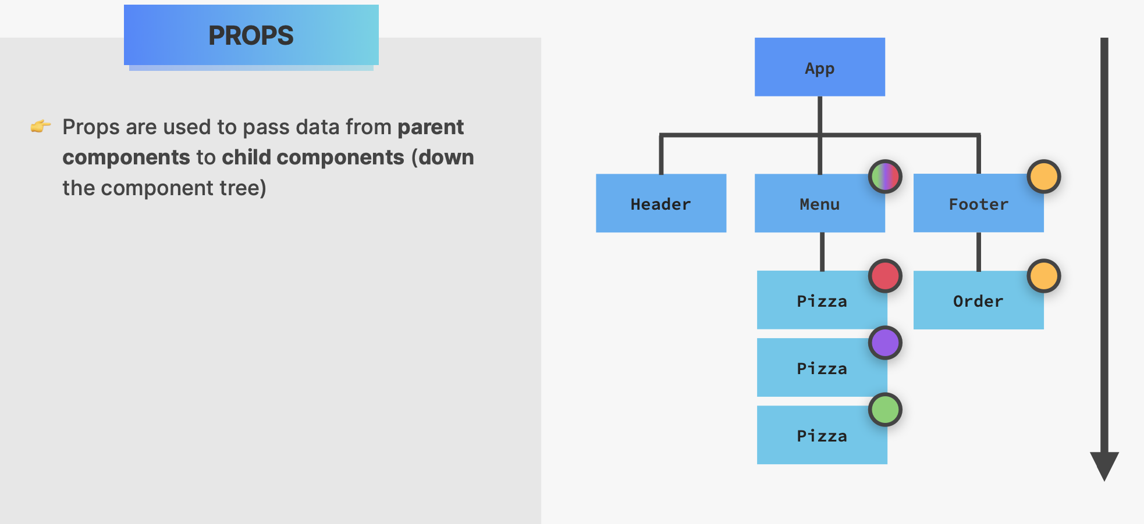

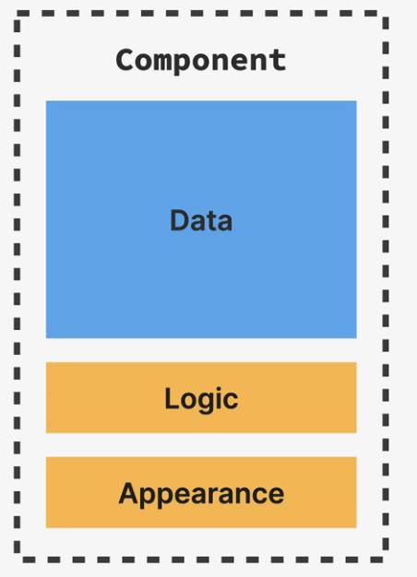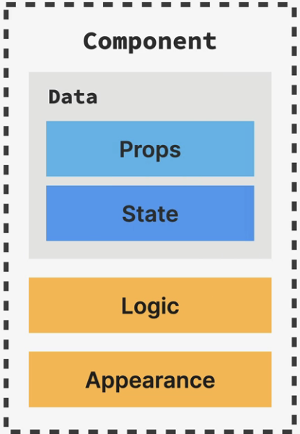

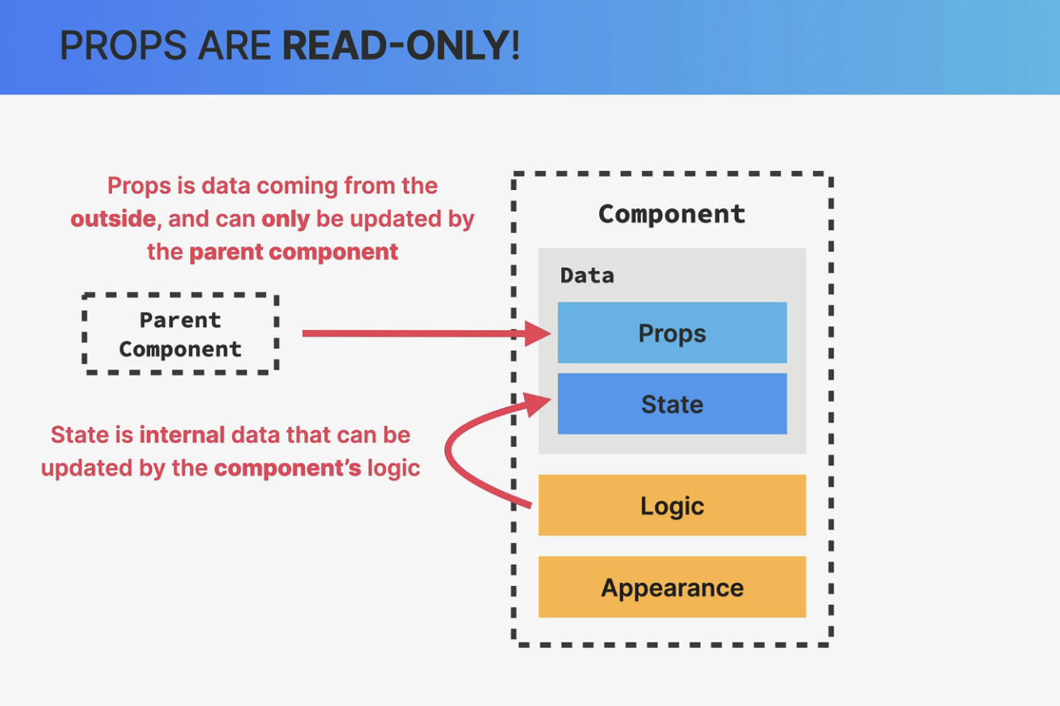

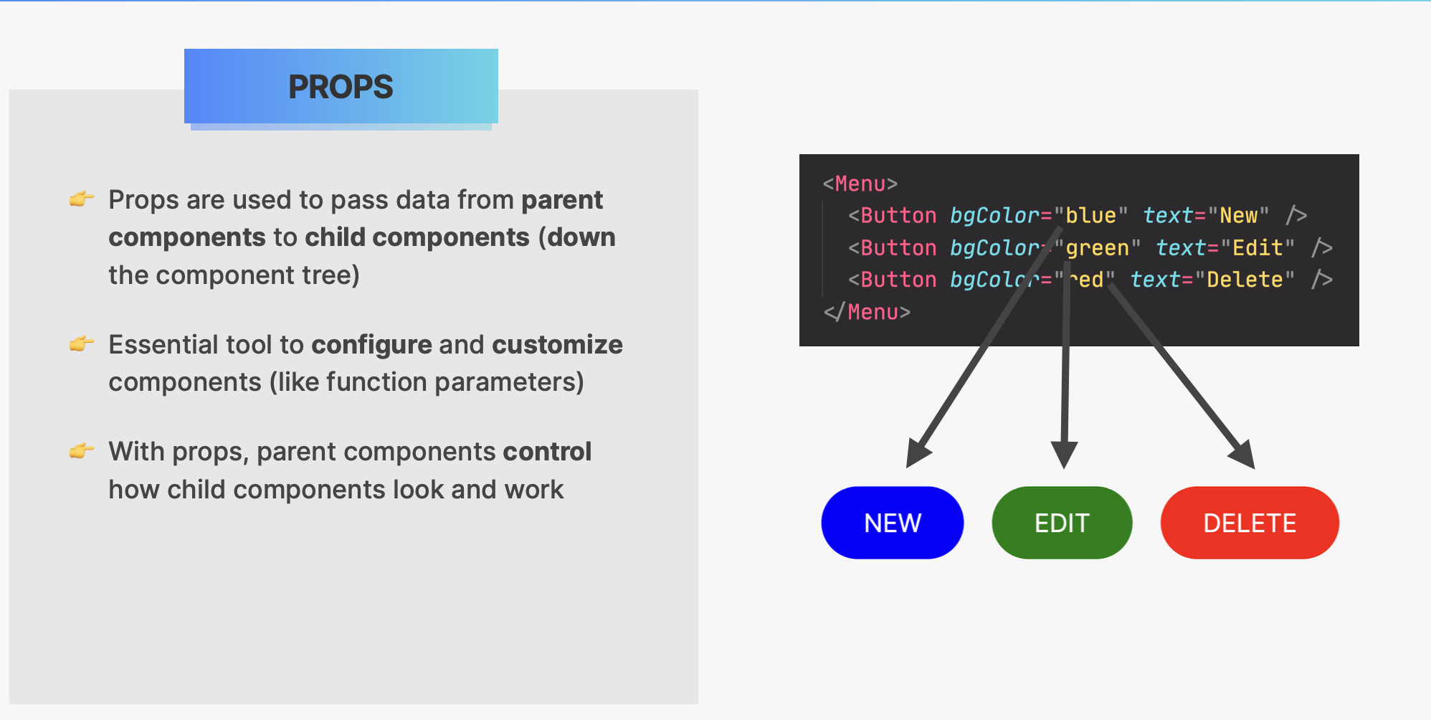

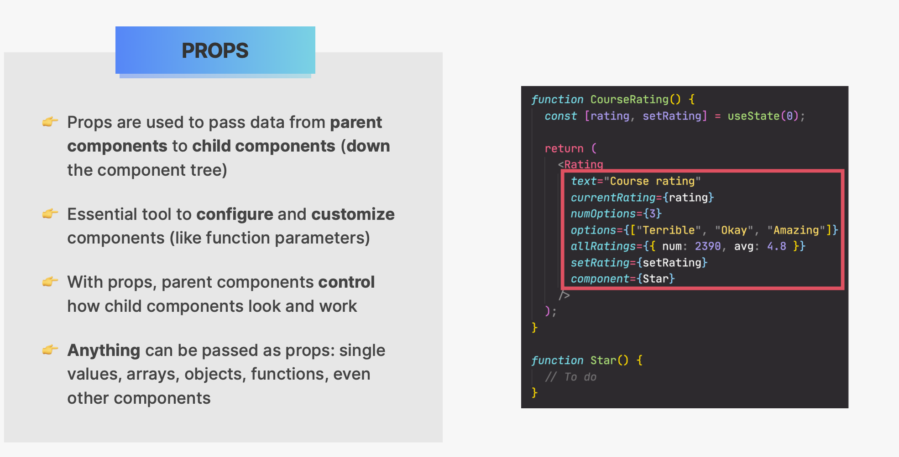

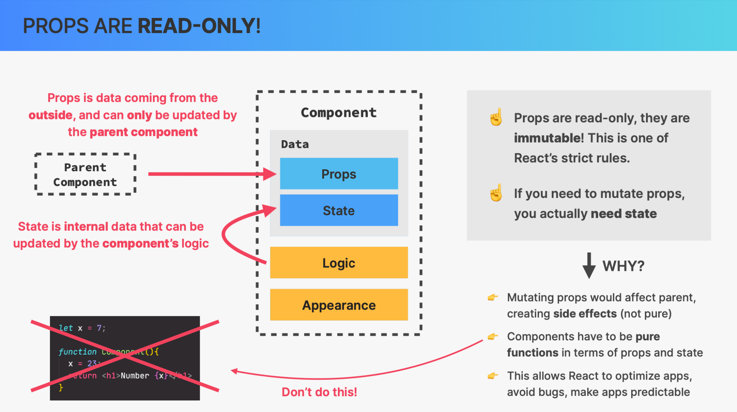

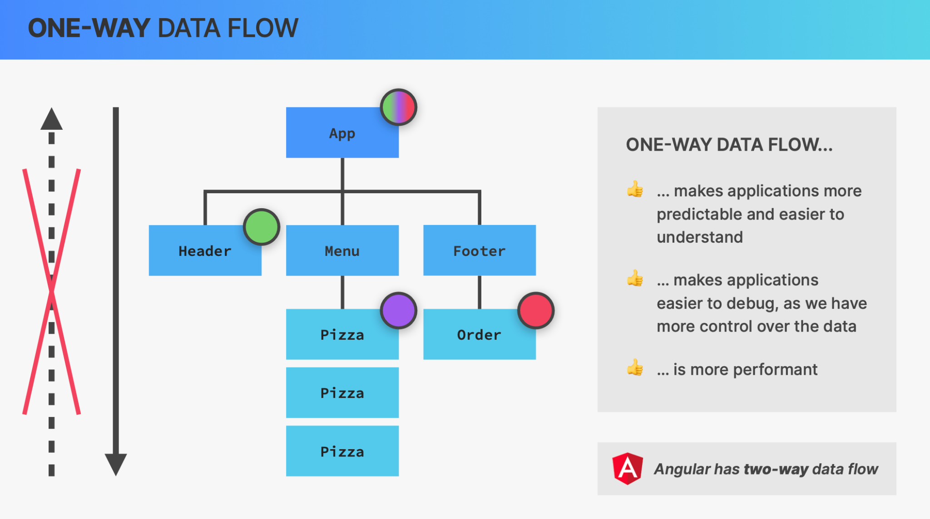

###### Props drilling

So basically prop drilling means that we need to pass some prop through several nested child components in order to get that data into some deeply nested component.

##### Props as an API

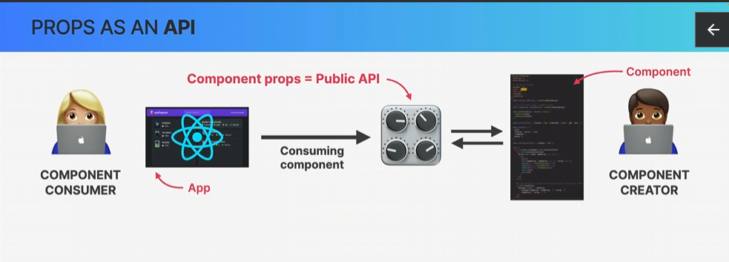

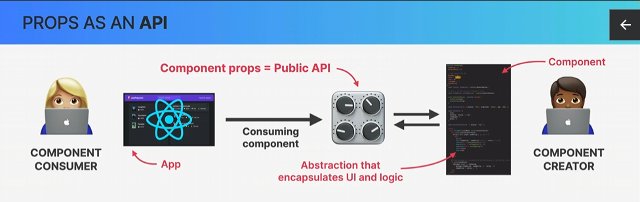

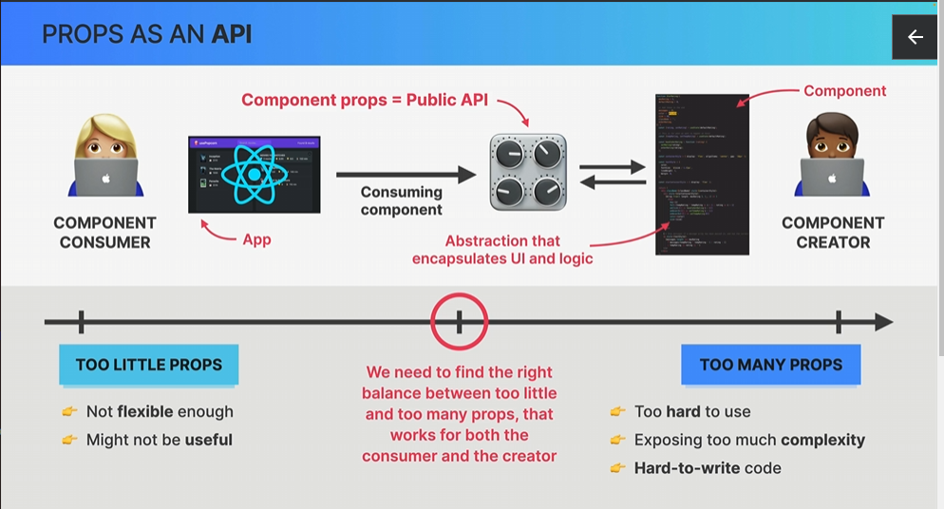

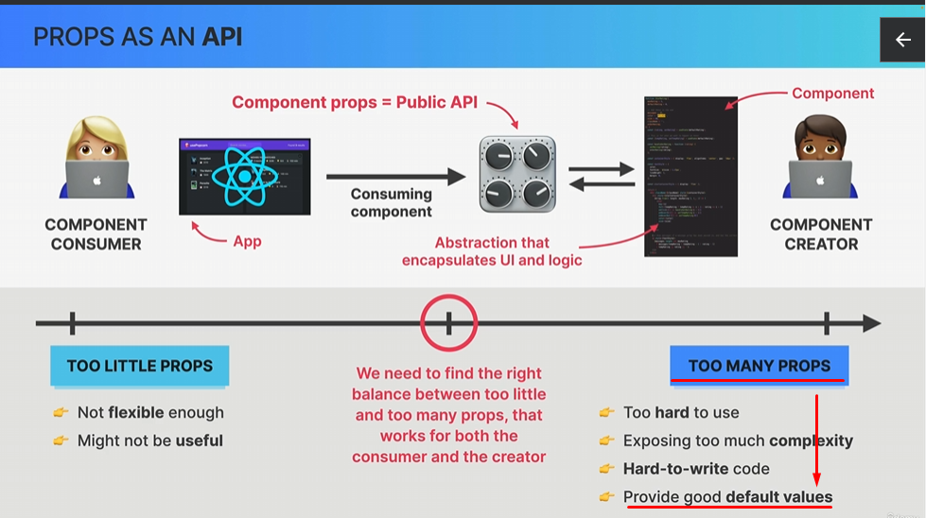

##### Rendering List

| const pizzaData = [  {  name: "Focaccia",  ingredients: "Bread with italian olive oil and rosemary",  price: 6,  photoName: "pizzas/focaccia.jpg",  soldOut: false,  },  {  name: "Pizza Margherita",  ingredients: "Tomato and mozarella",  price: 10,  photoName: "pizzas/margherita.jpg",  soldOut: false,  }, ]; |
| --- |

| <ul className="pizzas">  {pizzaData.map((pizza) => (  <Pizza key={pizza.name} pizzaObj={pizza} />  ))} </ul>; |
| --- |

| function Pizza(props) {  return (  <li className="pizza">  <img src={props.pizzaObj.photoName} alt={props.pizzaObj.name} />  <div>  <h3>{props.pizzaObj.name}</h3>  <p>{props.pizzaObj.ingredients}</p>  <span>{props.pizzaObj.price}</span>  </div>  </li>  ); } |
| --- |

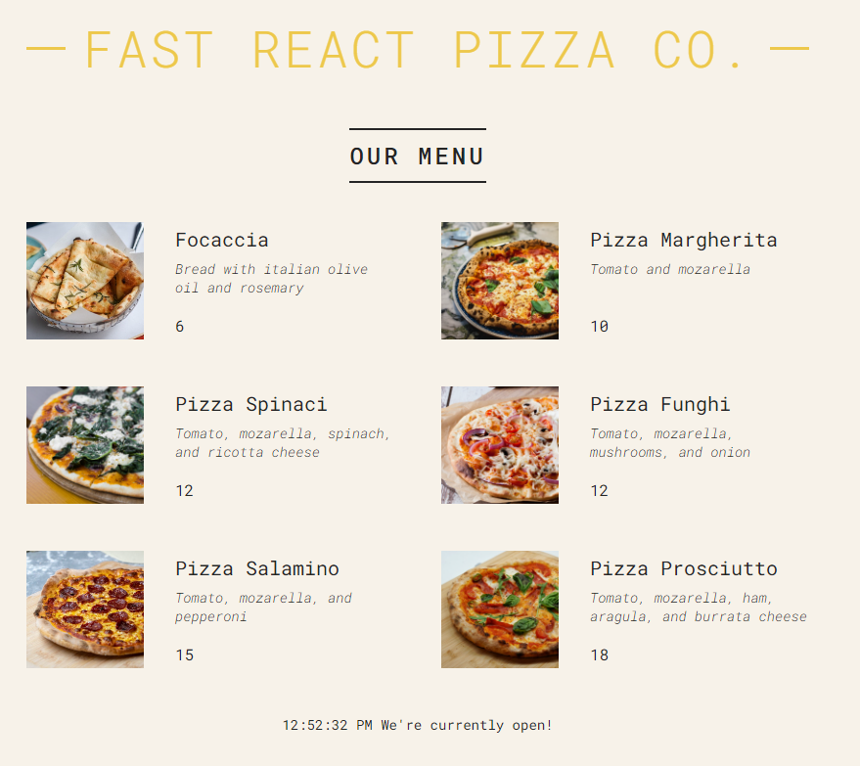

###### Conditional Rendering &&

| function Menu() {  const pizzas = pizzaData;  const numPizzas = pizzas.length;  return (  <main className="menu">  <h2>Our Menu</h2>   {numPizzas > 0 && (  <ul className="pizzas">  {pizzaData.map((pizza) => (  <Pizza key={pizza.name} pizzaObj={pizza} />  ))}  </ul>  )}  </main>  ); } |
| --- |

Be careful here numPizzas > 0 -> the value from the expression must be true or false. If the result of the expression is 0, then 0 will be displayed on the UI.  
  
For example if the check is

| {numPizzas && (  <ul className="pizzas">  {pizzaData.map((pizza) => (  <Pizza key={pizza.name} pizzaObj={pizza} />  ))}  </ul>  )} |
| --- |

Then if the numPizzas is 0, then the second condition will not executed at all, but the first expression which is numPizzas will give 0 as a result and then the 0 will be displayed on the UI. True, or false values are not displayed on the UI.

###### Conditional Rendering ?

| function Menu() {  const pizzas = pizzaData;  // const pizzas = [];  const numPizzas = pizzas.length;  return (  <main className="menu">  <h2>Our Menu</h2>   {numPizzas > 0 ? (  <ul className="pizzas">  {pizzaData.map((pizza) => (  <Pizza key={pizza.name} pizzaObj={pizza} />  ))}  </ul>  ) : (  <p>We are still working on our menu. Please come back later</p>  )}  </main>  ); } |
| --- |

#### 

| function Footer() {  const hour = new Date().getHours();  const openHour = 12;  const closeHour = 22;  const isOpen = hour >= openHour && hour <= closeHour;   return (  <footer className="footer">  {isOpen ? (  <div className="order">  <p>We'are open until {closeHour}:00. Come visit us or order online</p>  <button className="btn">Order</button>  </div>  ) : (  <p>  We are happy to wellcome you between {openHour}:00 and {closeHour}:00  </p>  )}  </footer>  ); } |
| --- |

###### Conditional Rendering With Multiple Returns

//useful when we want to render full components , no some piece of JSX

| if (!isOpen)  return (  <p>  We are happy to wellcome you between {openHour}:00 and {closeHour}:00  </p>  ); |
| --- |

#### 

| function Pizza(props) {  if (props.pizzaObj.soldOut) return null;   return (  <li className="pizza">  <img src={props.pizzaObj.photoName} alt={props.pizzaObj.name} />  <div>  <h3>{props.pizzaObj.name}</h3>  <p>{props.pizzaObj.ingredients}</p>  <span>{props.pizzaObj.price}</span>  </div>  </li>  ); } |
| --- |

###### Setting Classes and Text Conditionally

| function Pizza({ pizzaObj }) {  return (  // <li className={"pizza " + (pizzaObj.soldOut ? "sold-out" : "")}>  // <li className={`pizza ${pizzaObj.soldOut && "sold-out"}`}>  <li className={`pizza ${pizzaObj.soldOut ? "sold-out" : ""}`}>  <img src={pizzaObj.photoName} alt={pizzaObj.name} />  <div>  <h3>{pizzaObj.name}</h3>  <p>{pizzaObj.ingredients}</p>  <span>{pizzaObj.soldOut ? "SOLD OUT" : pizzaObj.price}</span>  </div>  </li>  ); } |
| --- |

##### React Fragments

| function Menu() {  const pizzas = pizzaData;  // const pizzas = [];  const numPizzas = pizzas.length;  return (  <main className="menu">  <h2>Our Menu</h2>   {numPizzas > 0 ? (  <>  <p>  Authentic Italian cuisine. 6 creative dishes to choose from. All  from our stone oven, all organic, all drlicious  </p>  <ul className="pizzas">  {pizzaData.map((pizza) => (  <Pizza key={pizza.name} pizzaObj={pizza} />  ))}  </ul>  </>  ) : (  <p>We are still working on our menu. Please come back later</p>  )}  </main>  ); } |
| --- |

If we need to put key attribute on the fragment the we must use this syntax

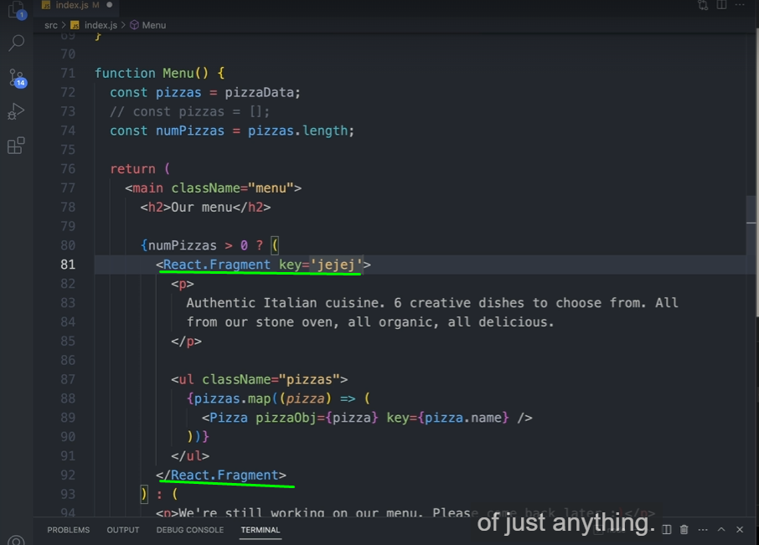

##### Component Size Matters

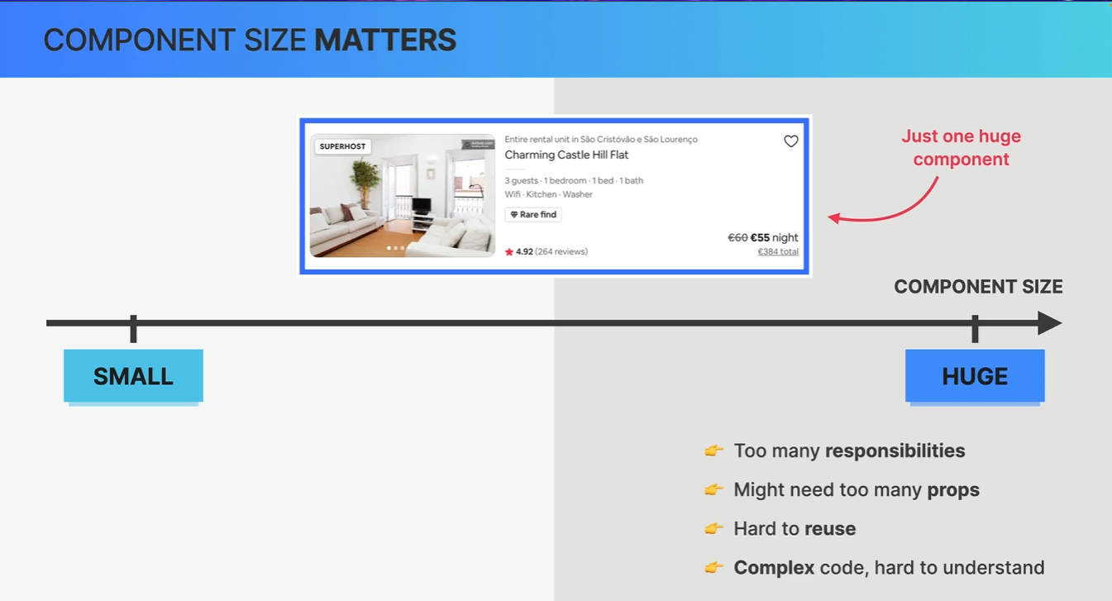

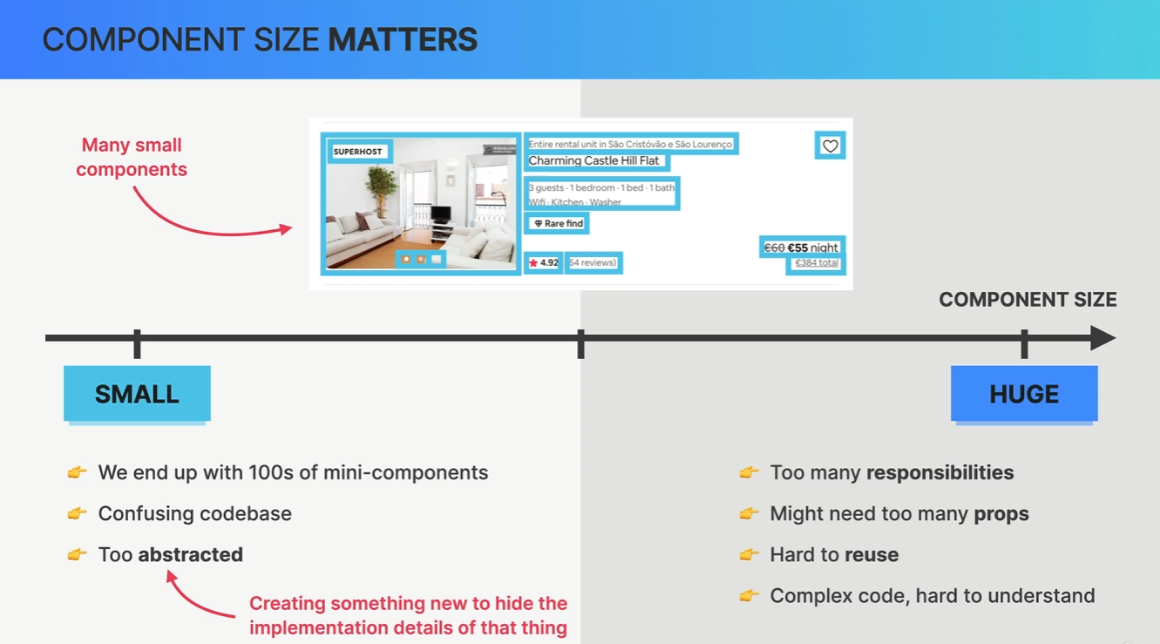

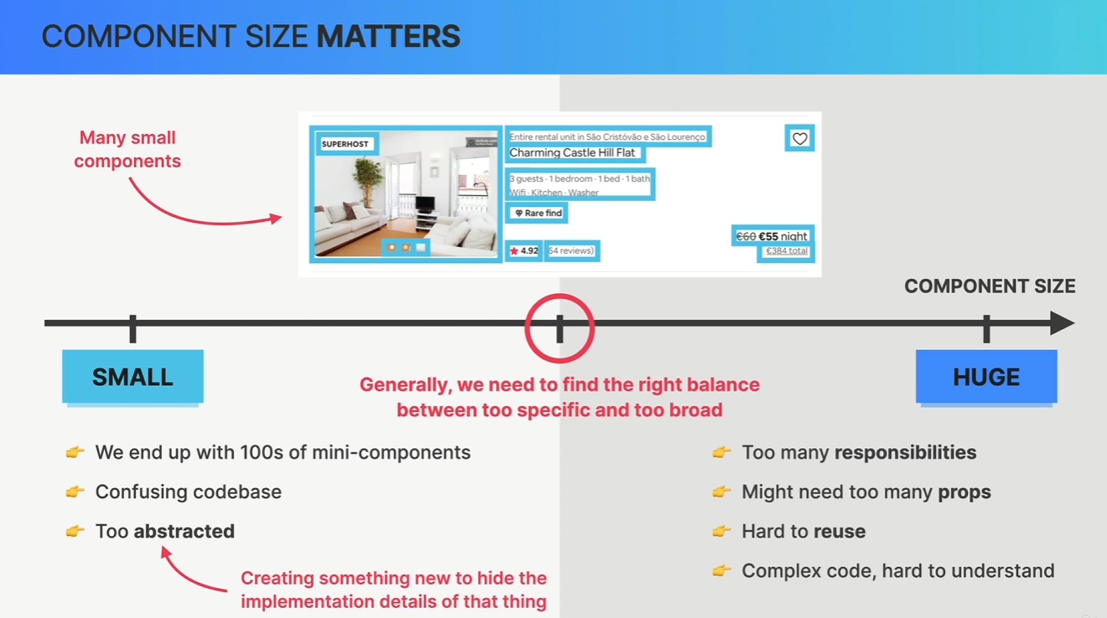

##### How to split UI into components

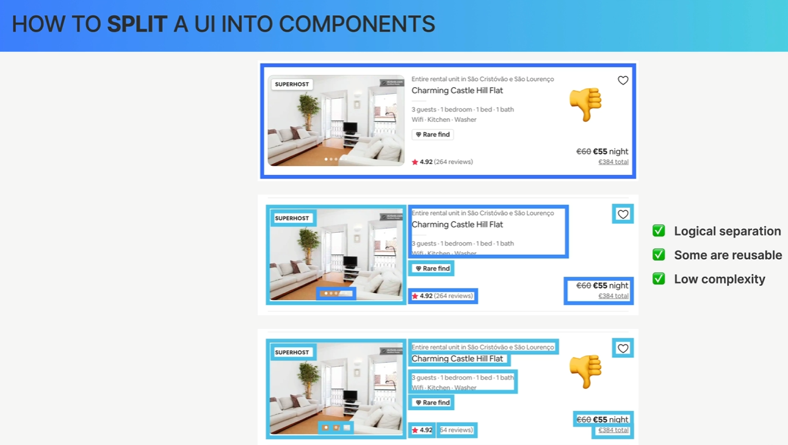

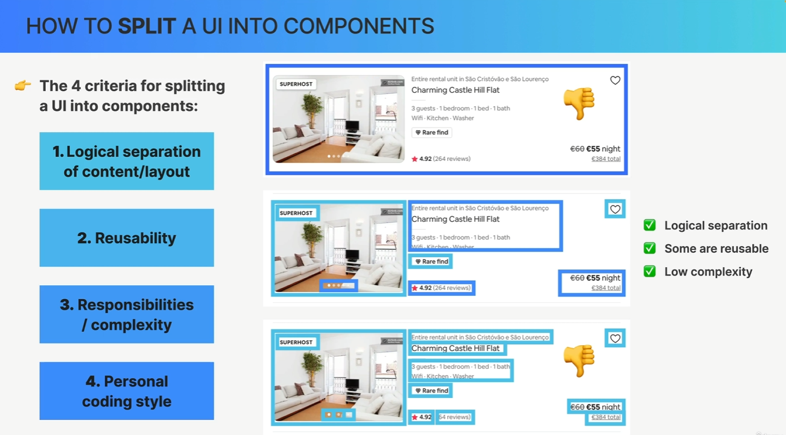

##### When to create a new component

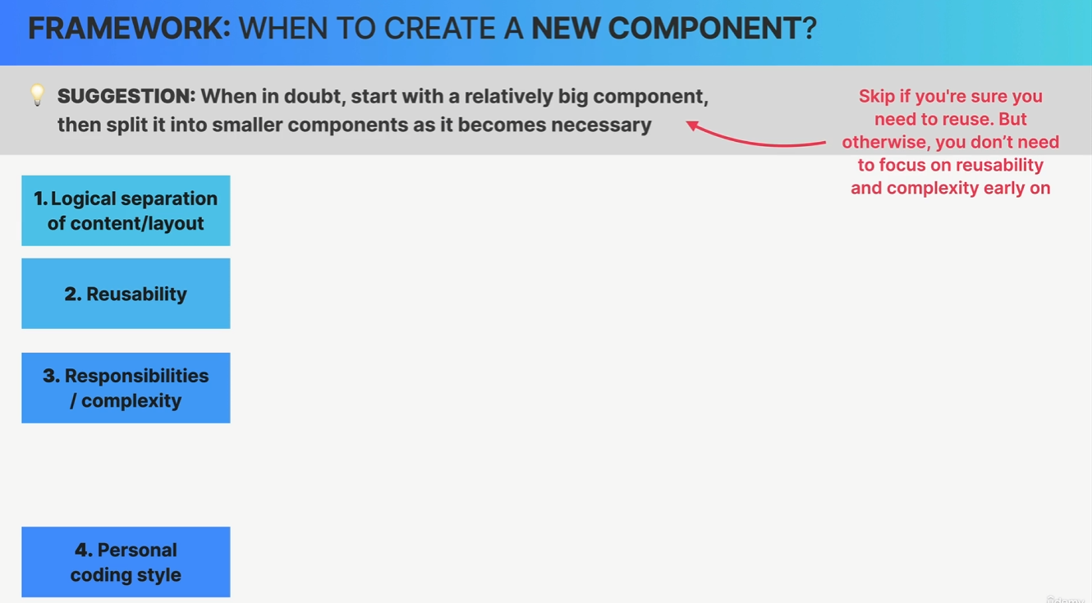

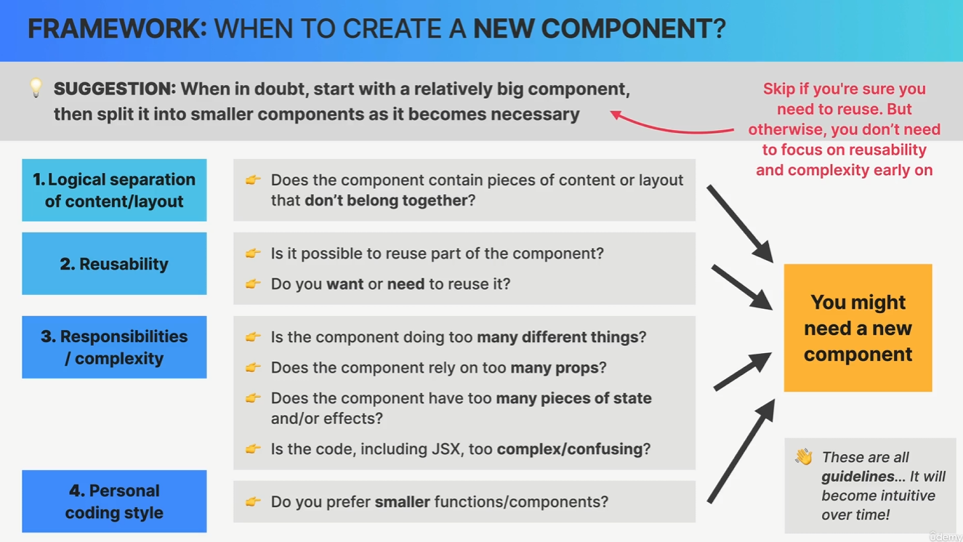

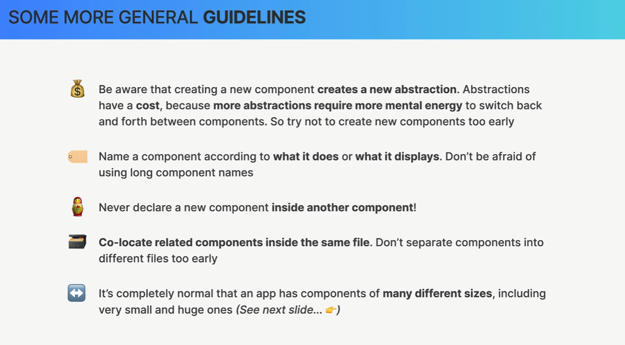

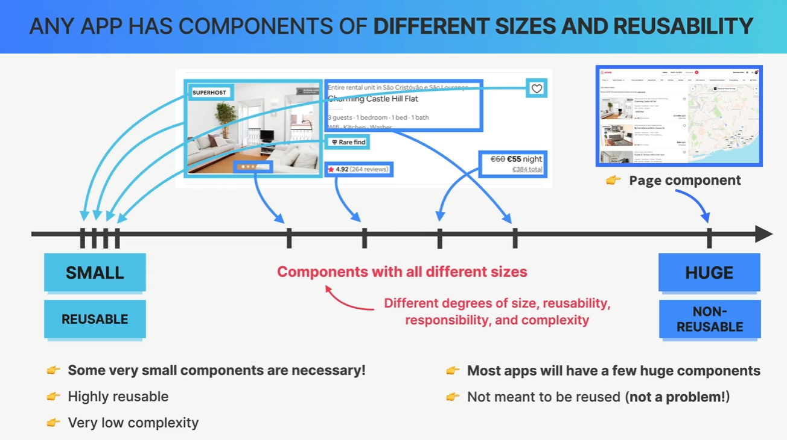

##### Component Categories

##### 

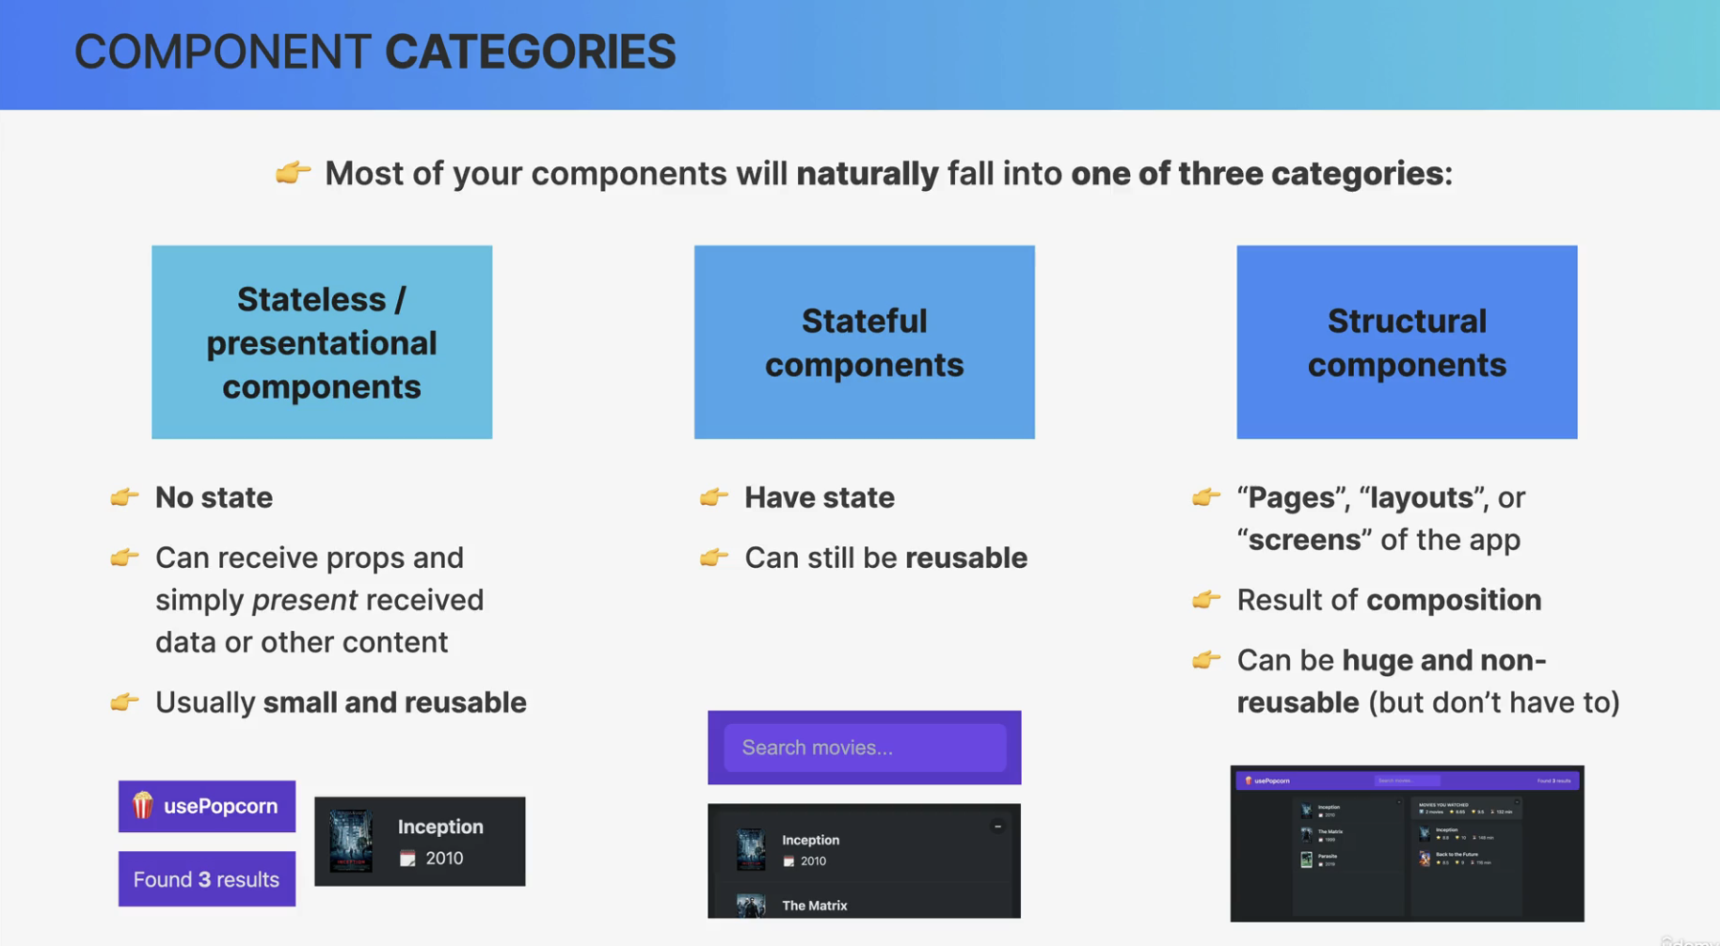

##### Component Composition

Combining different components using the children prop (or explicitly defined props)

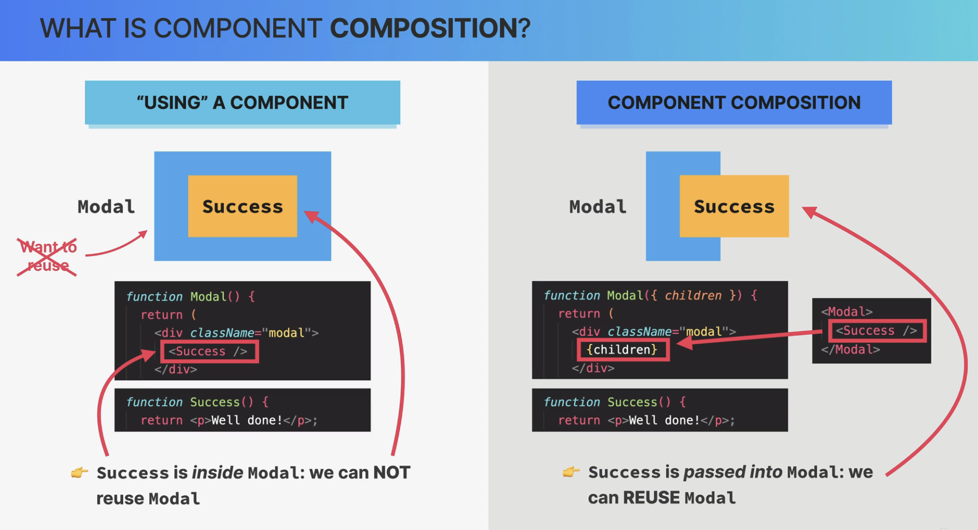

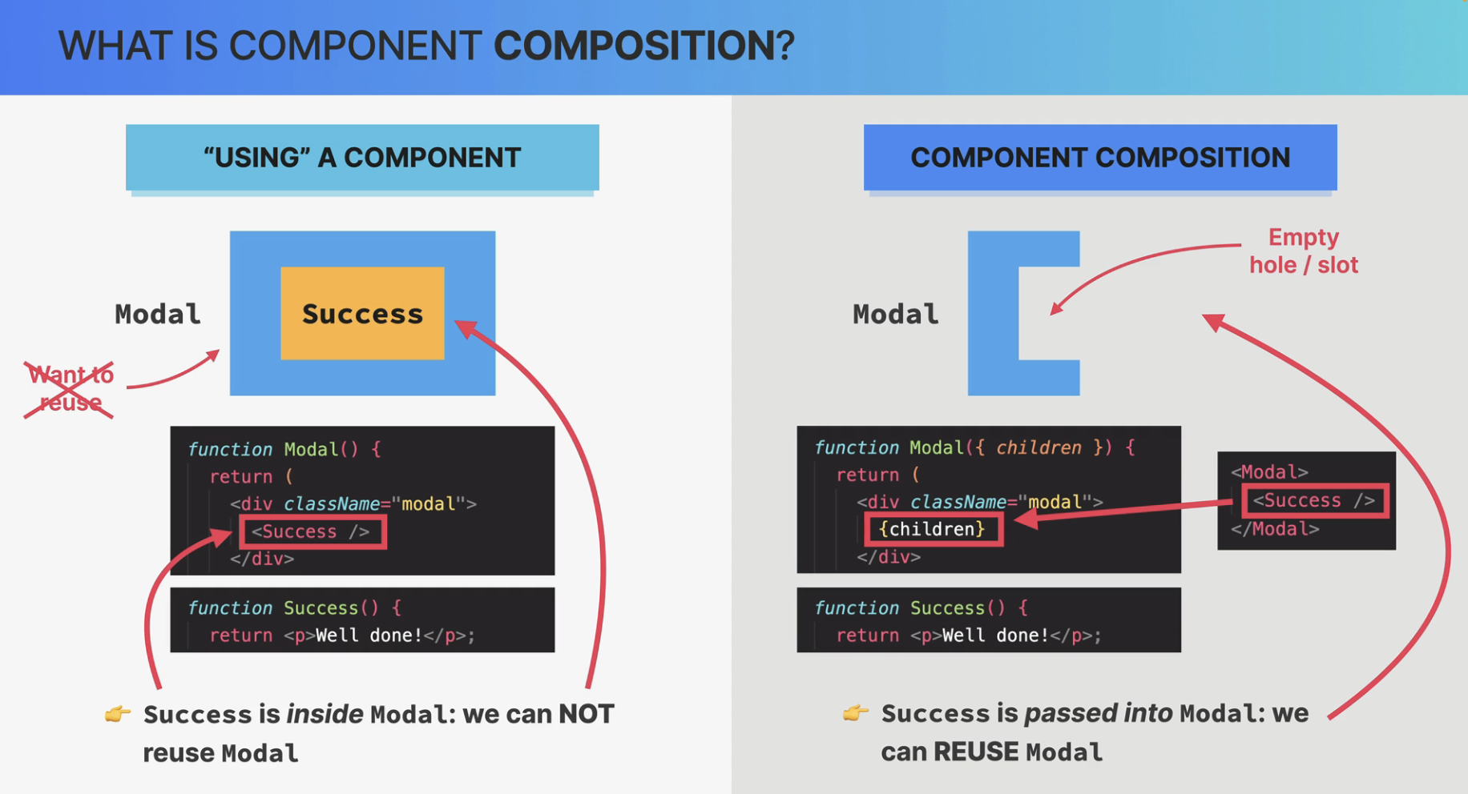

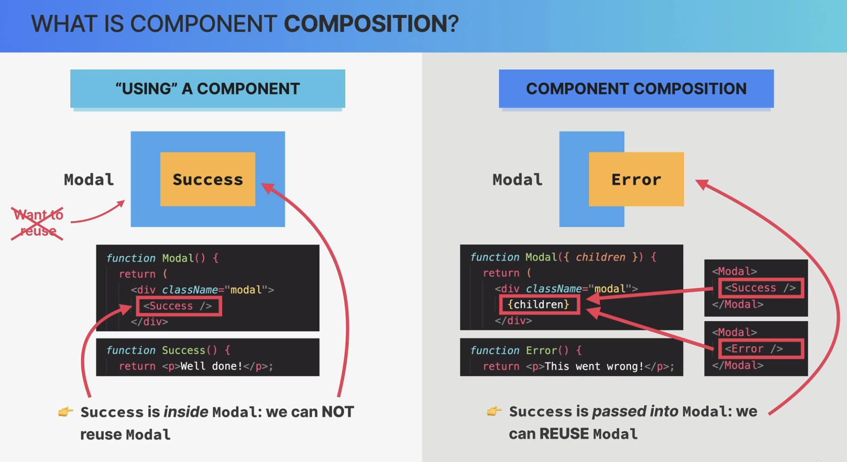

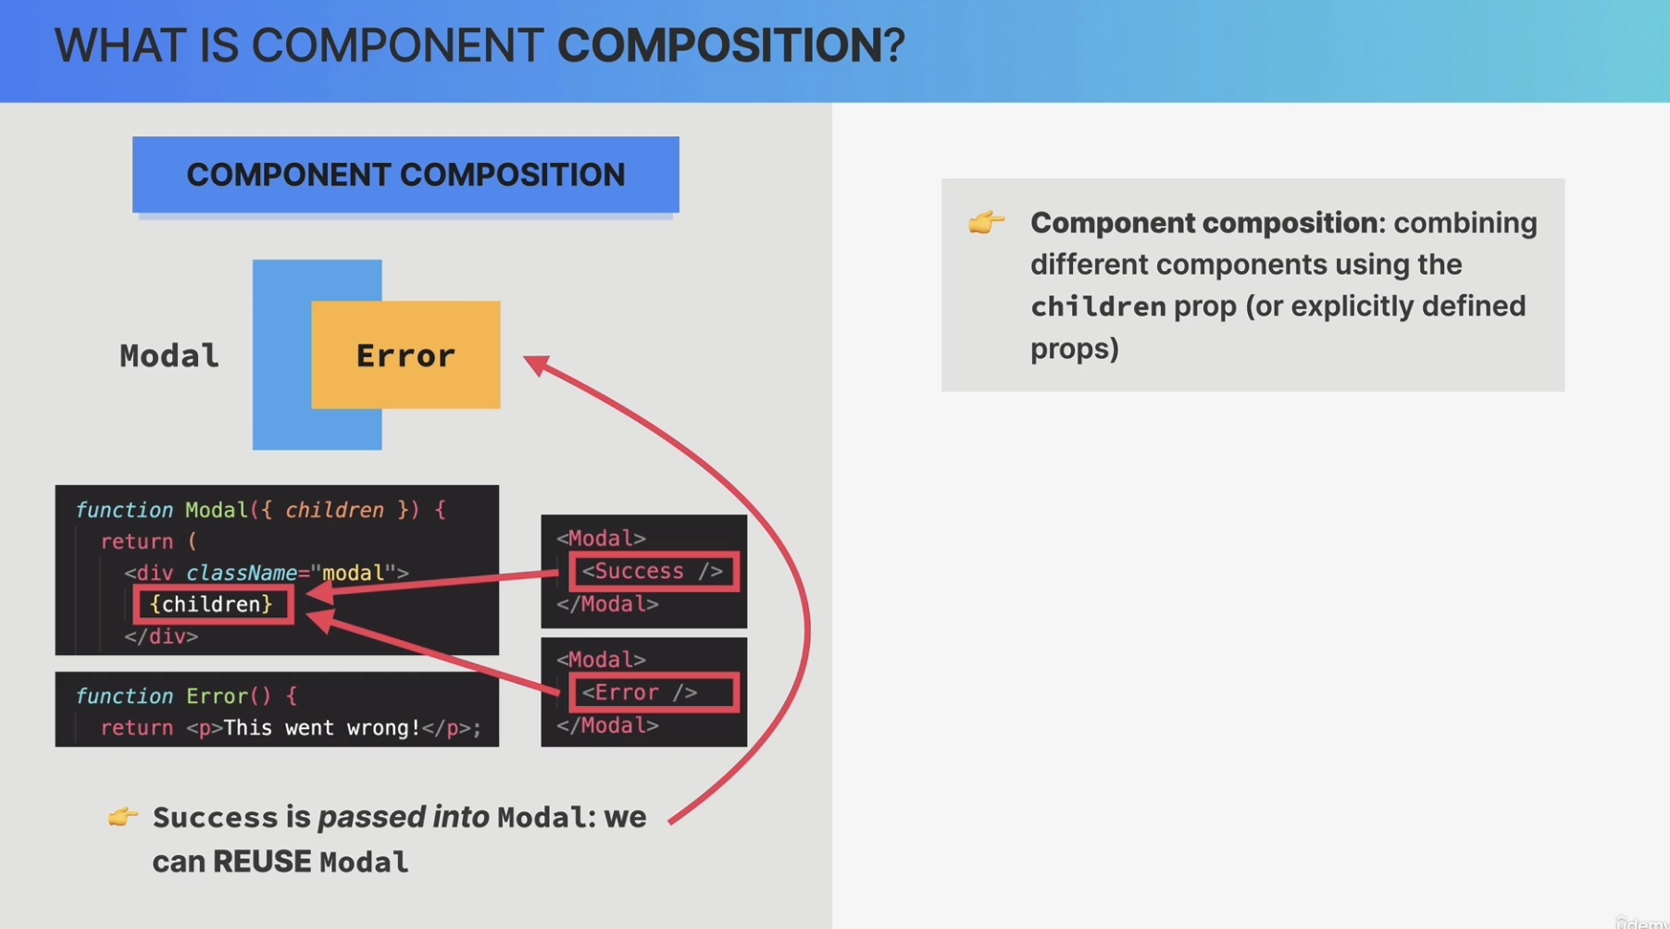

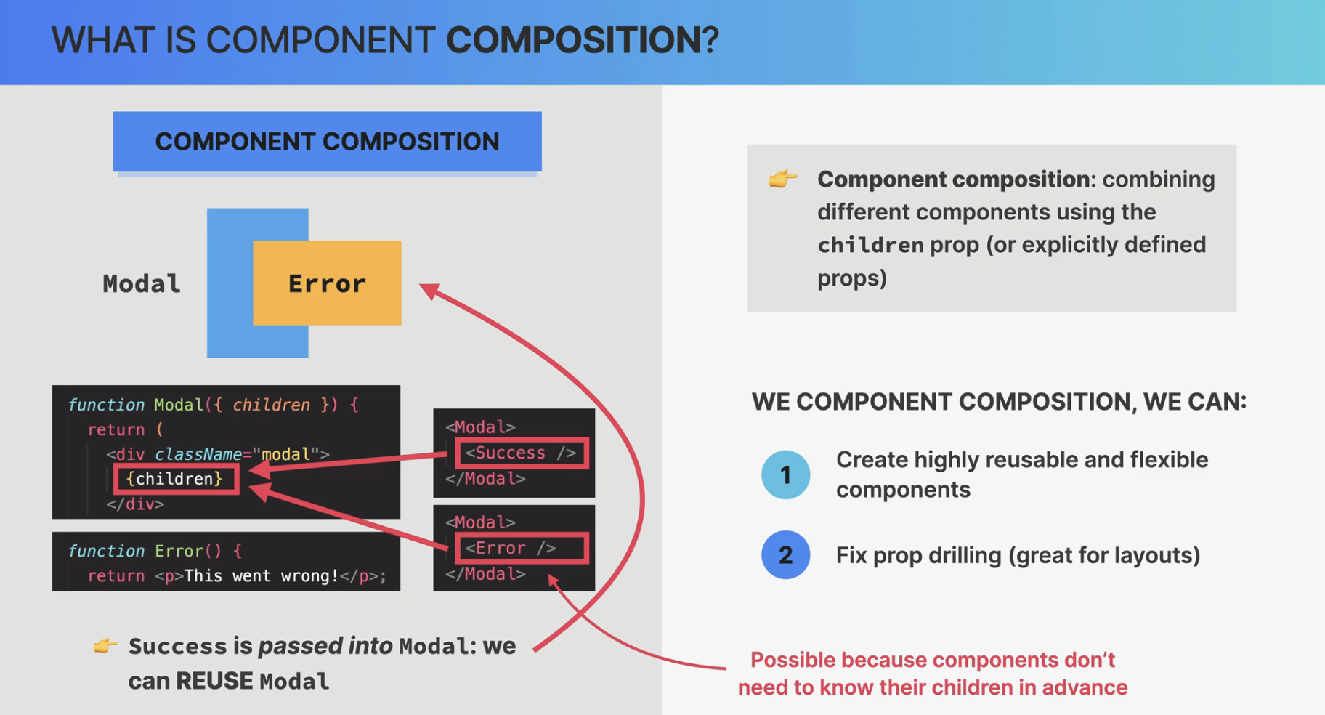

#### Separation of concerns

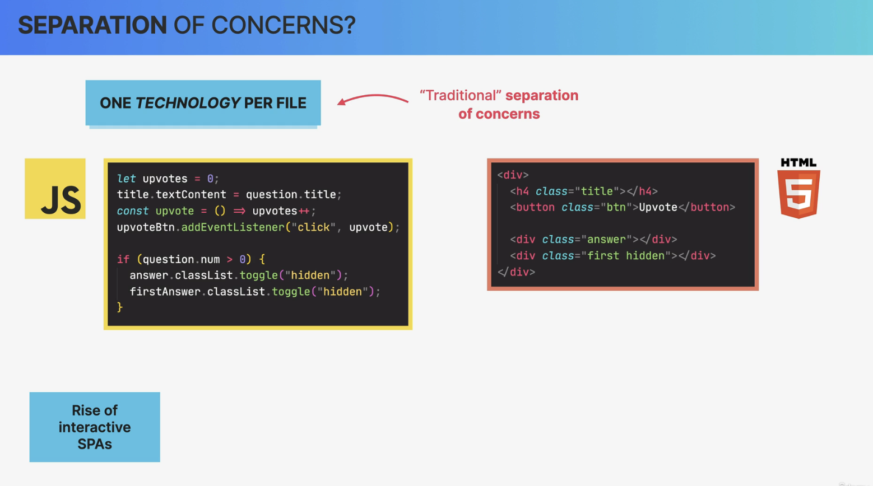

#### 

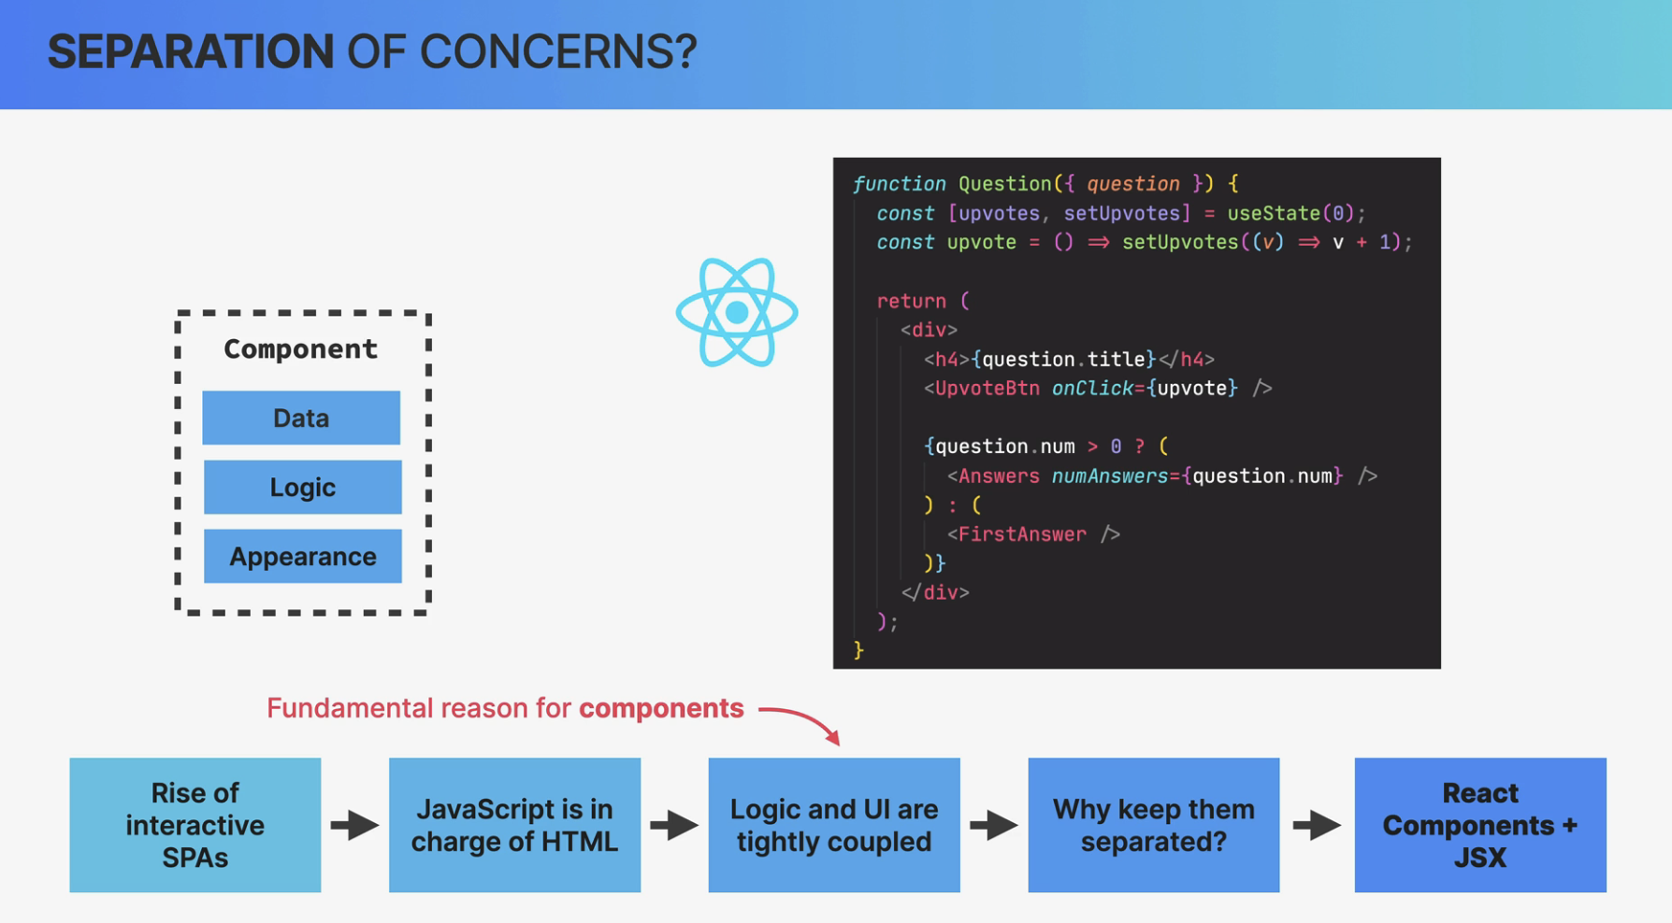

So content and logic are tightly coupled together and so it makes sense that they are co-located here.

Co-located simply means that things that change together should be located as close as possible together.

And in the case of React apps, that means that instead of one technology profile, we have one component profile. So one component that contains data logic and appearance,

all mixed together.

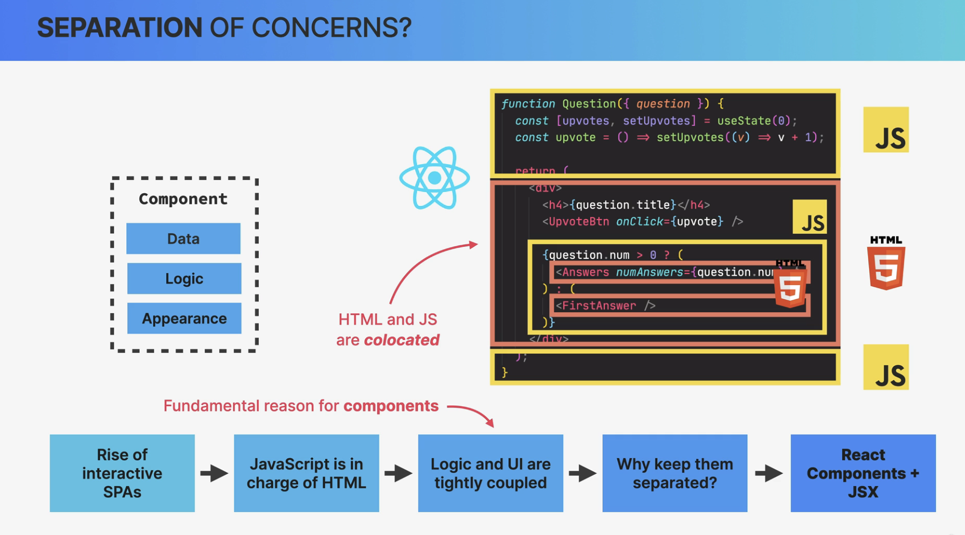

Well, I think that the people who say that React has no separation of concerns, got it all wrong.

Because React does actually have a separation of concerns. It's just not one concern per file,

as we had traditionally but one concern per component.

So each component is in fact, only concerned with one piece of the UI.

Then within each of these components, of course we still have the three concerns of HTML, CSS, and JavaScript all mixed up, as we have been discussing.

So compared to the traditional separation of concerns, this is a completely new paradigm that many people were really not used to in the beginning. But now, many years later, we all got used to this and it works just great.

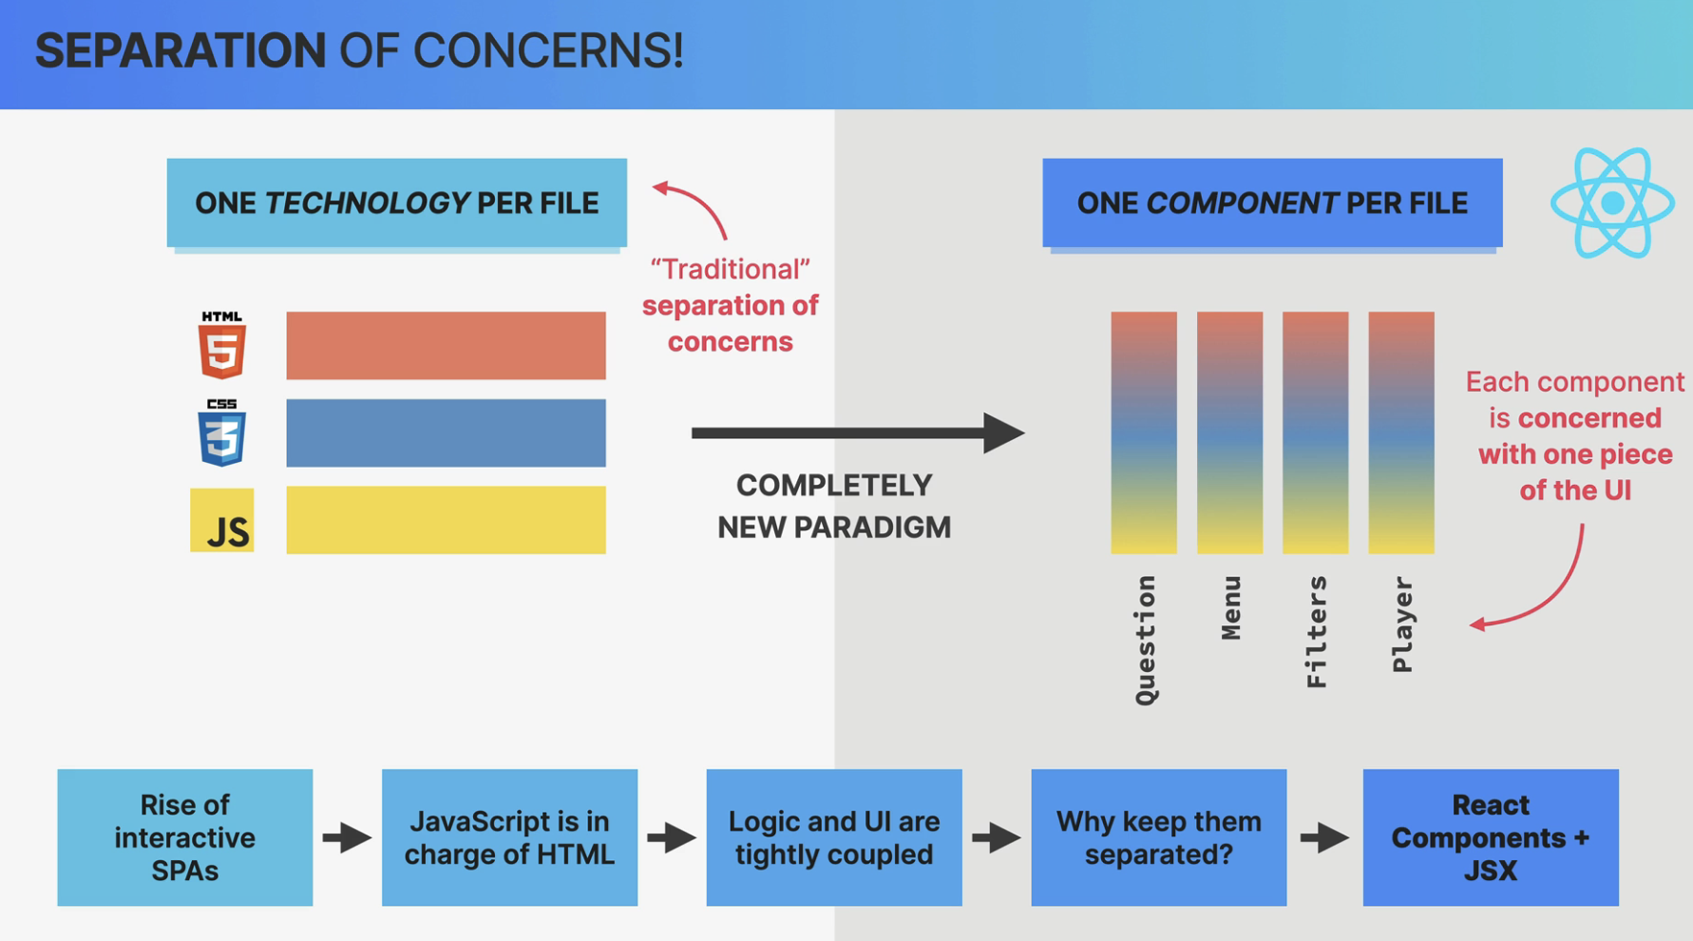

#### State

And the state is the most fundamental concept of React. So whenever we need something to change in the user interface, we change the state. So we update something that we call state.

##### 

##### 

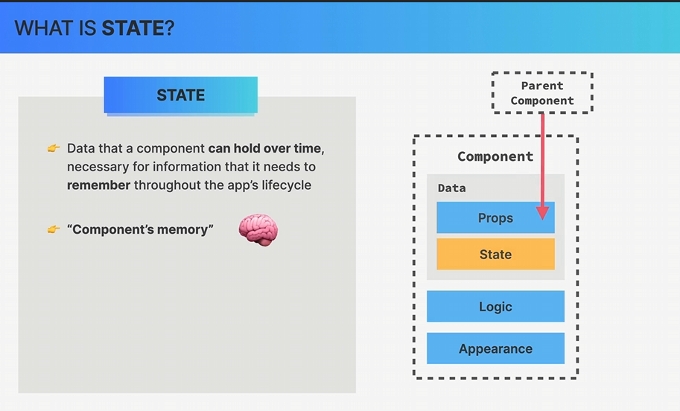

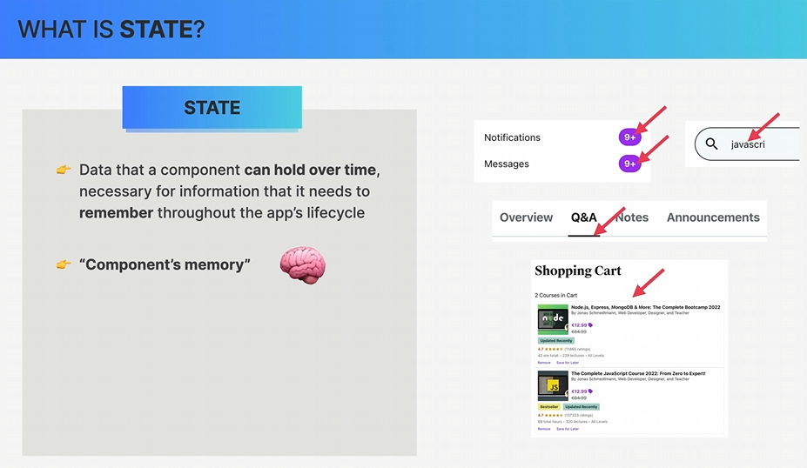

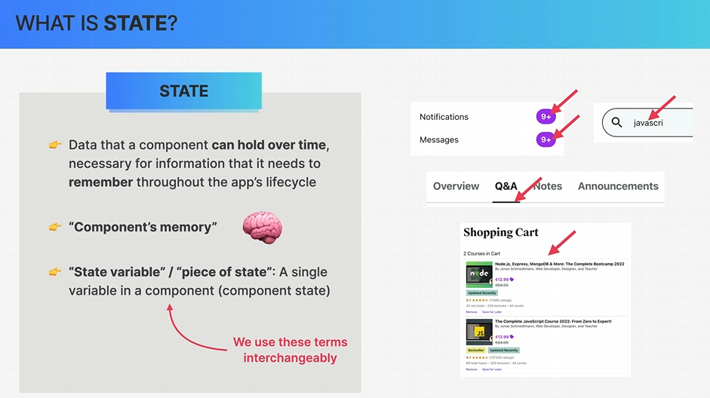

##### 

##### 

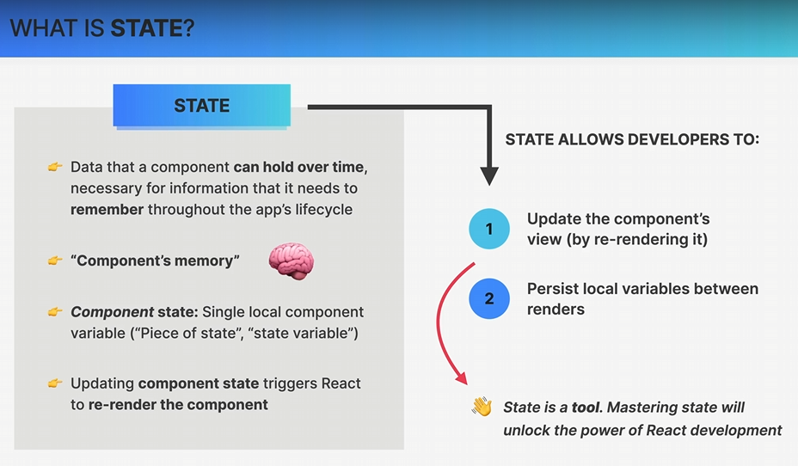

##### 

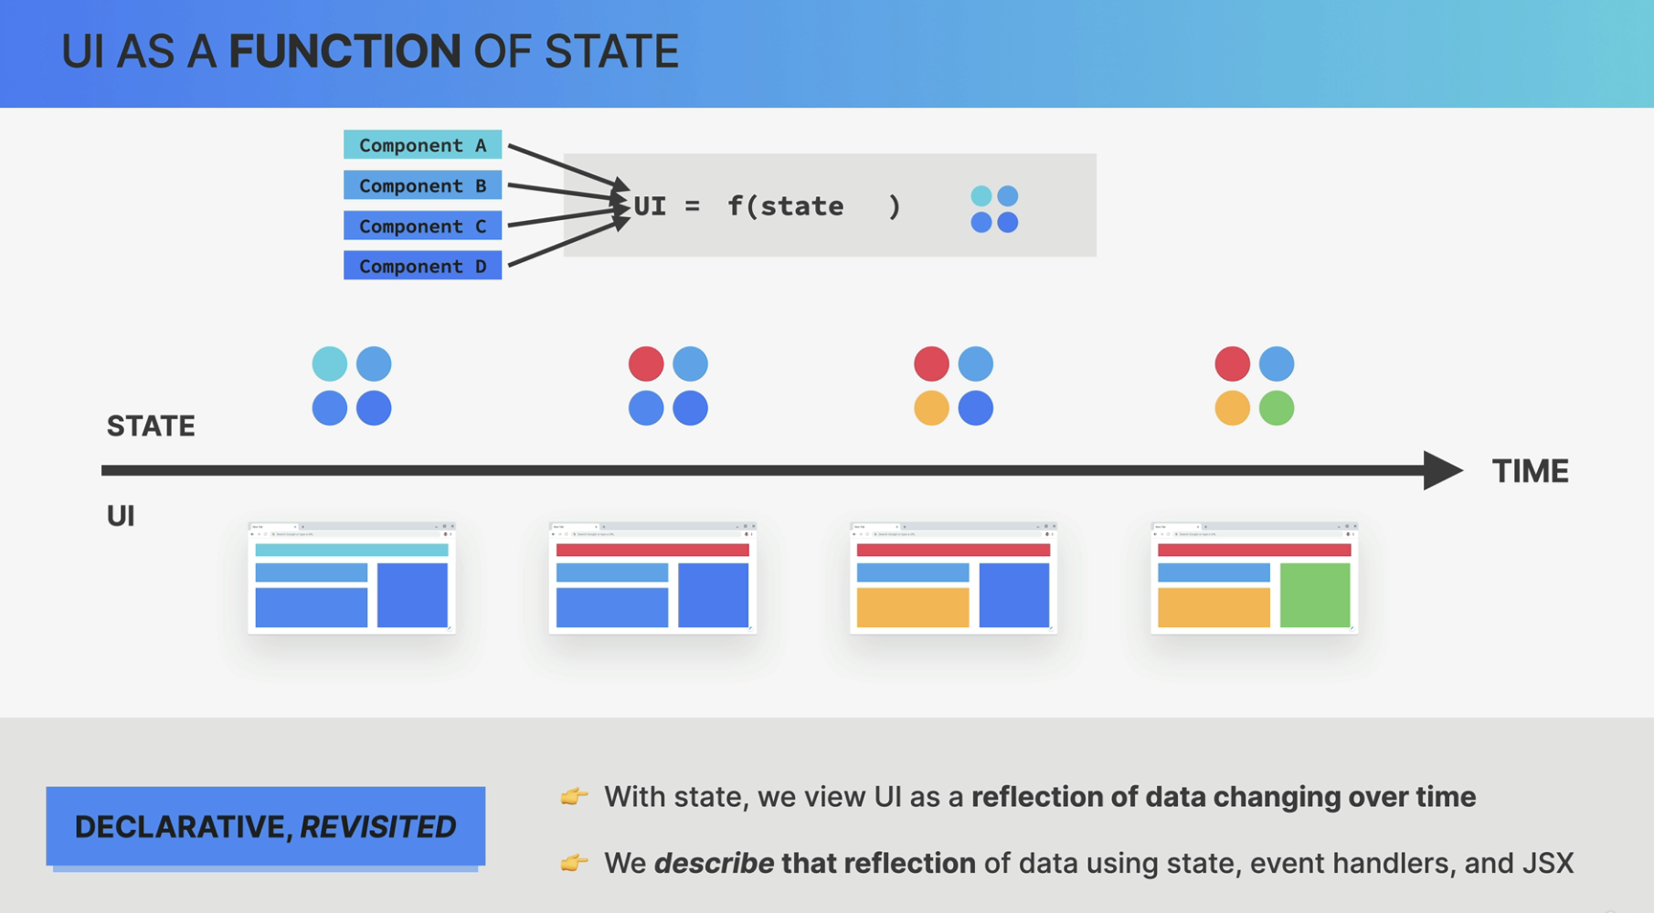

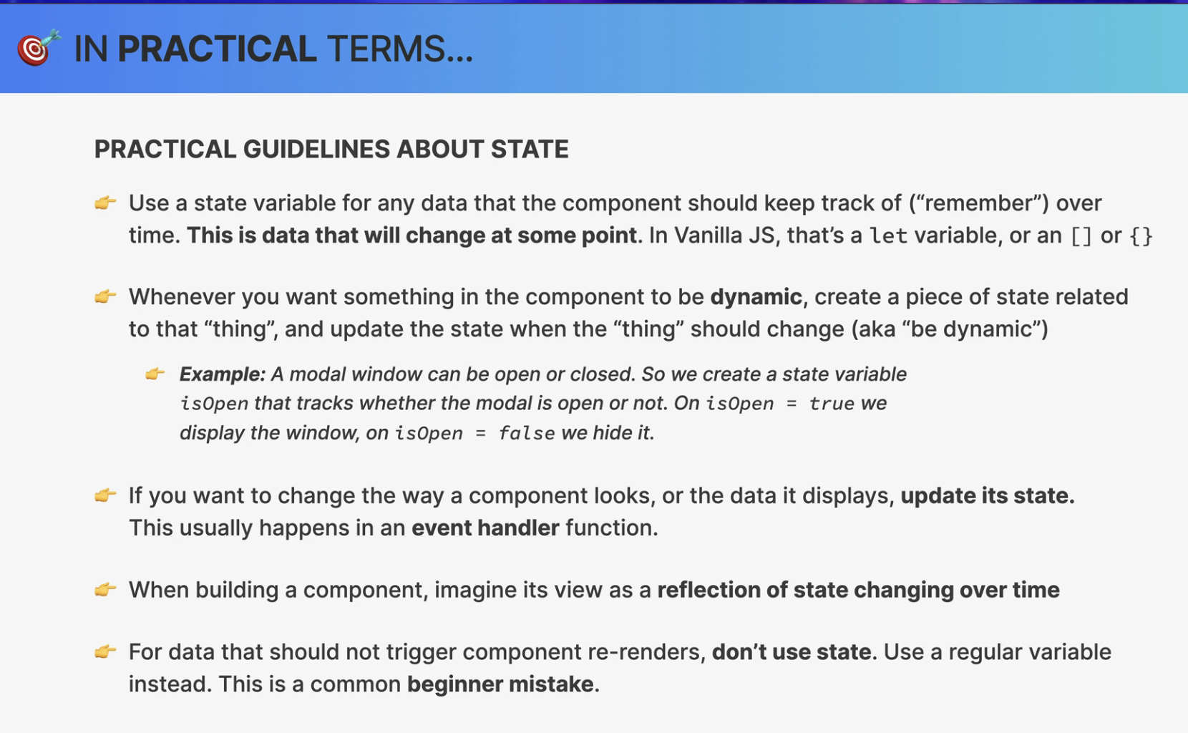

##### Lifting The State Up

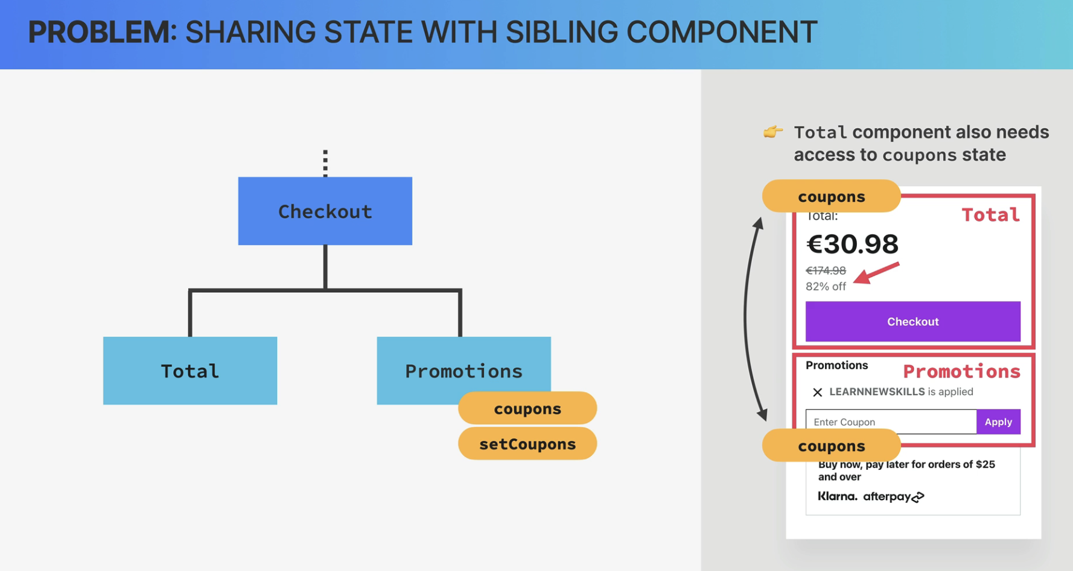

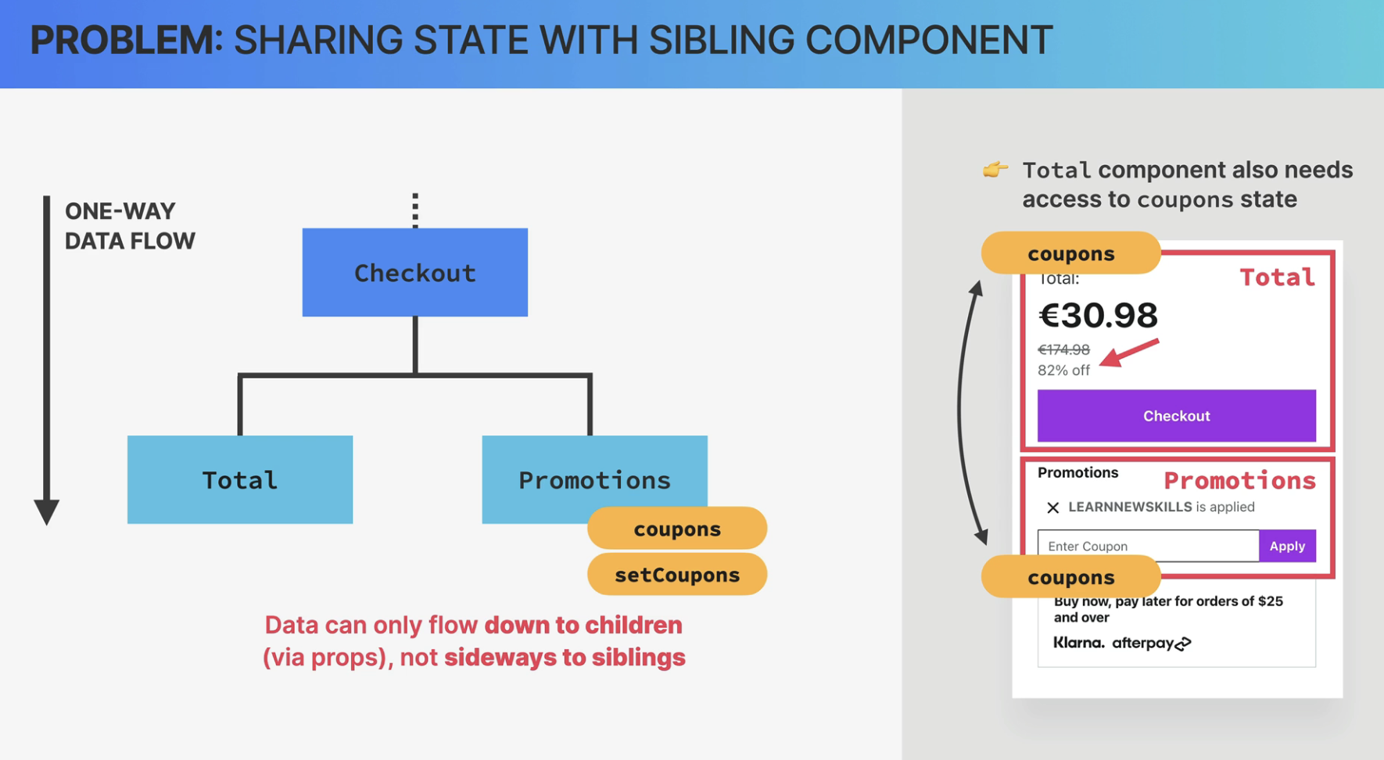

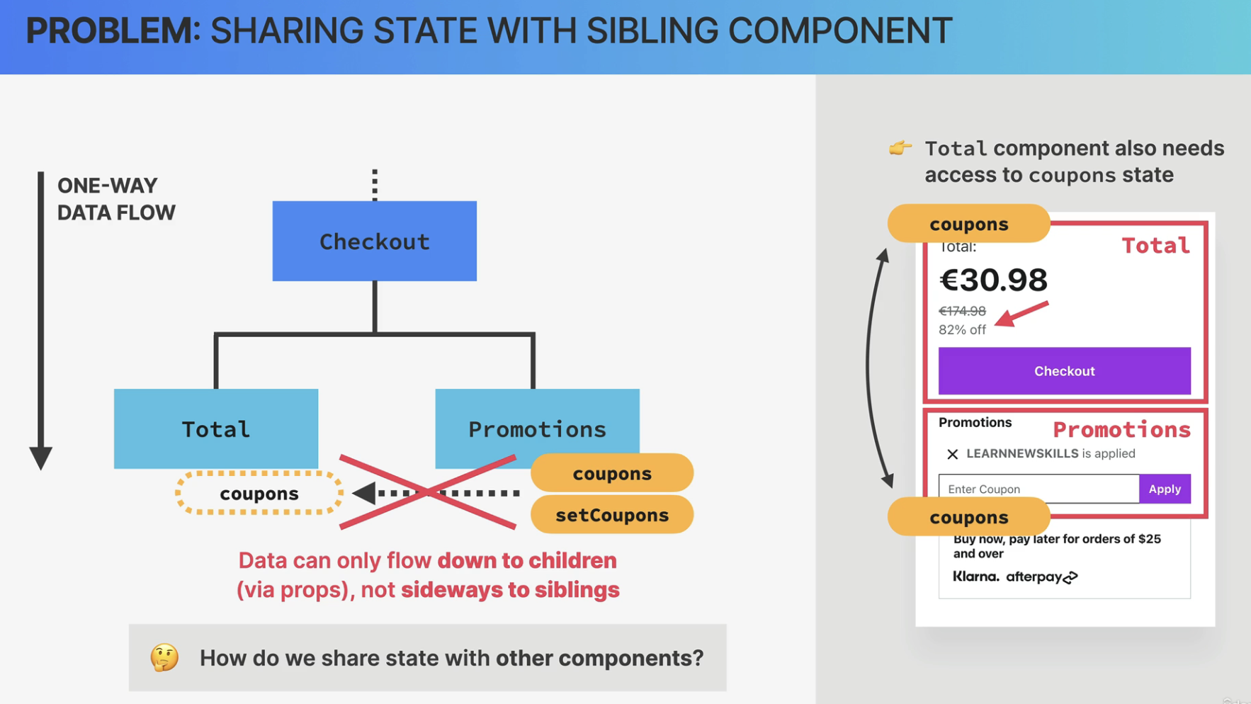

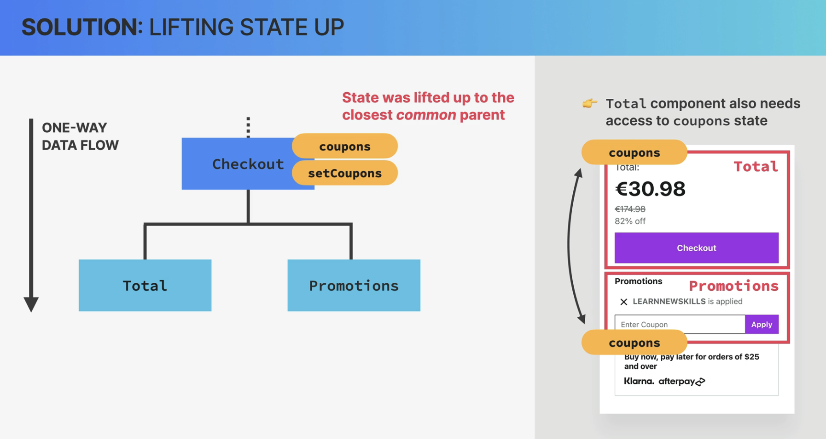

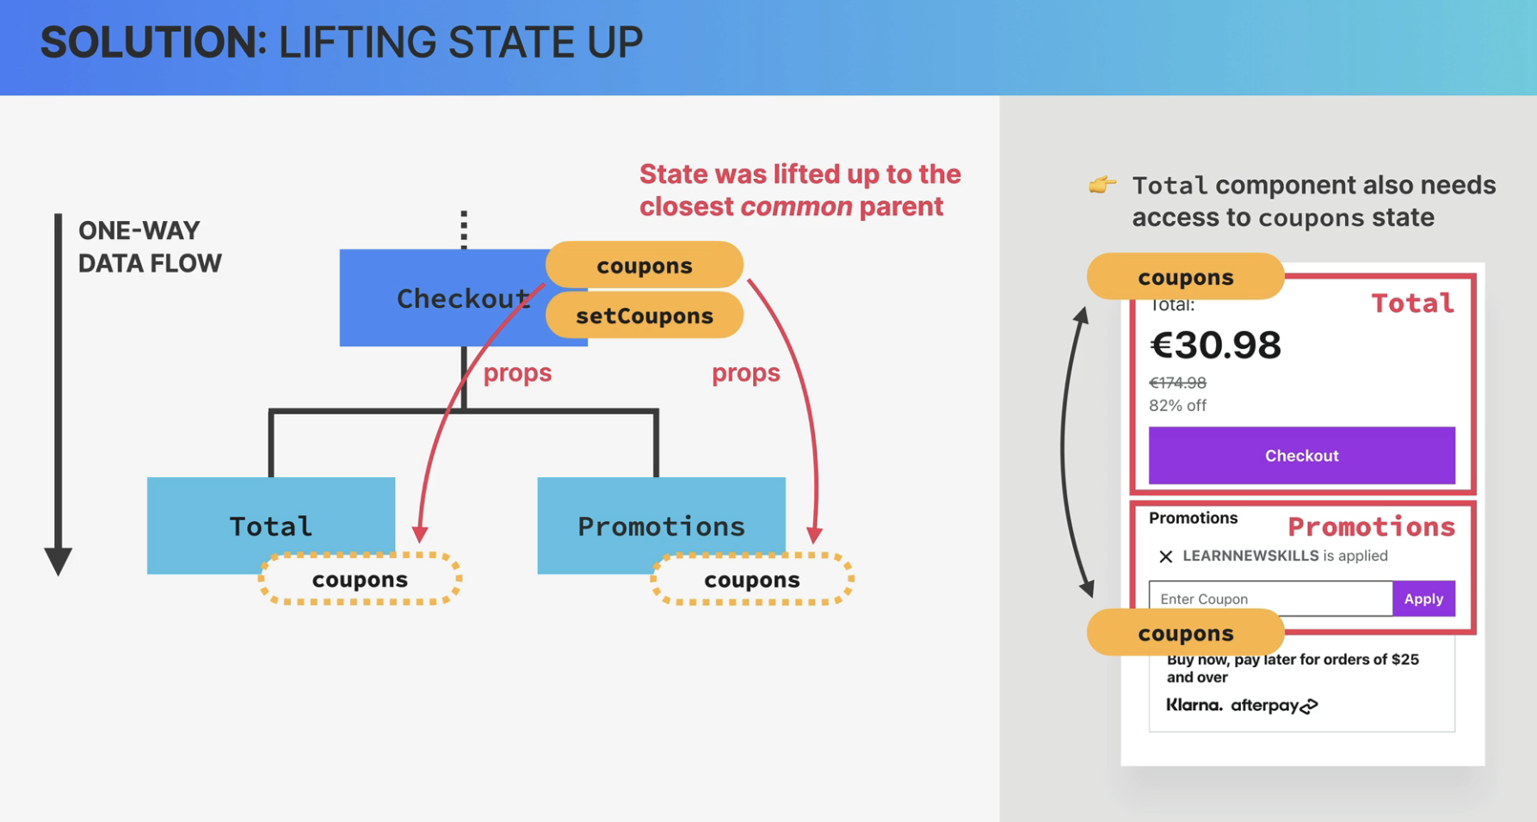

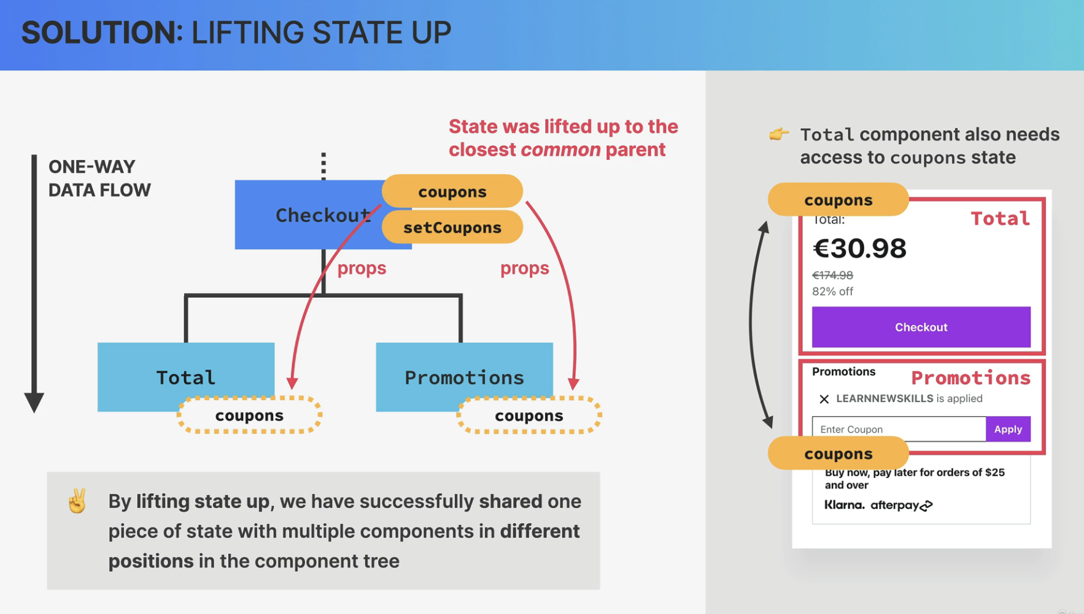

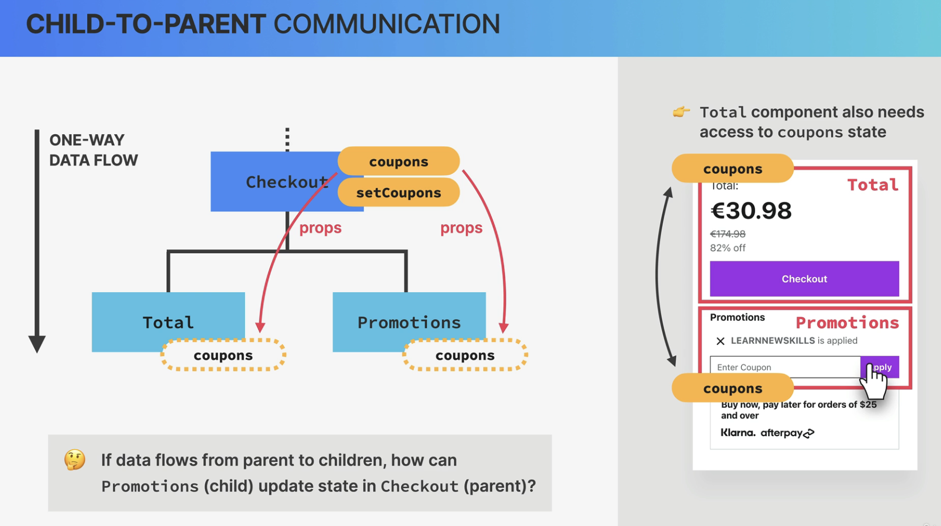

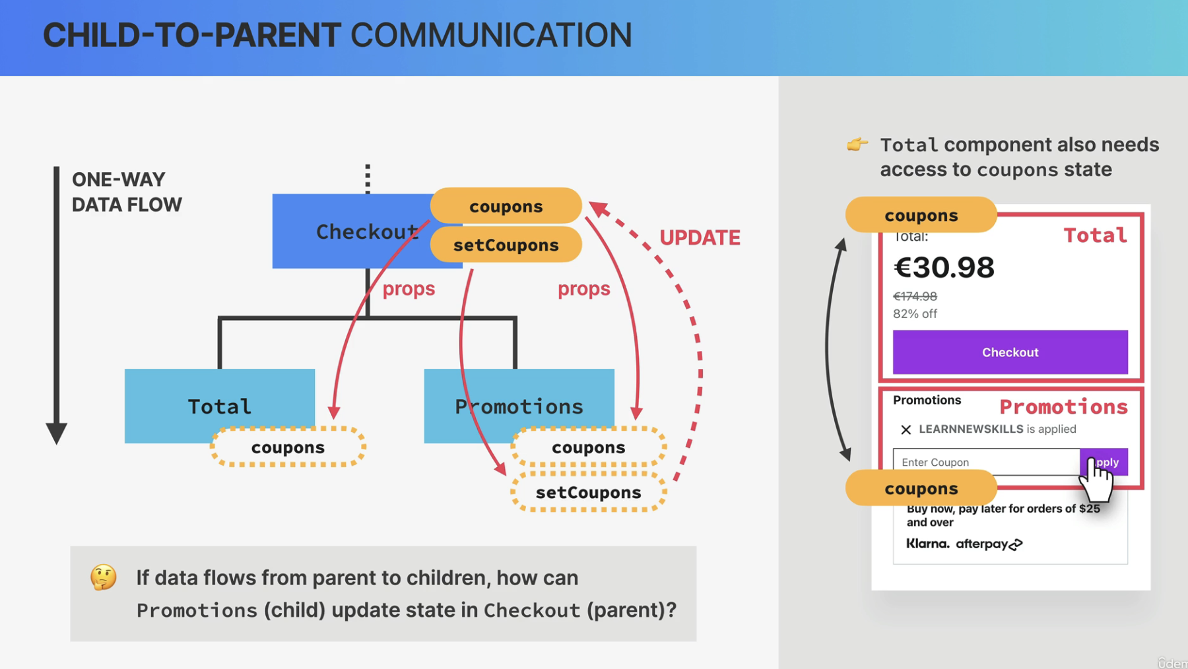

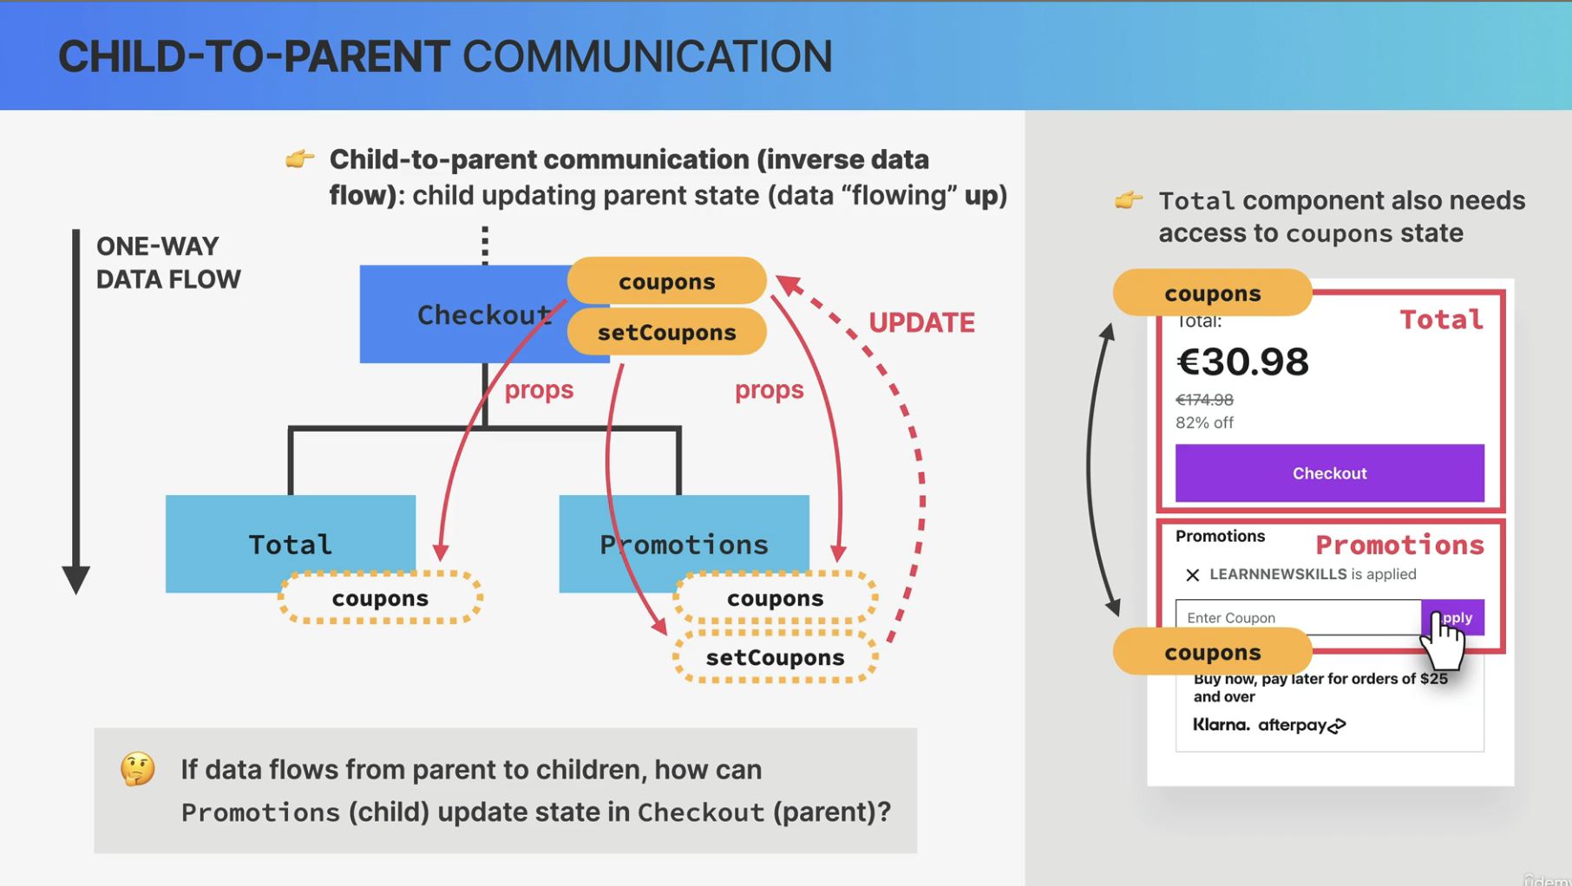

##### Derived state

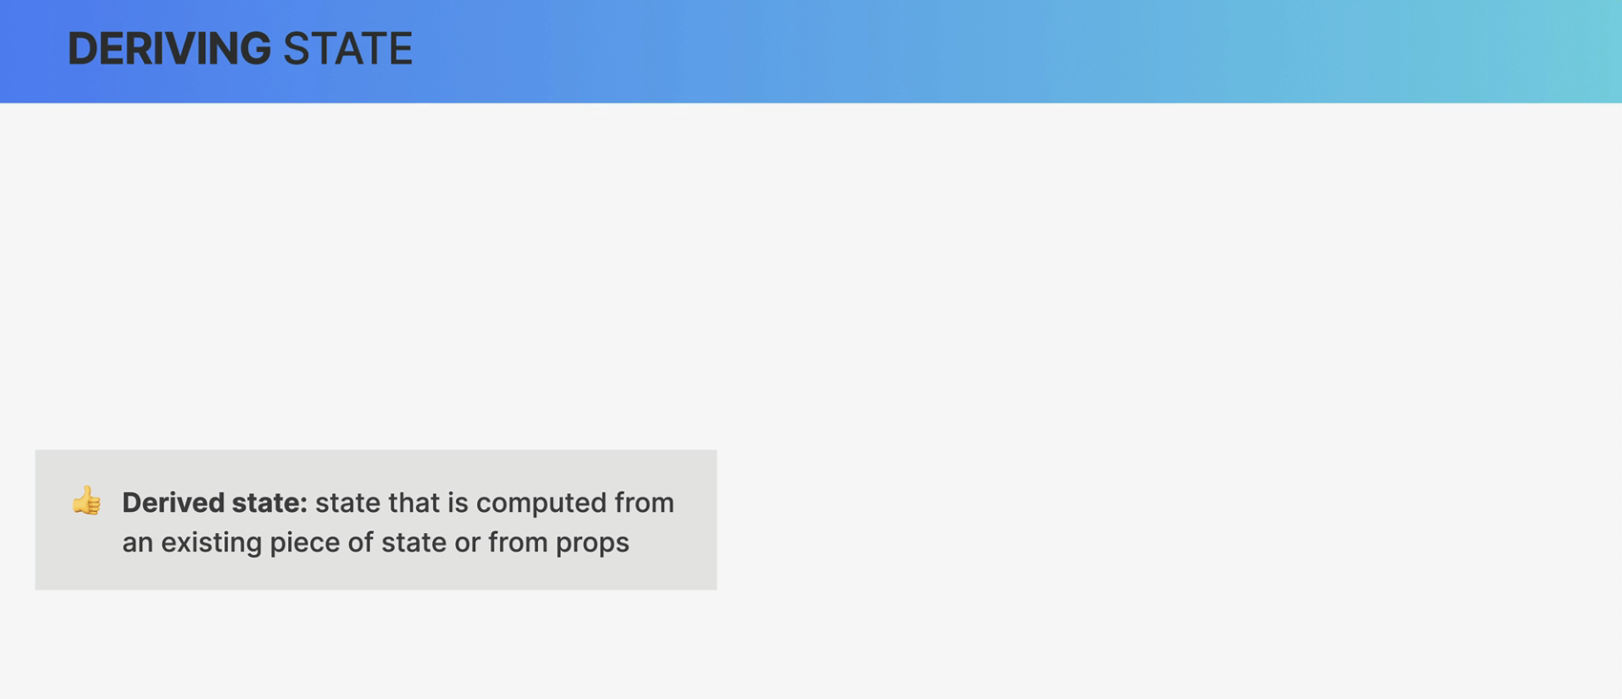

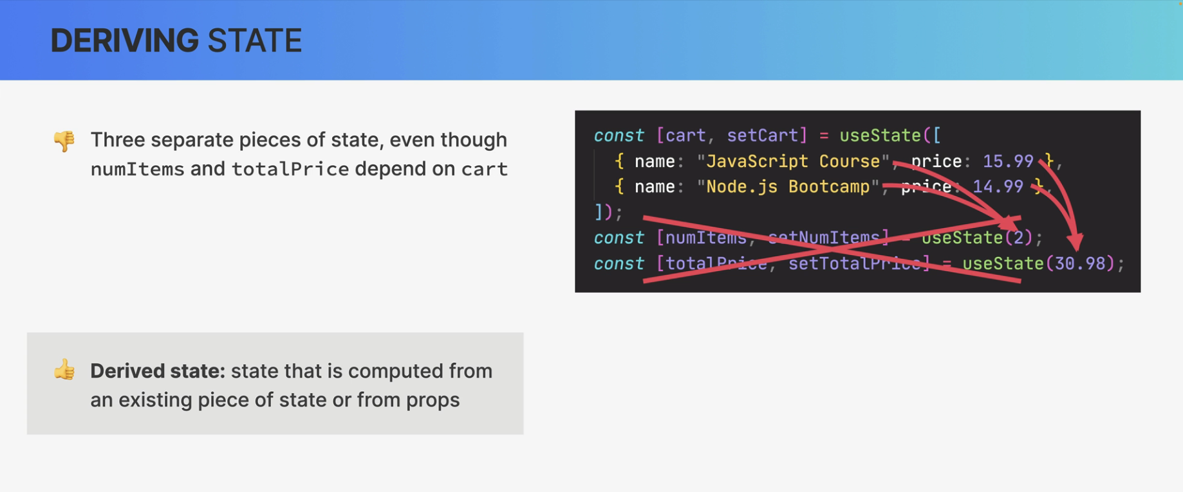

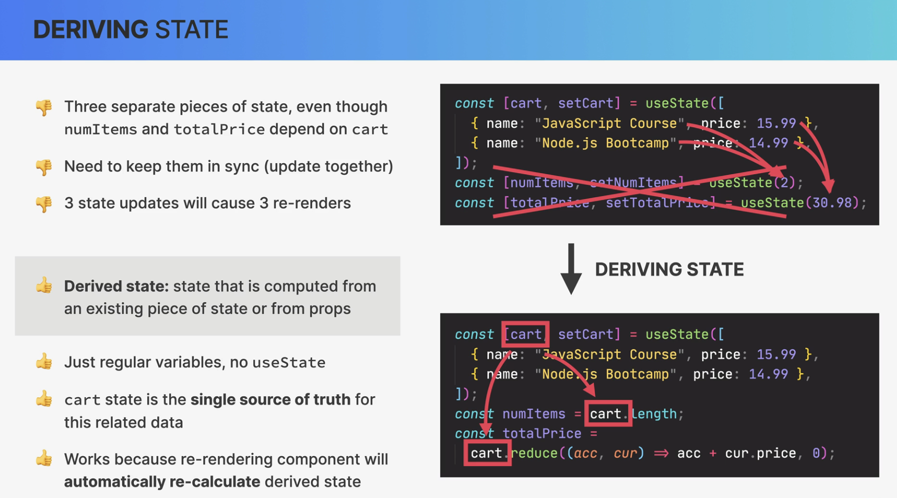

##### useState

So this useState here is a React function that returns an array.

And so here, we are destructuring that array.

So in the first position of the array, we have the value of the state that we call advice here.

The second value is a setter function.

So a function that we can use to update the piece of state.

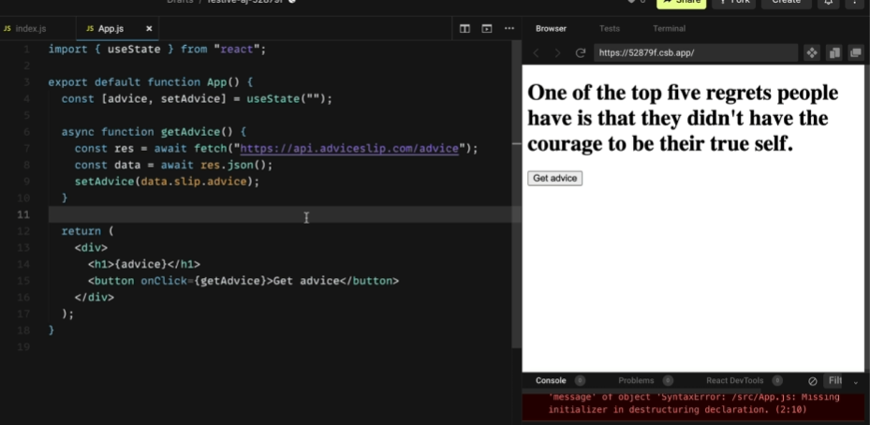

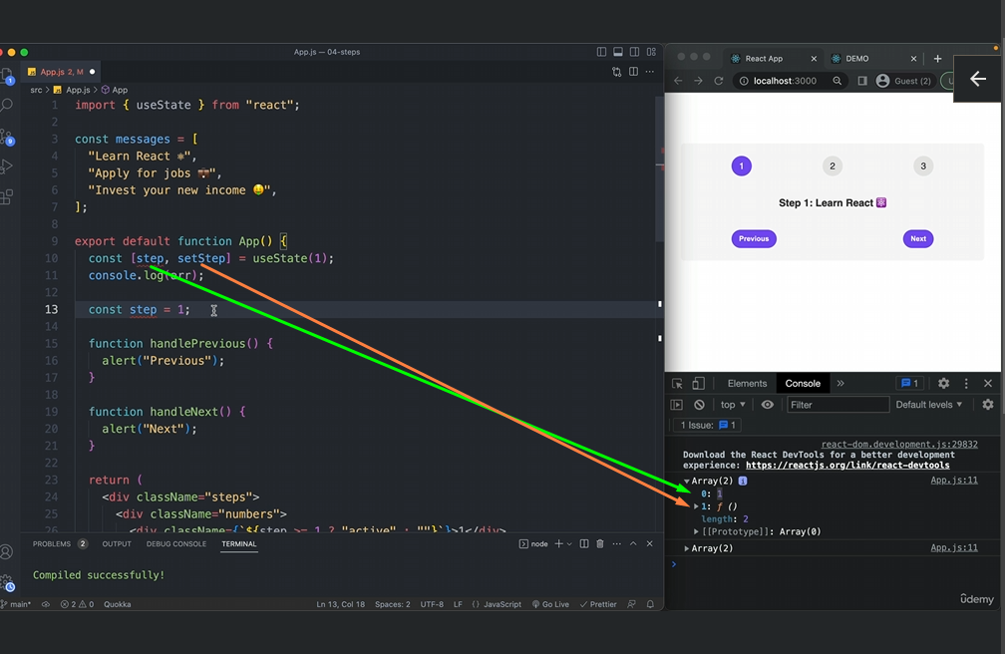

##### 

##### 

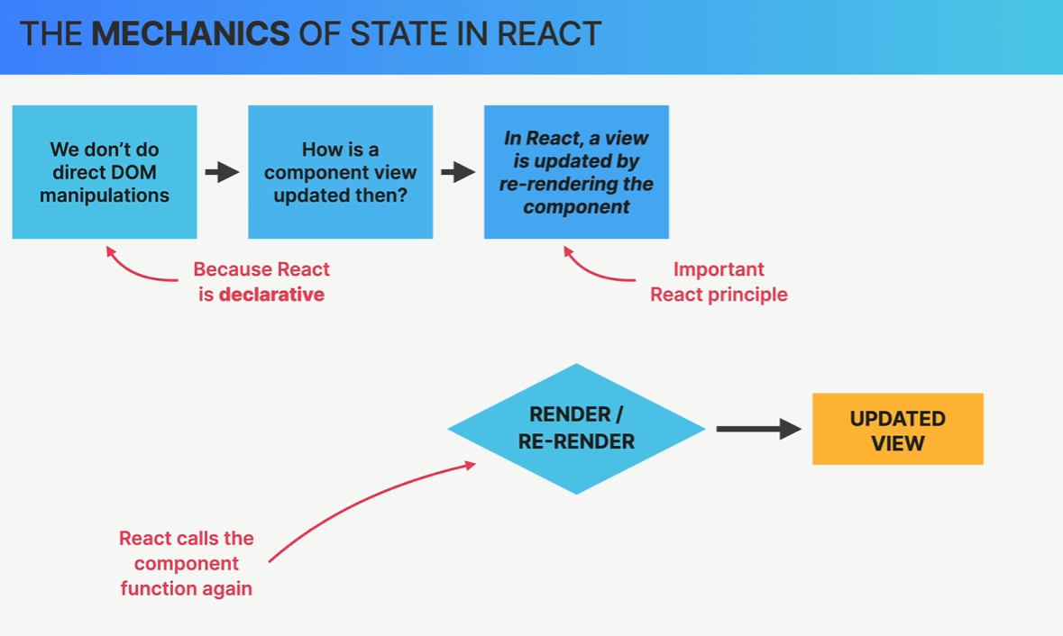

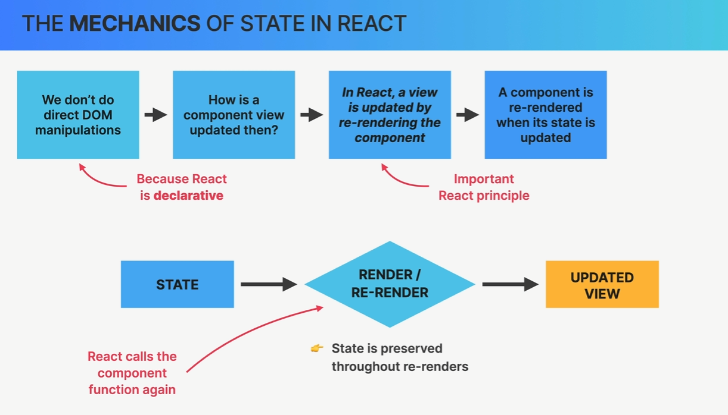

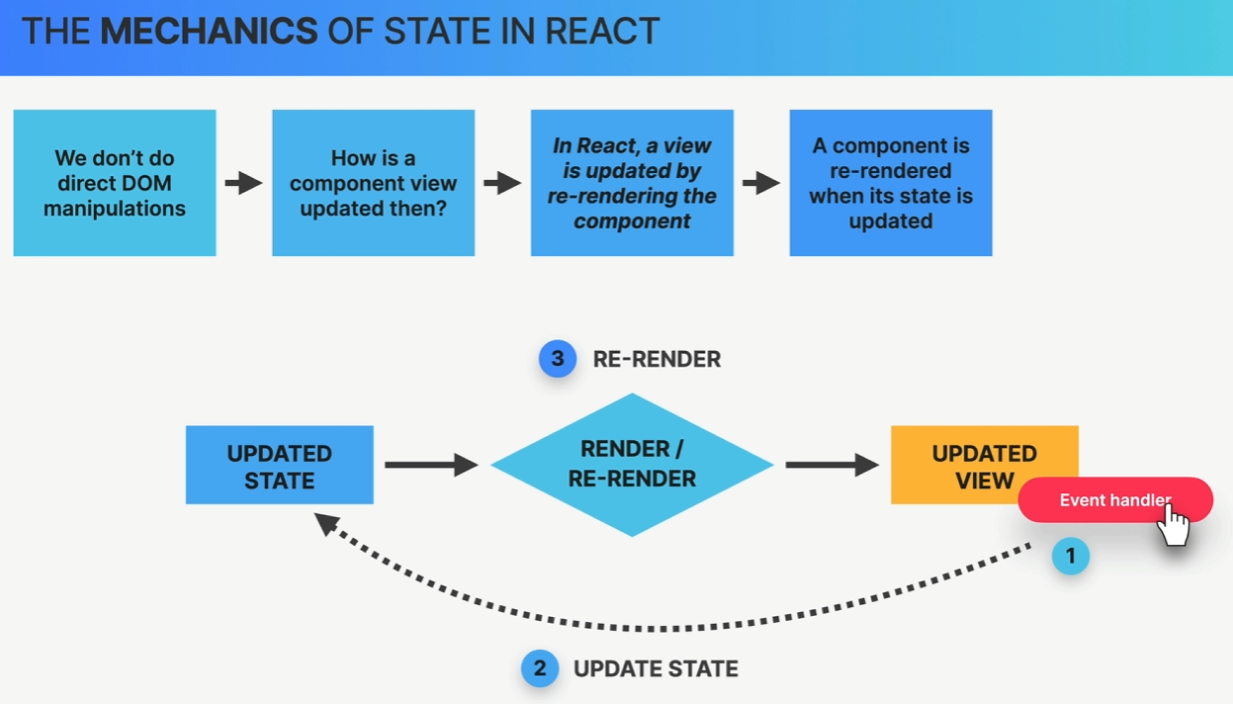

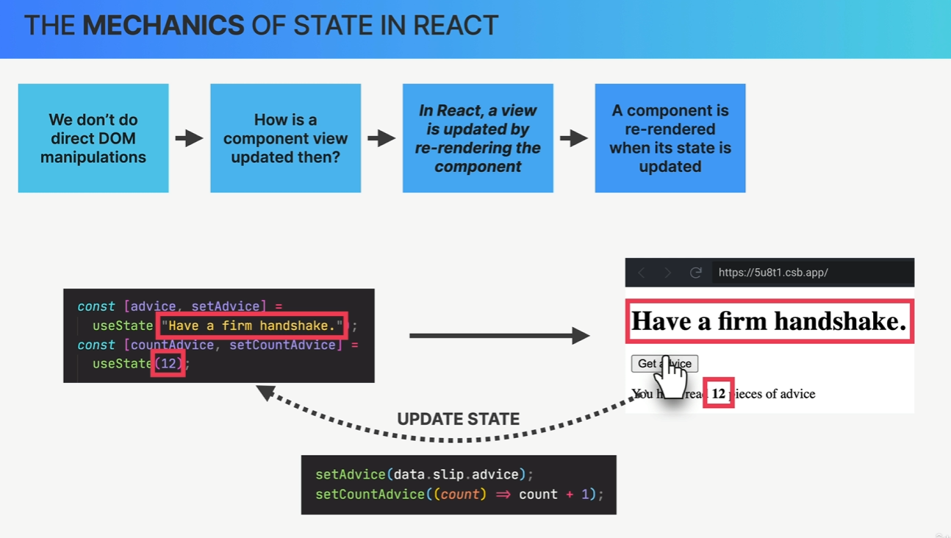

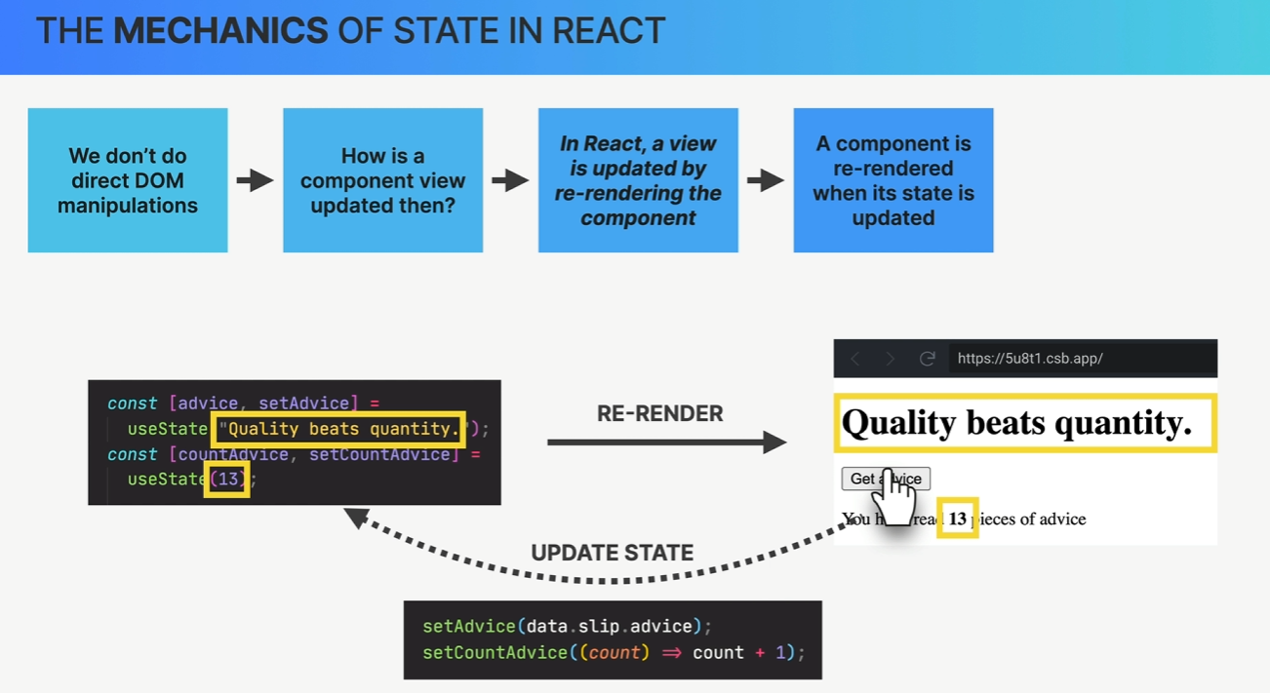

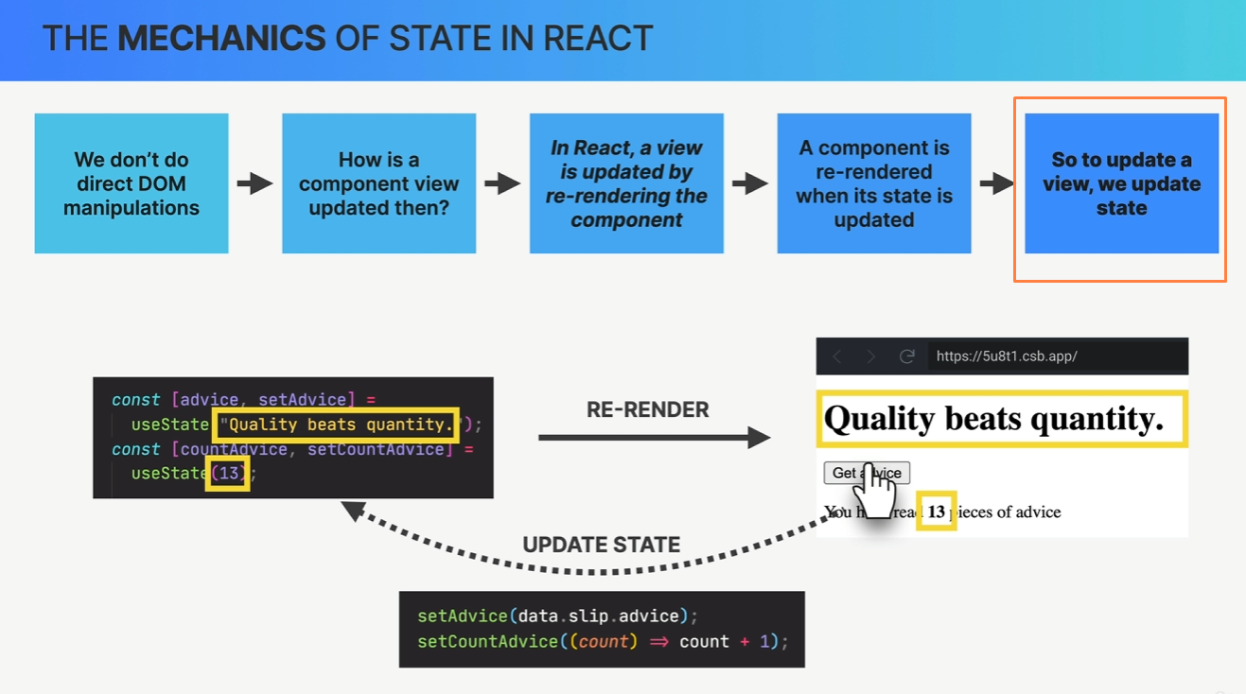

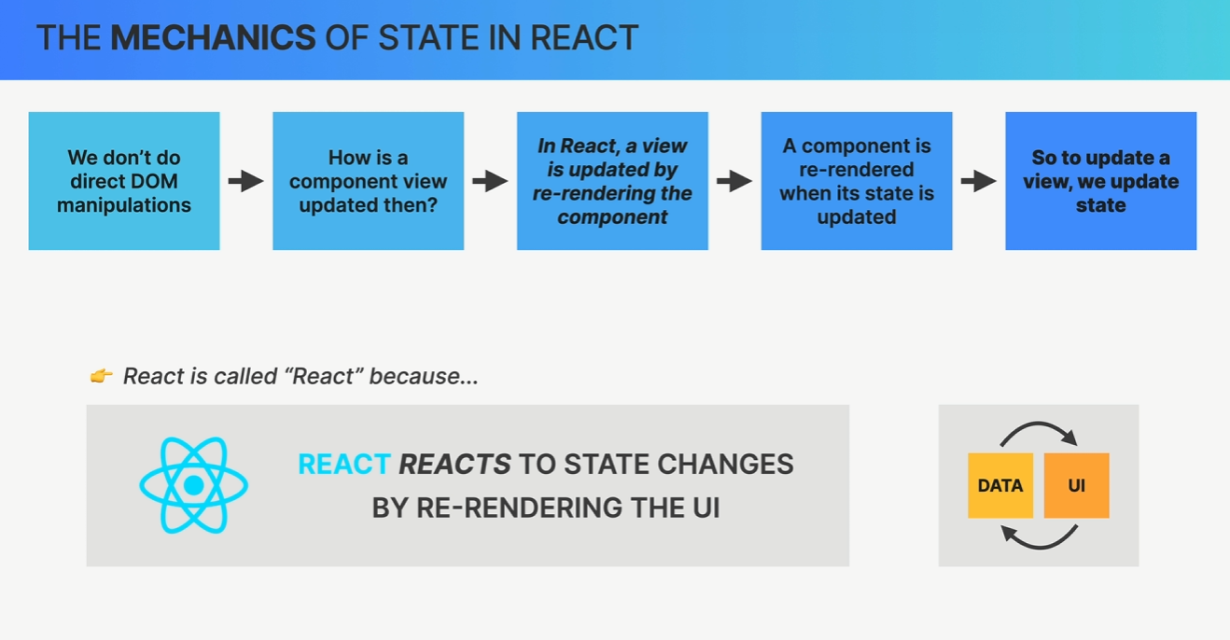

##### 

##### 

##### useEffect So useEffect takes two arguments. First, a function that we want to get executed at the beginning. So when this component first gets loaded. And then a second argument, which is called the dependency array.

#### Build our first react app

| import { useEffect } from "react"; import { useState } from "react";  function App() {  const [advice, setAdvice] = useState("");  const [count, setCount] = useState(0);  async function getAdvice() {  const res = await fetch("https://api.adviceslip.com/advice");  const data = await res.json();  setAdvice(data.slip.advice);  setCount((c) => c + 1);  }   useEffect(function () {  getAdvice();  }, []);   return (  <div>  <h1>{advice}</h1>  <button onClick={getAdvice}>Get advice</button>  <Message count={count} />  </div>  ); }  function Message(props) {  return (  <p>  You have read <strong>{props.count}</strong> pieces of advice  </p>  ); }  export default App; |
| --- |

#### Summary

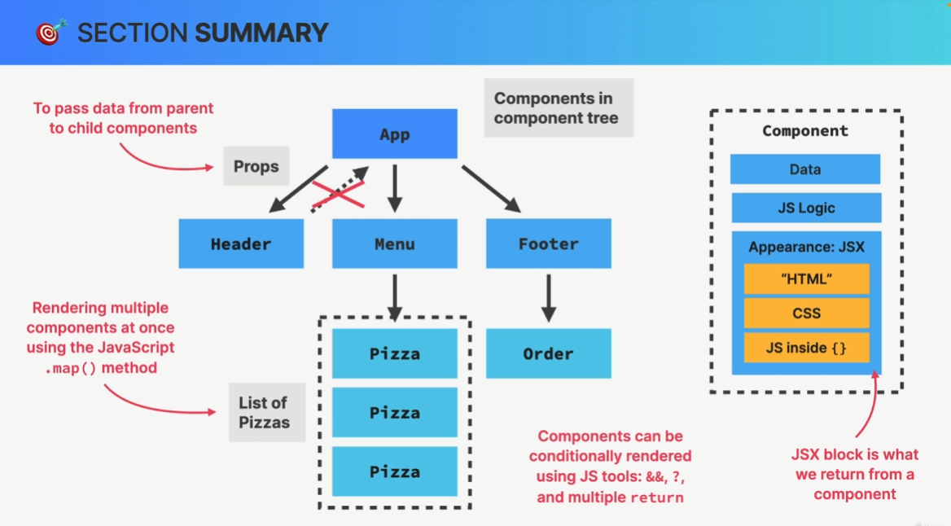

Section 6

#### Summary

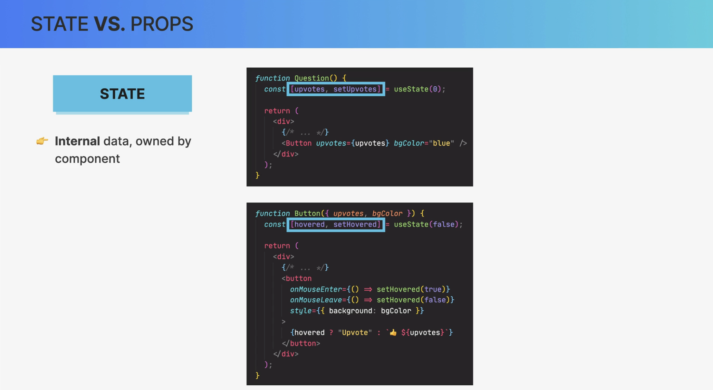

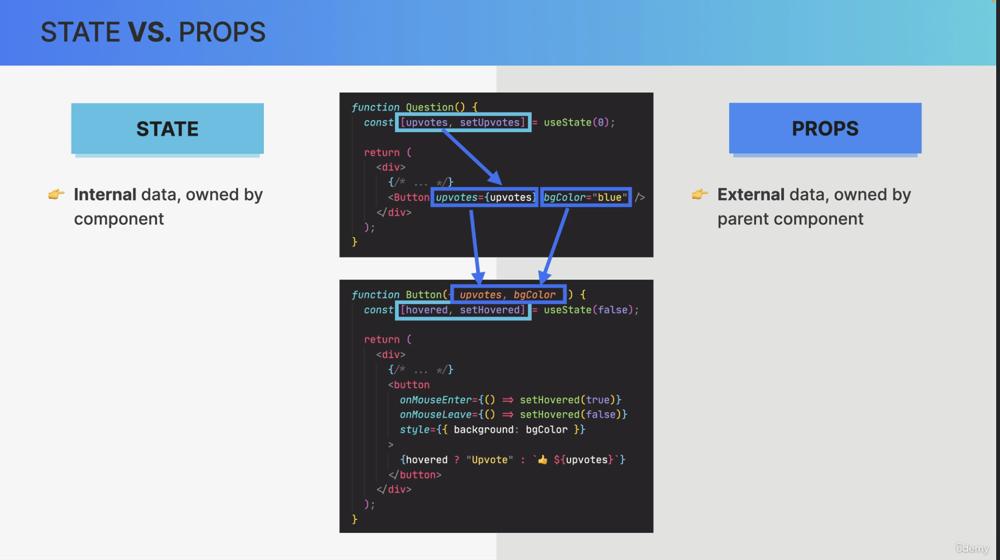

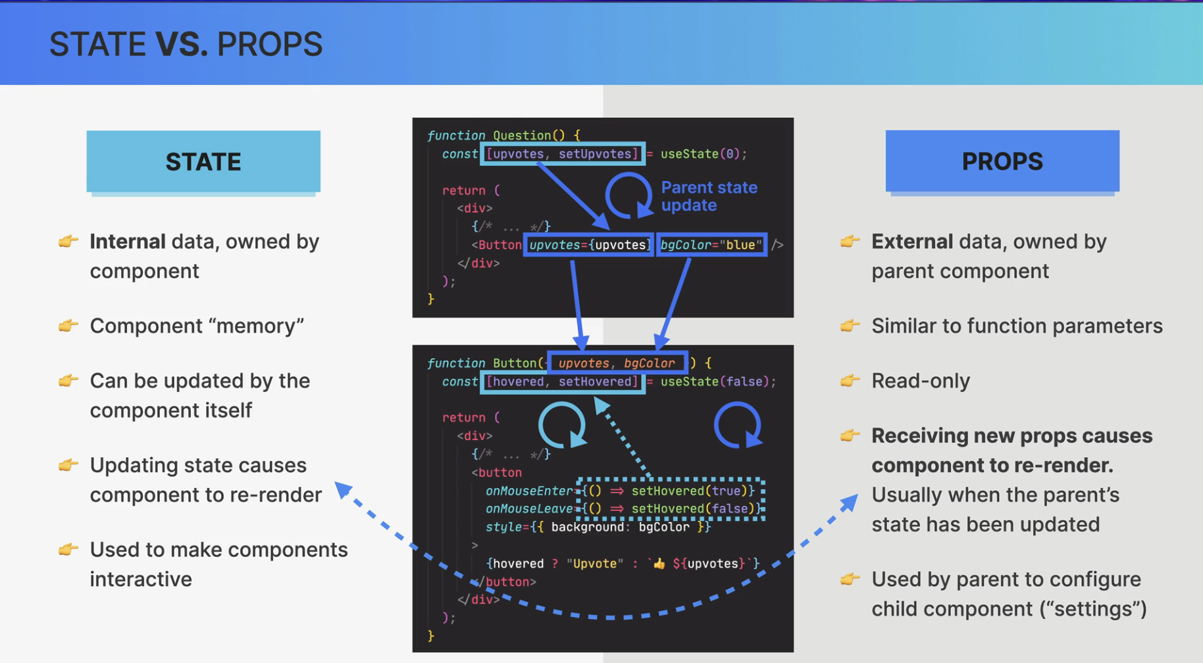

Section 7

#### Thinking in React

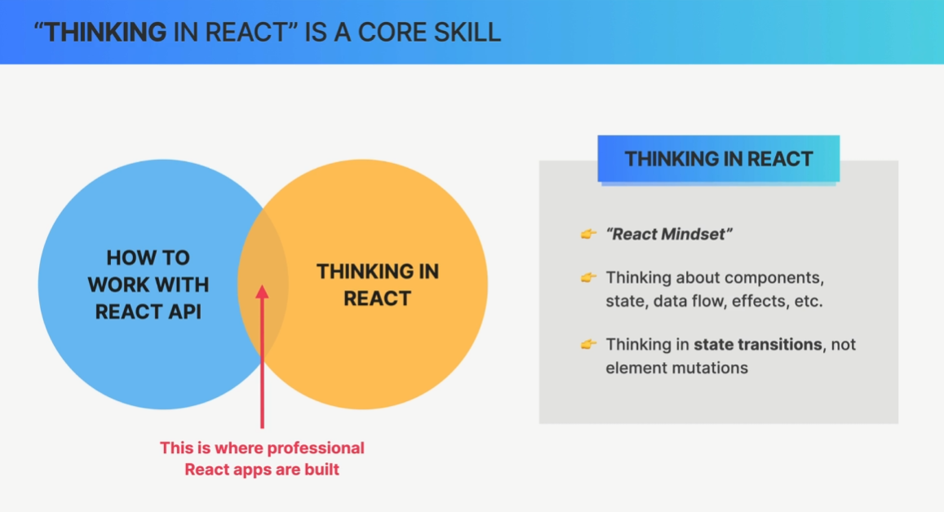

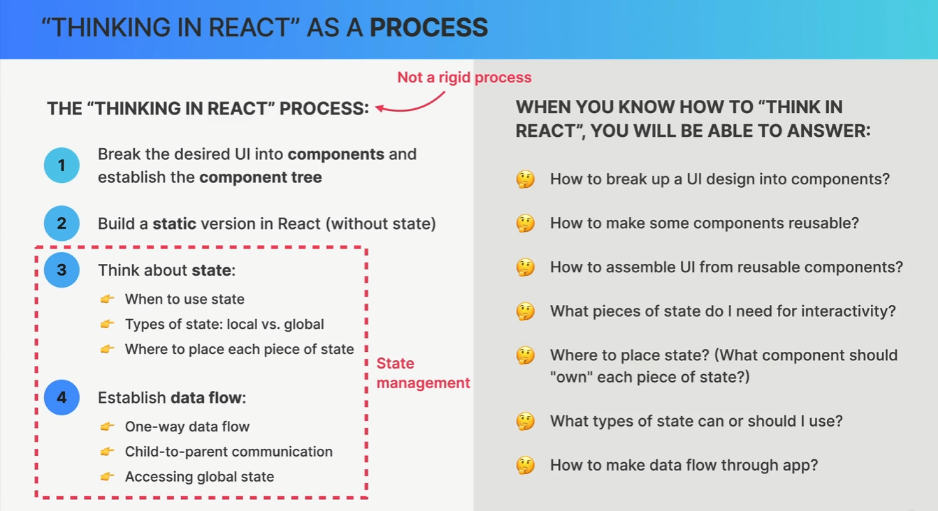

#### State Management

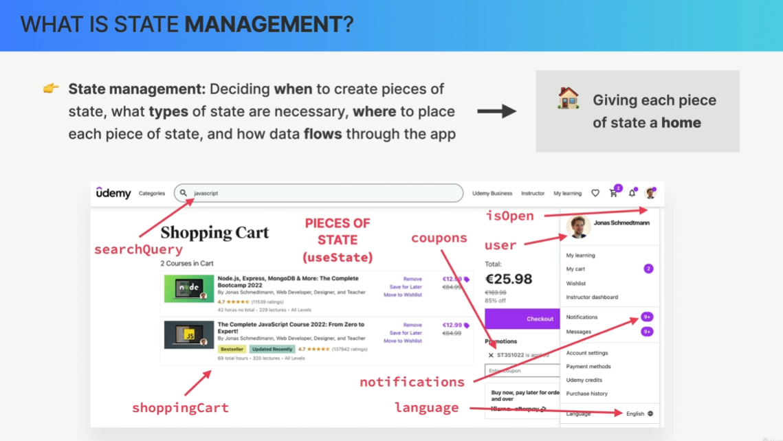

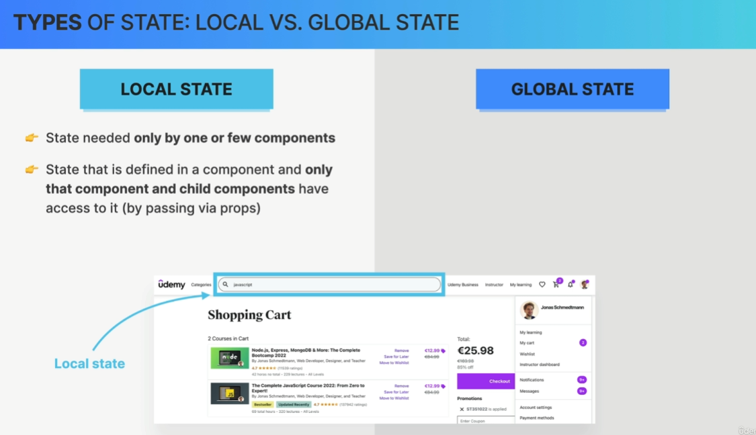

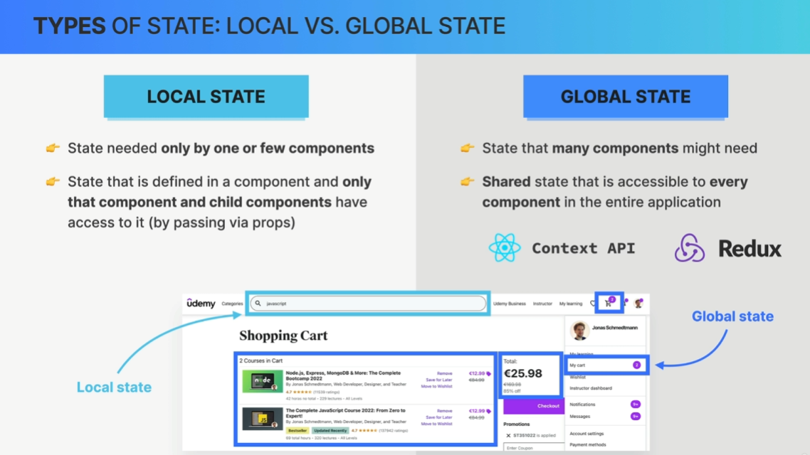

In fact, one important guideline in state management is to always start with local state

and only move to a global state if you truly need it.

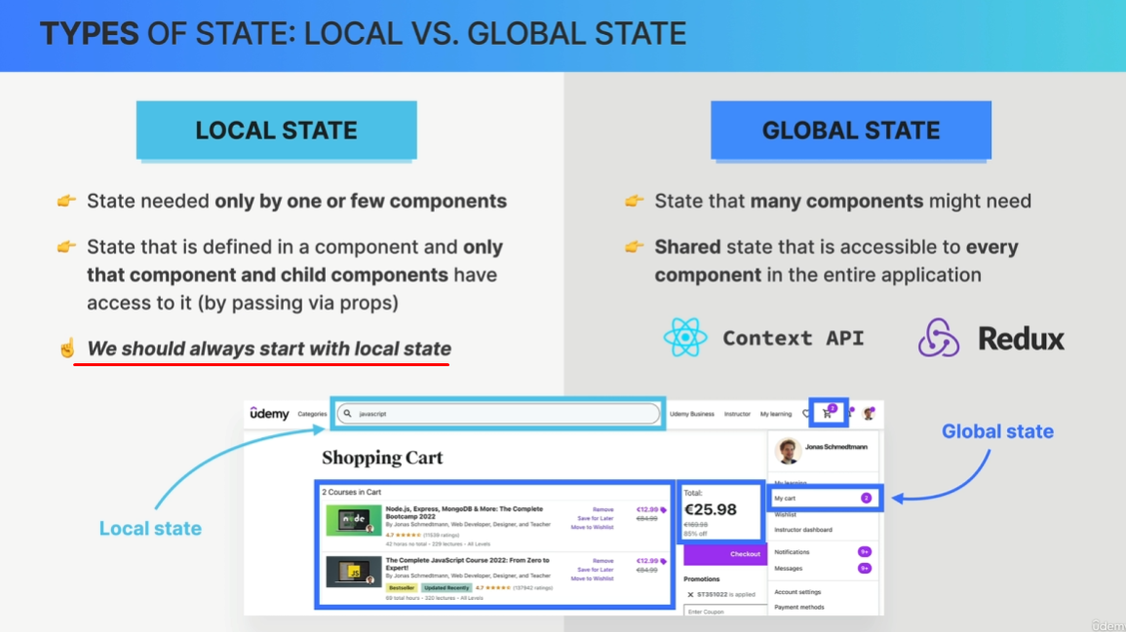

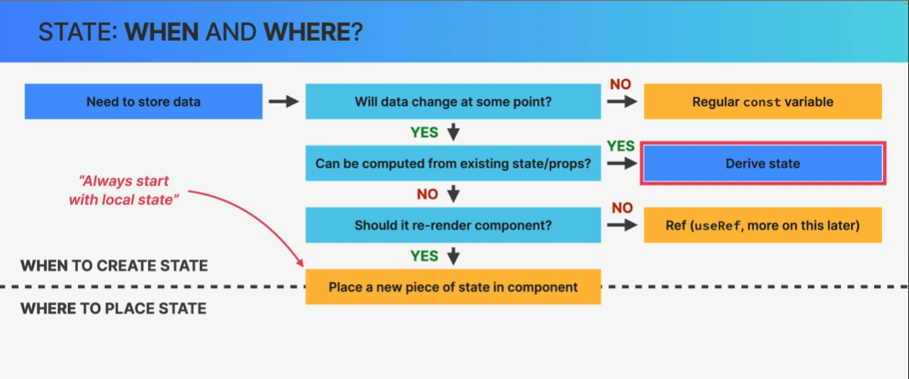

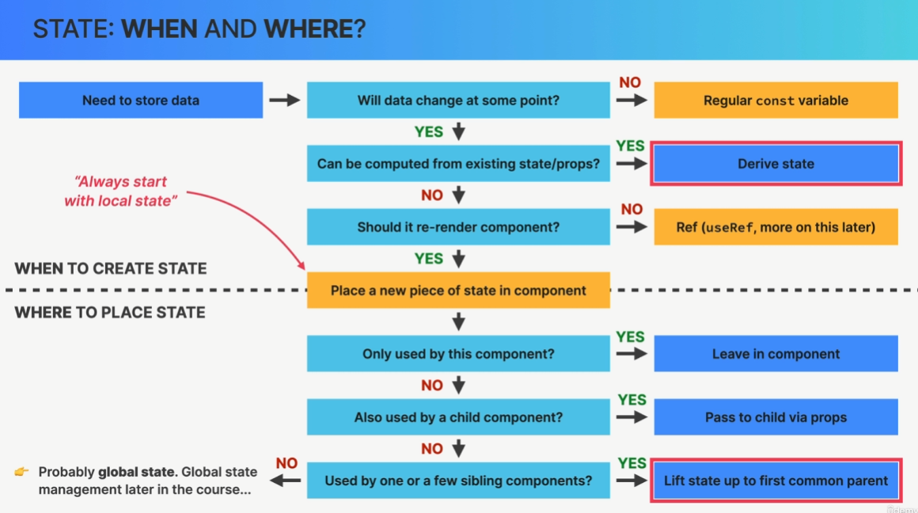

#### The Children prop

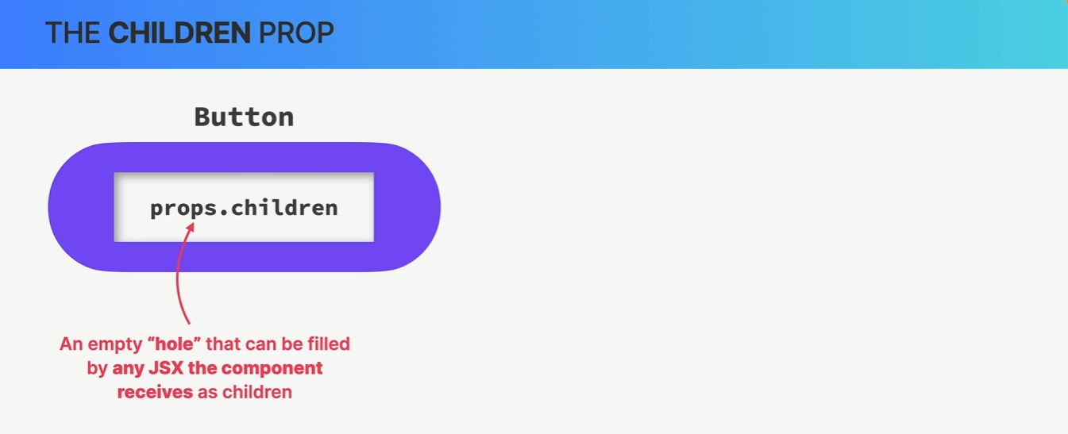

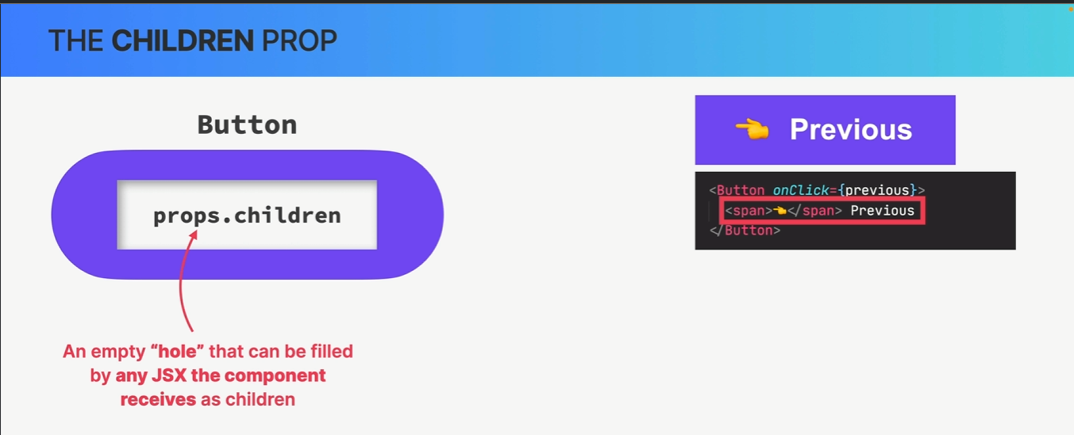

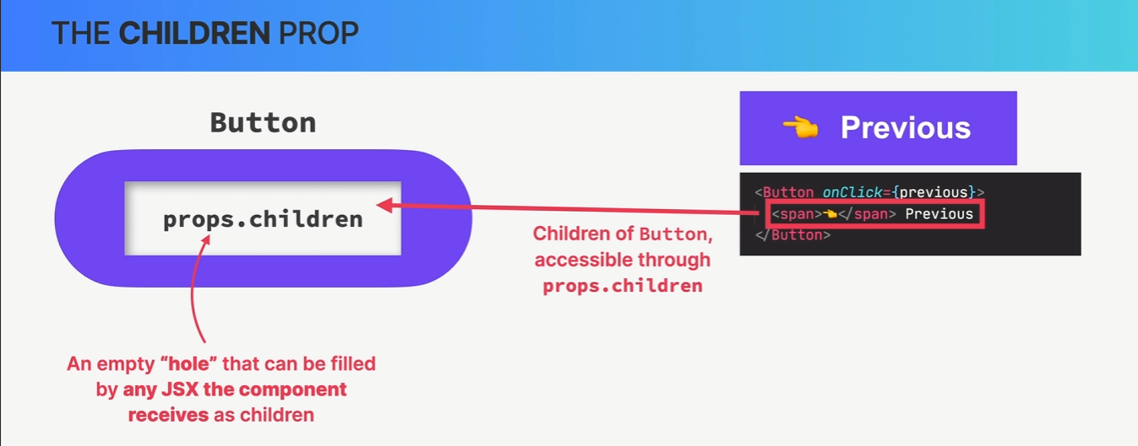

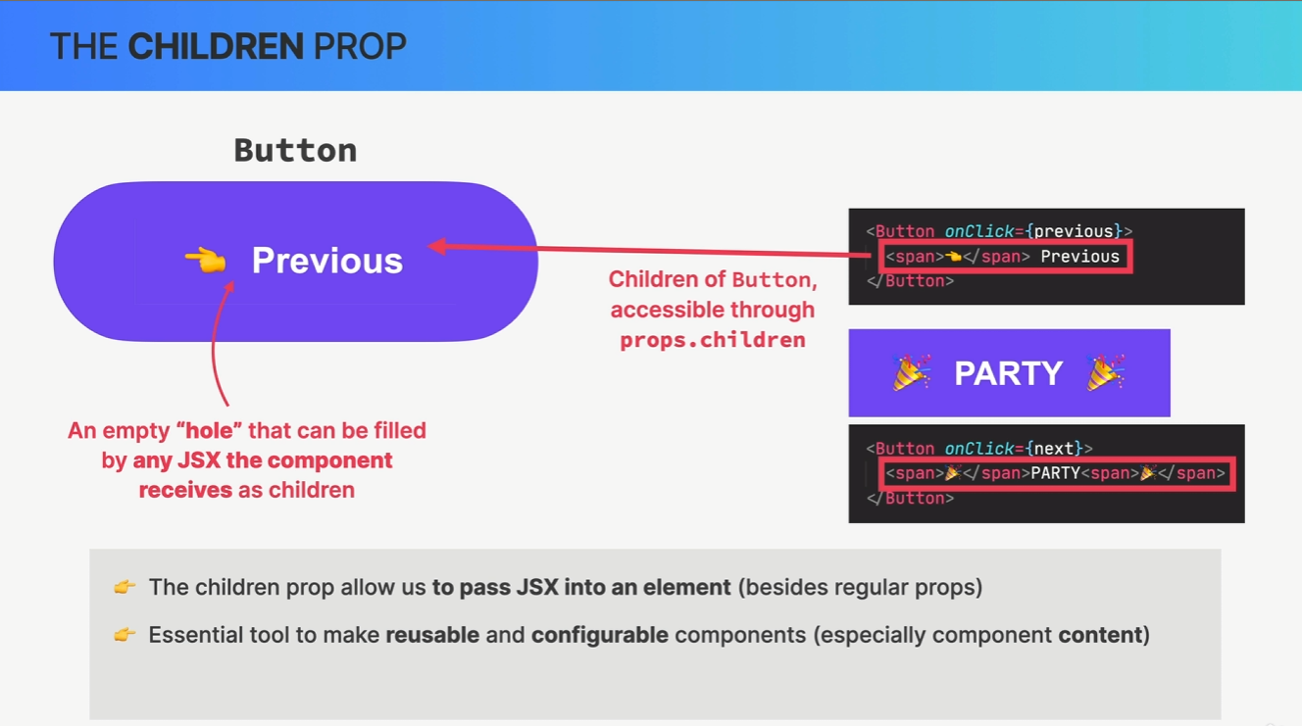

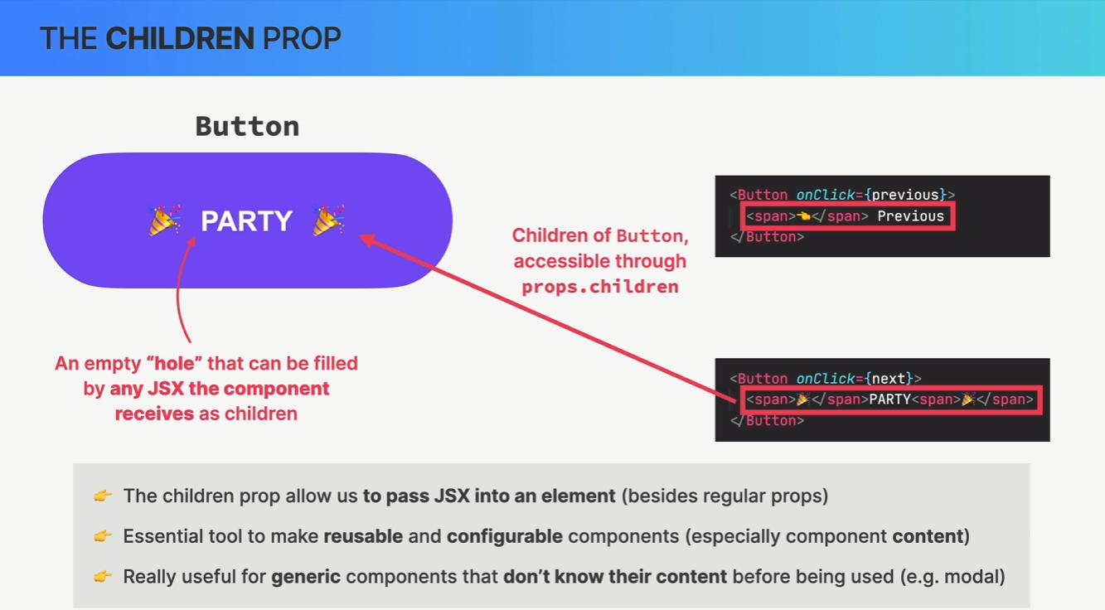

Section 11: How React Works Behind the Scenes

#### Components, Instances, and Elements

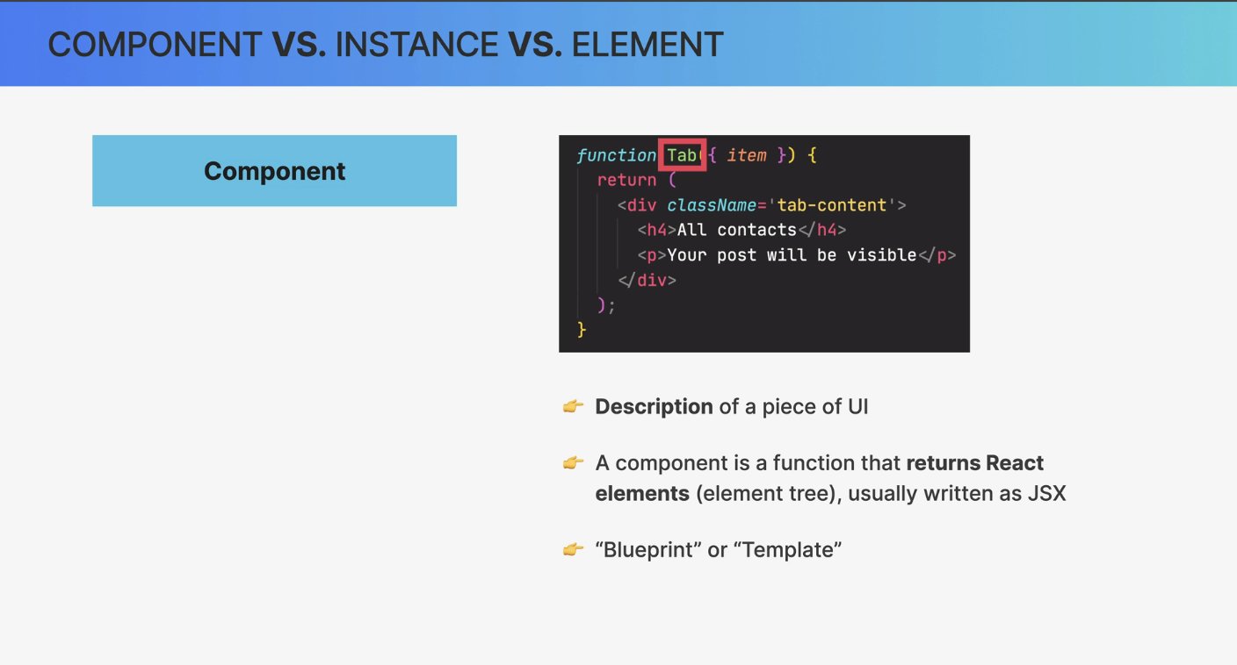

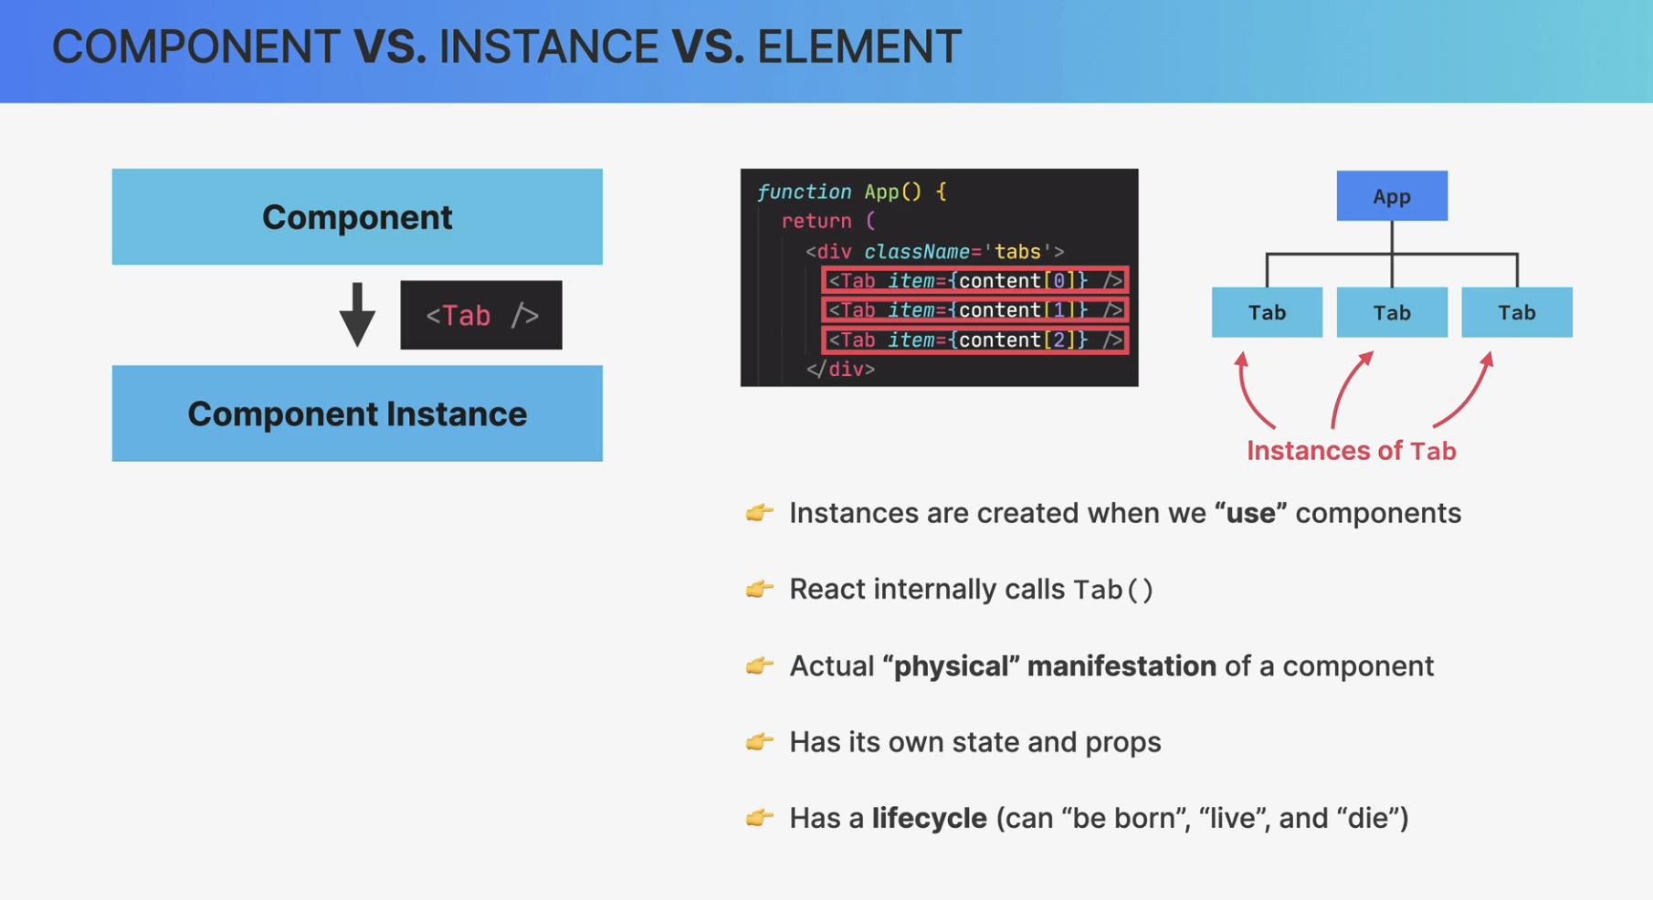

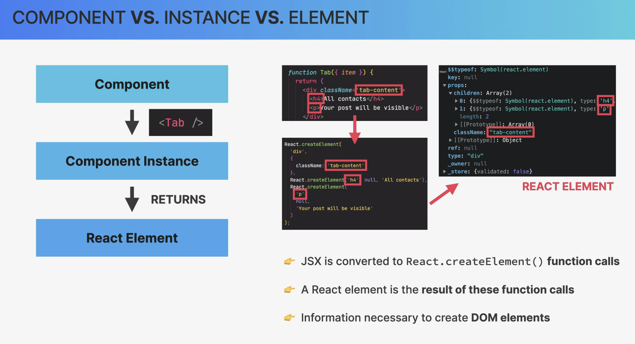

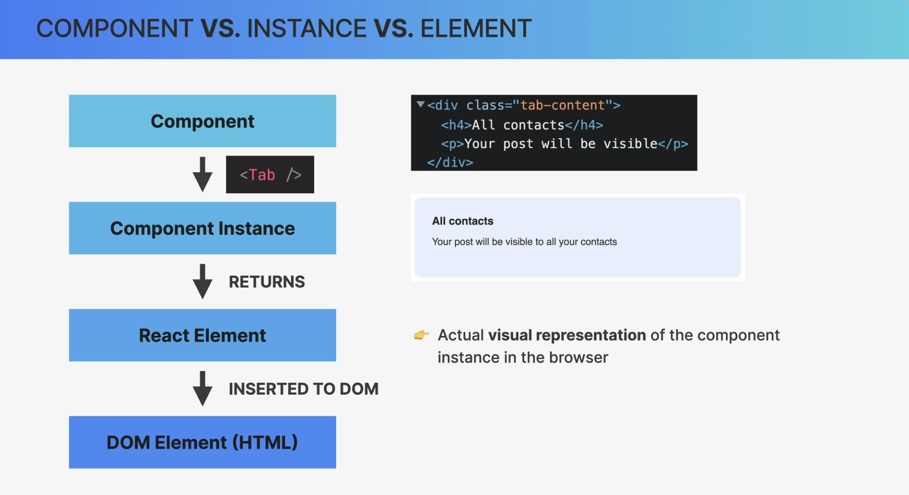

React elements just live inside the React app and have nothing to do with the DOM.

They are simply converted to DOM elements when painted on the screen in this final step.

#### Quick Recap

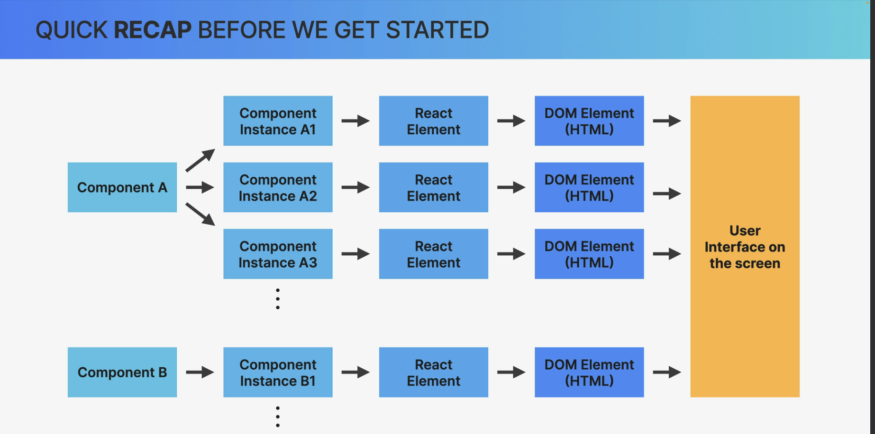

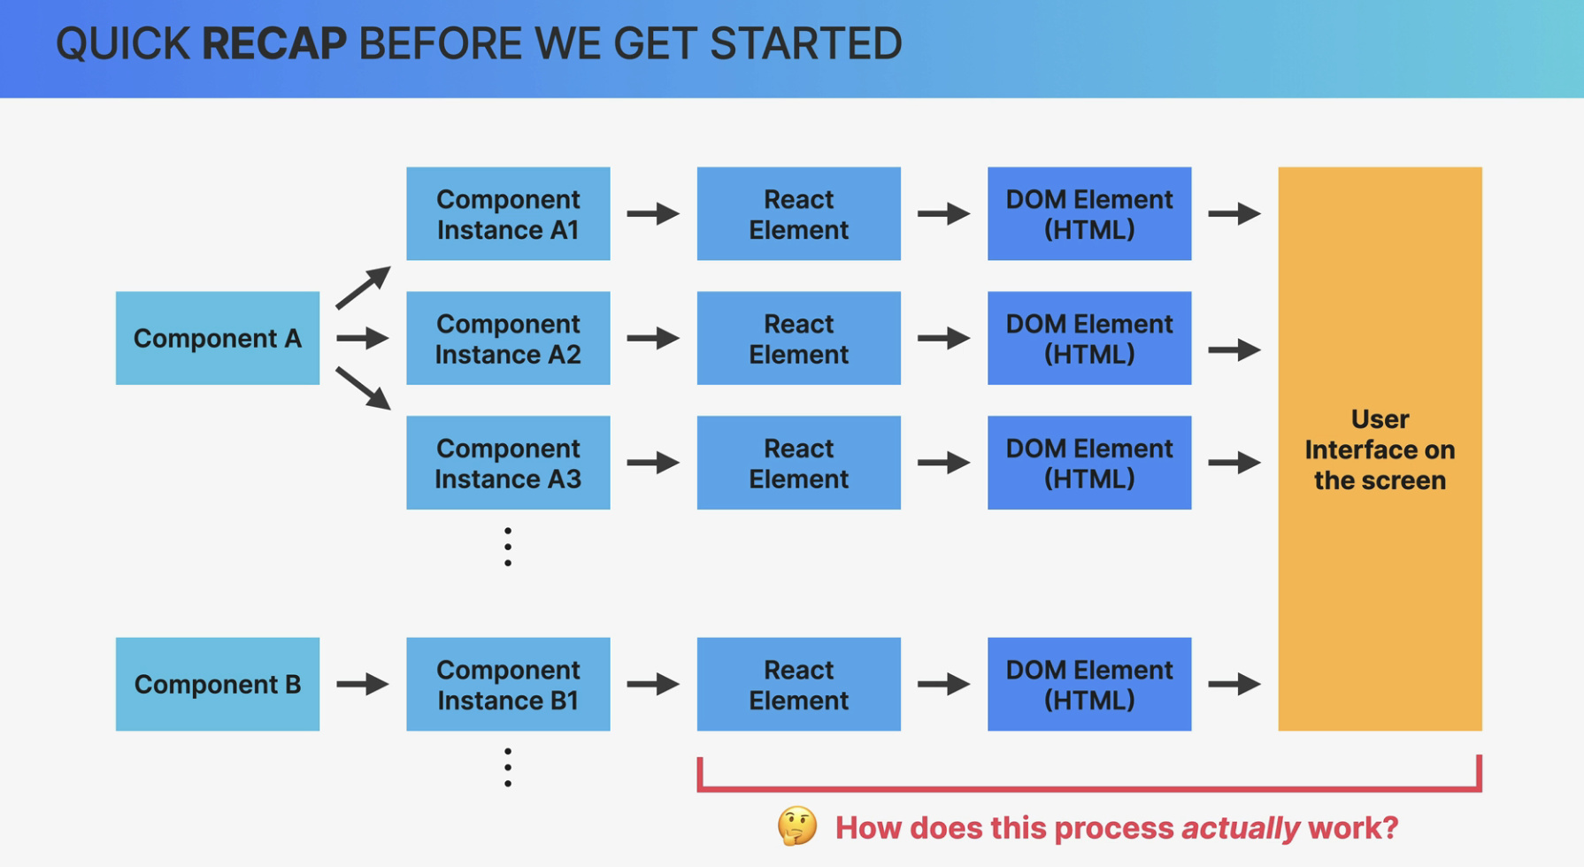

#### 

#### Overview - How components are displayed on the screen

So this process we're about to study is started by React each time a new render is triggered, most of the time by updating the state somewhere in the application.

So state changes trigger renders and so it makes sense that the next phase is the render phase.

In this phase, React calls our component functions and figures out how it should update the DOM.

However, it does not update the DOM in this phase. And so Reacts definition of render is very different from what we usually think of as a render, which can be quite confusing.

So again, in React, rendering is not about updating the DOM or displaying elements on the screen.

Rendering only happens internally inside of React so it does not produce any visual changes.

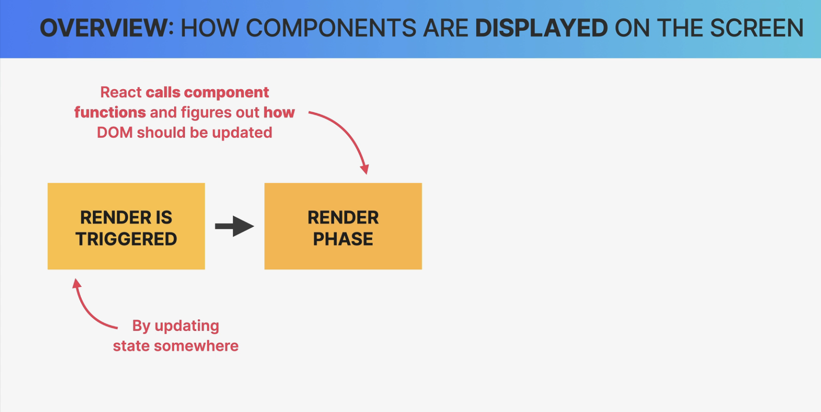

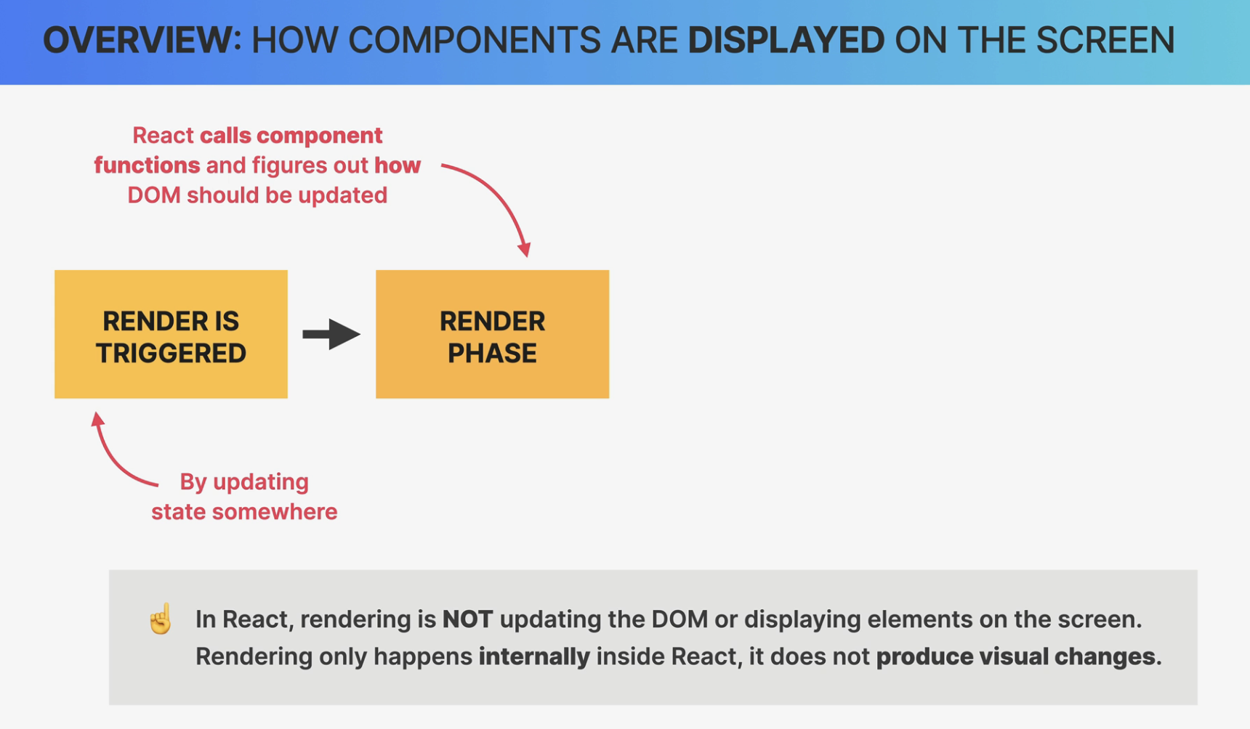

I have always used the term rendering with the meaning of displaying elements on the screen

because that was just easy to understand and it just made sense, right?

However, as we just learned, the rendering that I used to mean is this render plus the next phase. And speaking of that next phase, once React knows how to update a DOM,

it does so in the commit phase.

So, in this phase, new elements might be placed in the DOM and already existing elements might get updated or deleted to correctly reflect the current state of the application.

So it's this commit phase that is responsible for what we traditionally call rendering

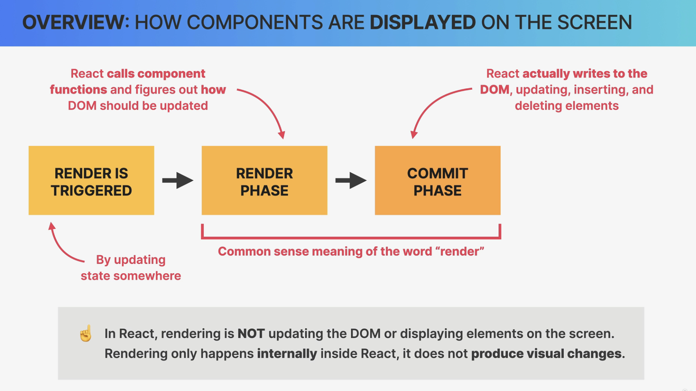

Then finally, the browser will notice that the DOM has been updated and so it repaints the screen.

Now this has nothing to do with React anymore but it's still worth mentioning that it's this final step that actually produces the visual change that users see on their screens.

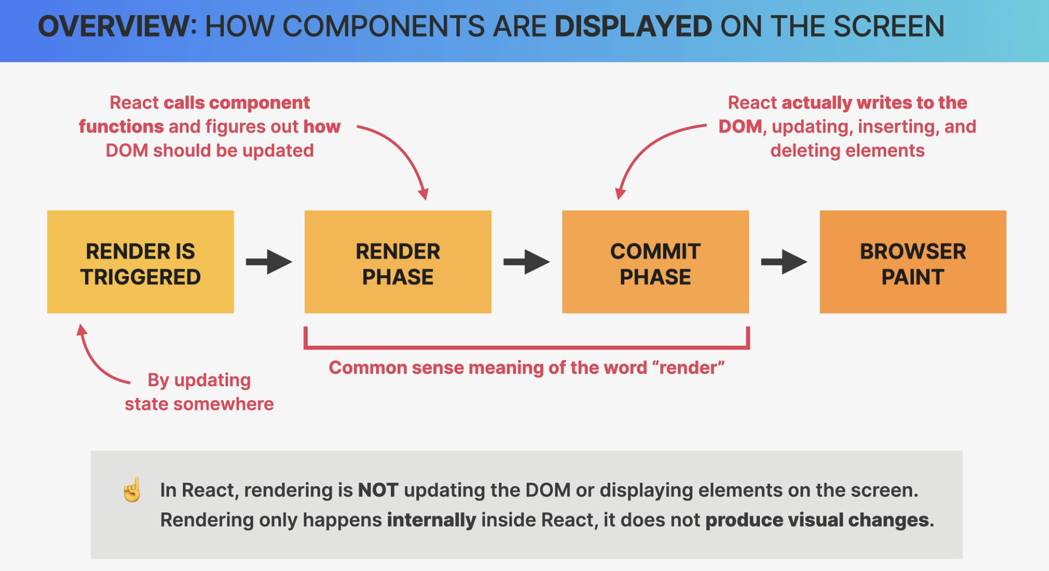

Finally, I just want to mention that a render is not triggered immediately after a state update happens.

Instead, it's scheduled for when the JavaScript engine has some free time on its hands. But this difference is usually just a few milliseconds that we won't notice.

There are also some situations like multiple sets of state calls in the same function where renders will be batched

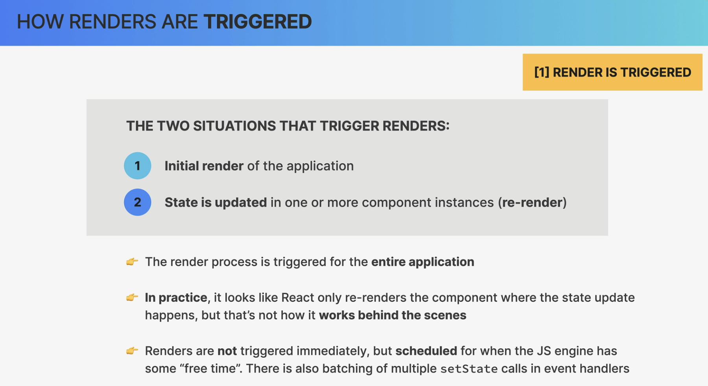

#### How rendering works

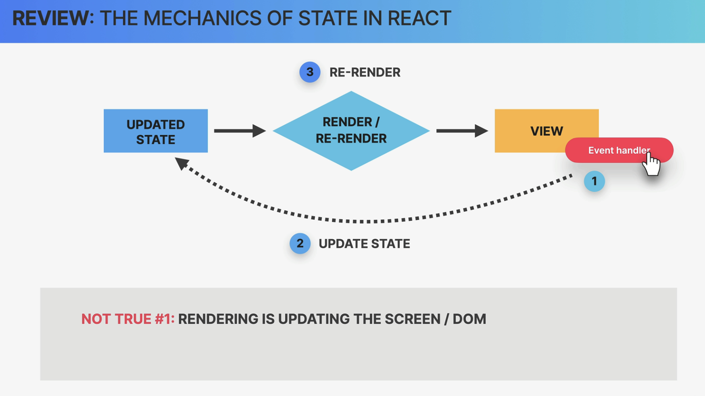

Remember this diagram?

I told you we can conceptually imagine this as a new view rendered on the screen, so into the DOM.

However, now we know that this was **technically not true** because **rendering is not about the screen or the DOM or the view, it's just about *calling component functions*.**

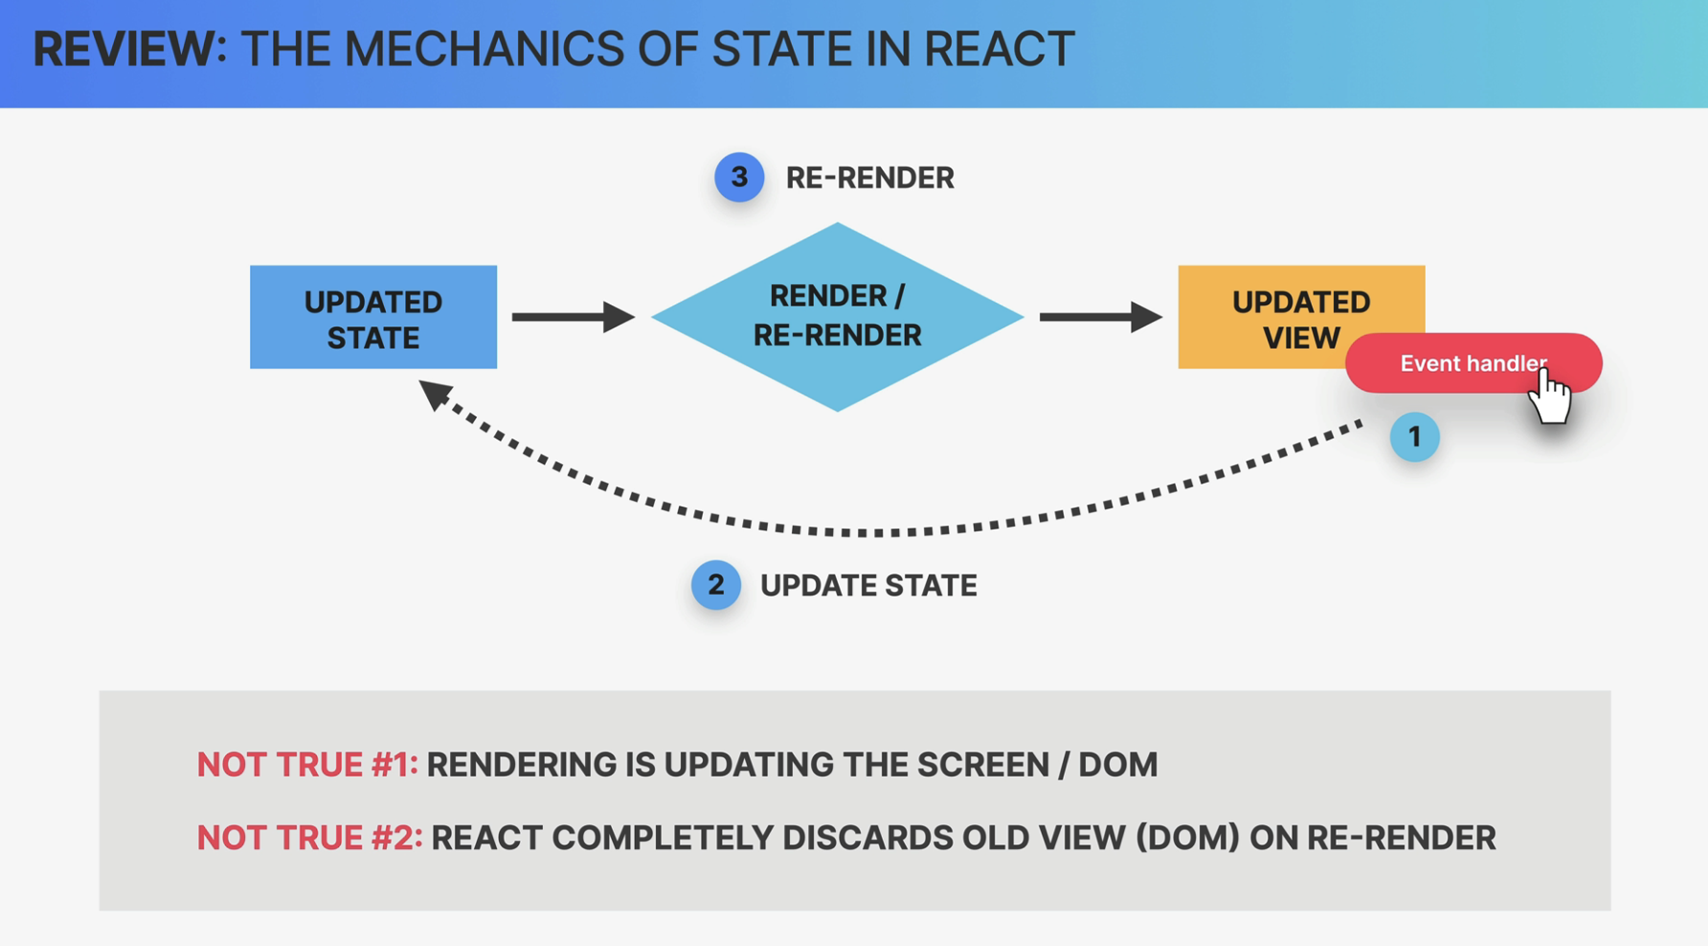

So, at the **beginning of the render phase**, **React will go through the entire component tree**, **take all the component instances that triggered a re-render**, **and render them, which simply means calling the corresponding component functions**

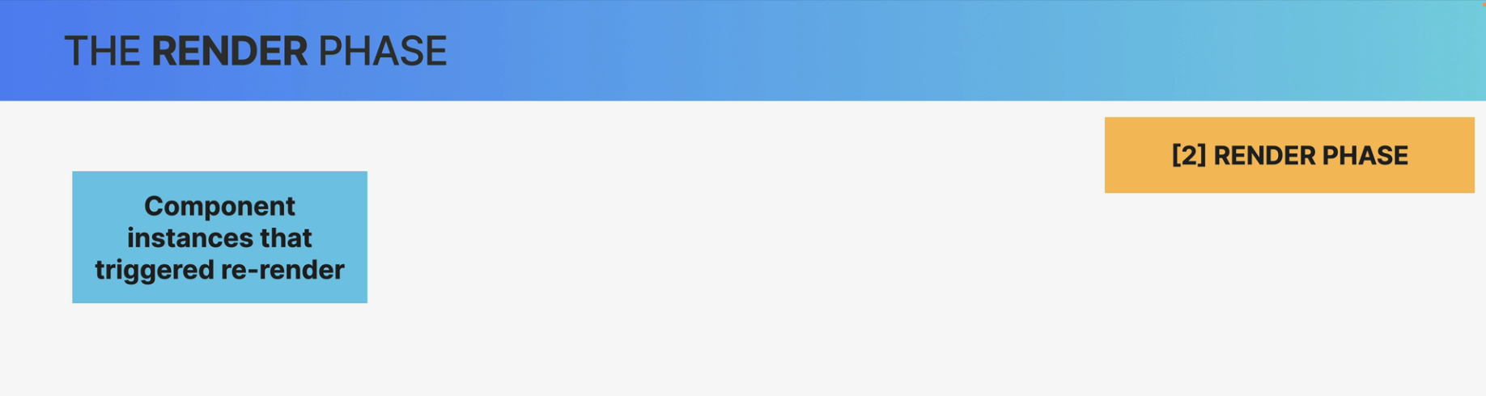

This will create updated React elements that altogether make up the so-called virtual DOM.

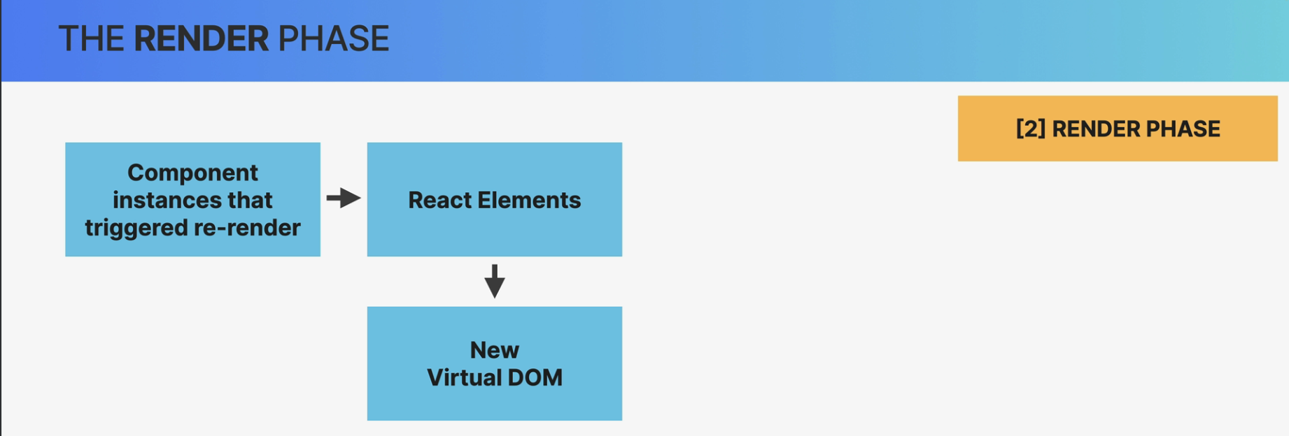

So on the **initial render**, **React will take the entire component tree and transform it into one big React element** which will be a React element tree like this one. And this is what we call the **virtual DOM**

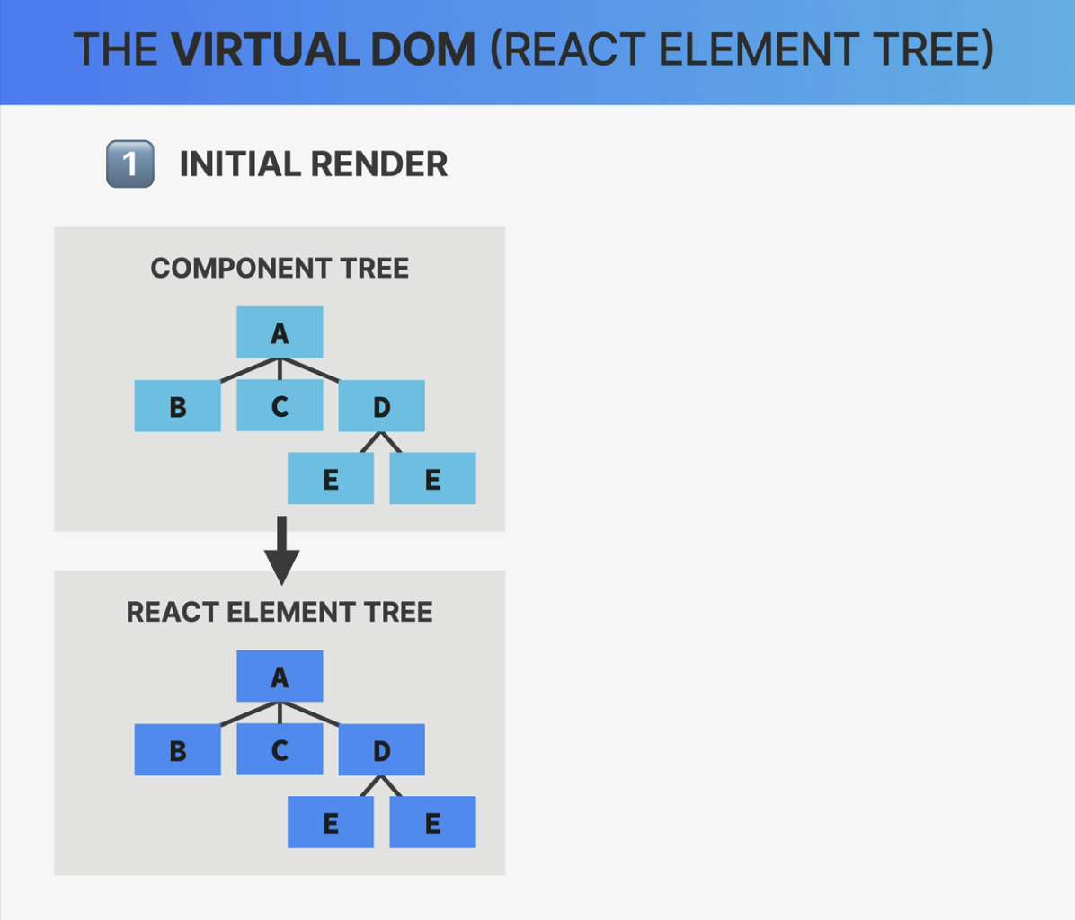

So, the **virtual DOM is just a *tree of all React elements* created from all instances in the component tree.**

And **it's relatively cheap and fast to create a tree like this**, even if we need many iterations of it because, in the end, **it's just a JavaScript object.**

Now, virtual DOM is probably the most hyped and most used term when people describe

what React is and how it works.

But if we think about it, if the virtual DOM is just a simple object, it's not such a big deal, right?

And that's why the React team has downplayed the meaning of this name. And the official documentation no longer mentions the term virtual DOM anywhere.

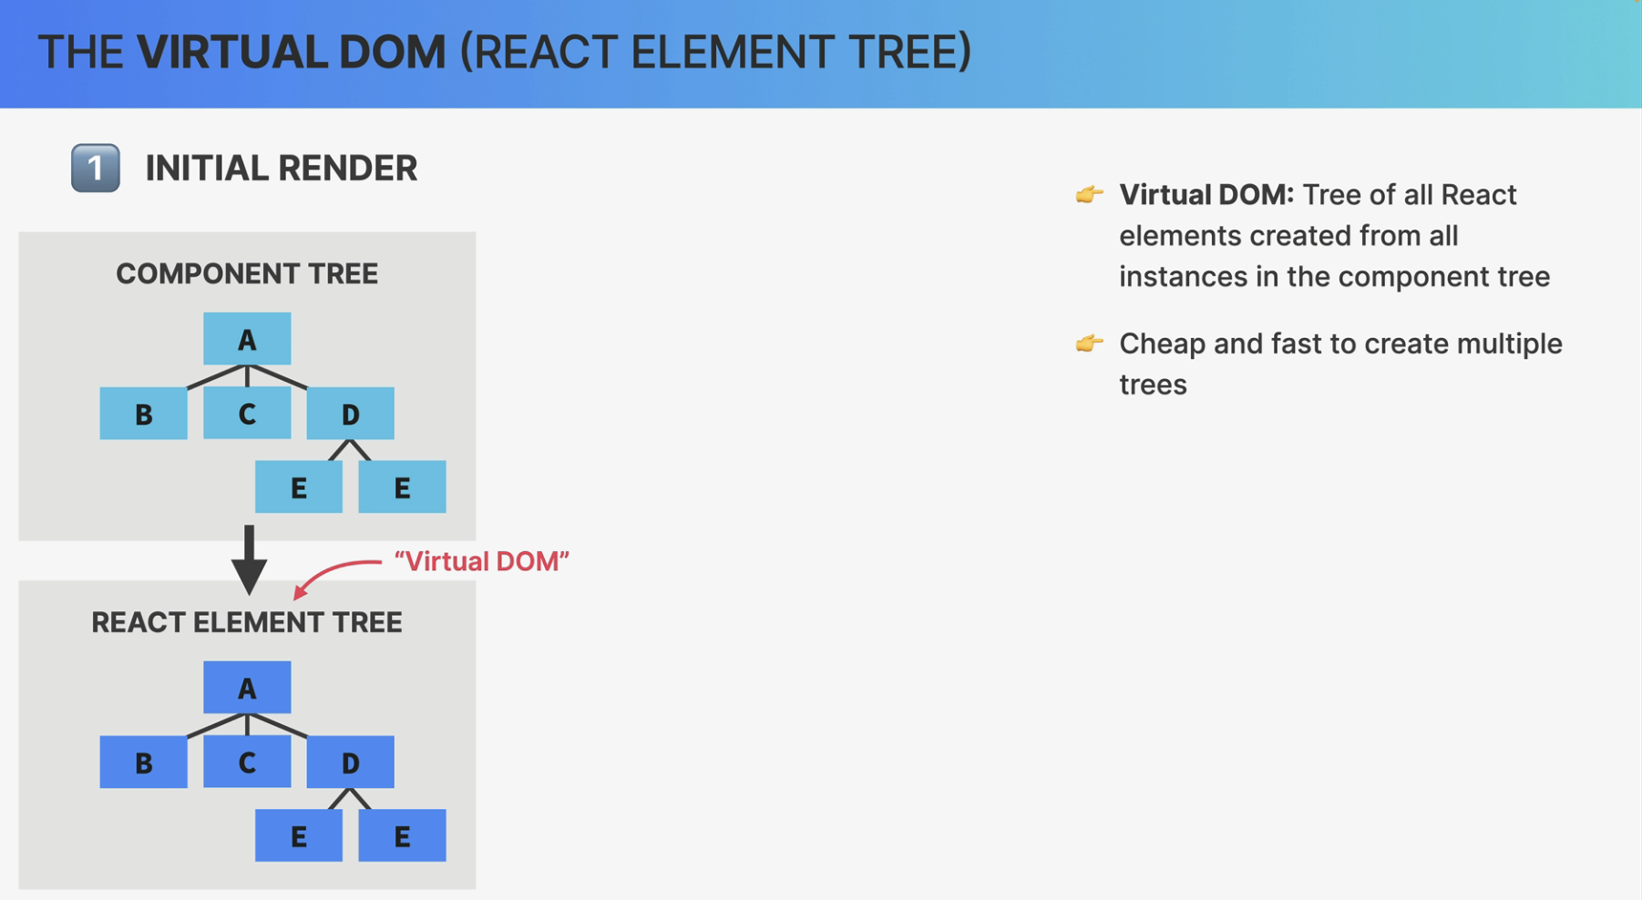

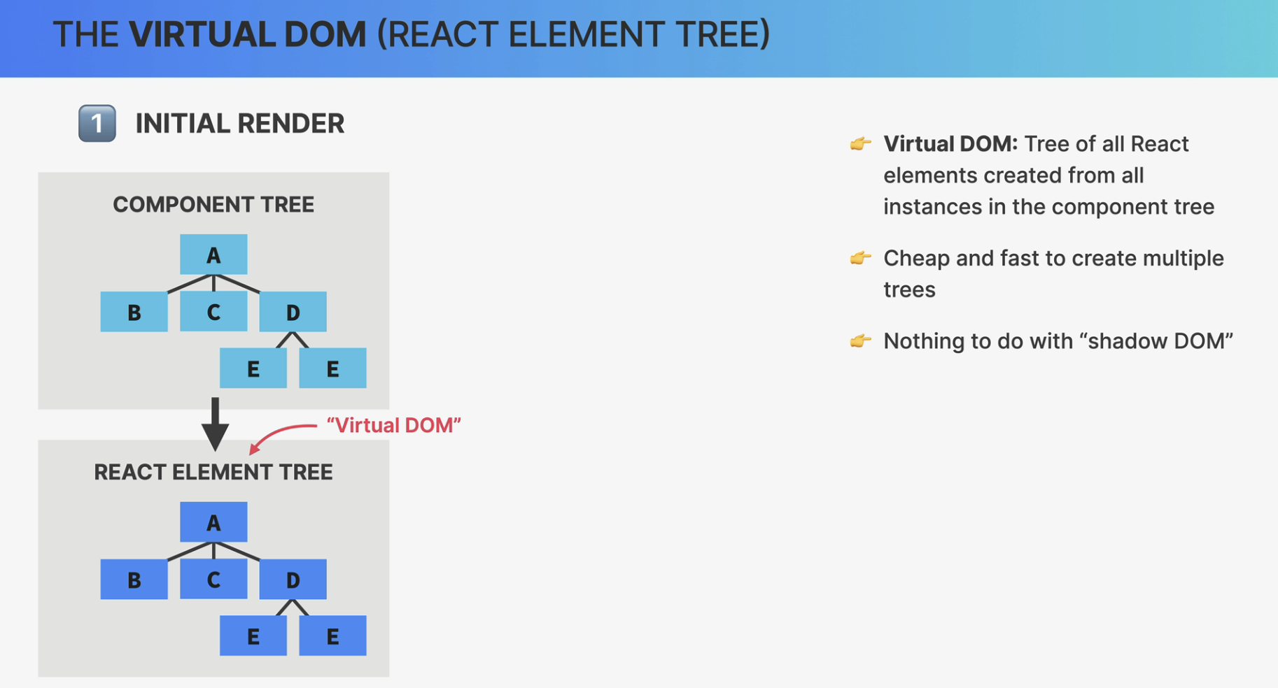

Also, some people confuse the term with the shadow DOM, even though it has nothing to do

with the virtual DOM in React.

So the shadow DOM is just a browser technology that is used in stuff like web components.

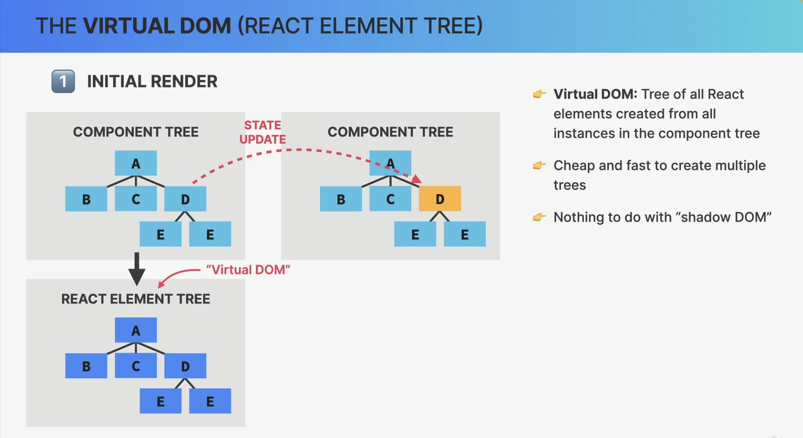

But anyway, let's now suppose that there is gonna be a state update in component D, which will of course trigger a re-render.

That means that React will call the function of component D again and place the new React element in a new React element tree.

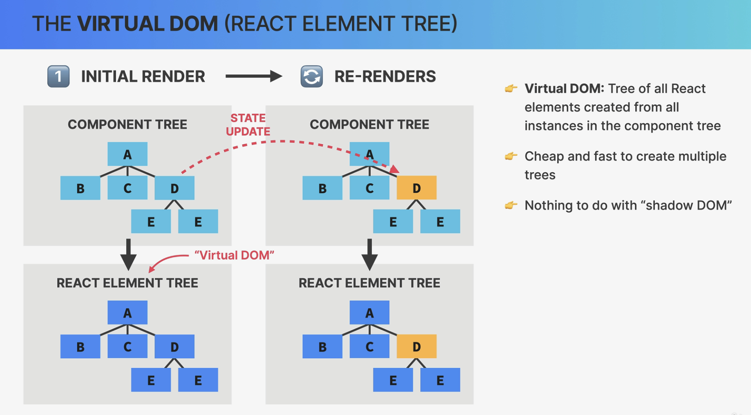

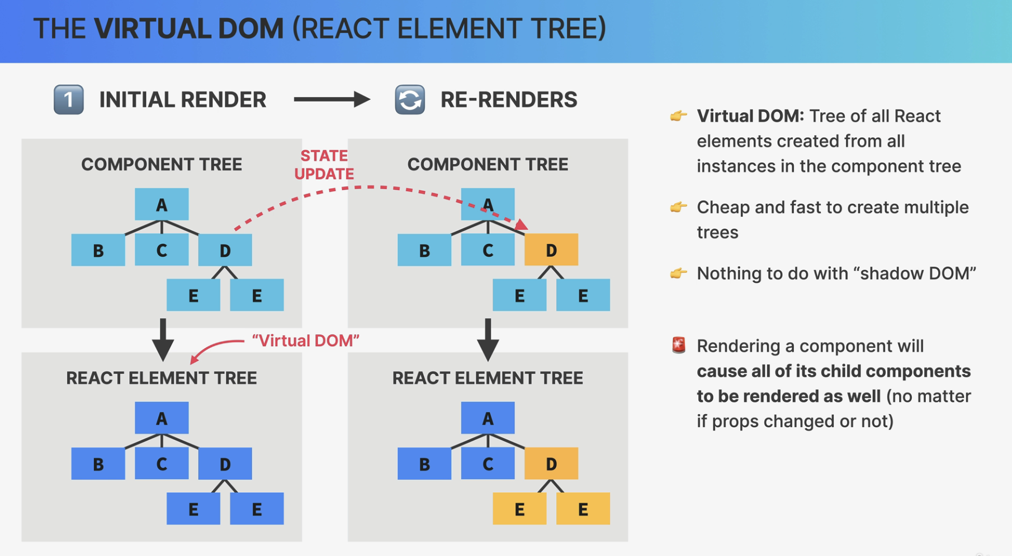

But now comes the **very important** part, which is this.

**Whenever React renders a component, that render will cause all of its child components to be rendered as well. And that happens no matter if the props that we passed down have changed or not.**

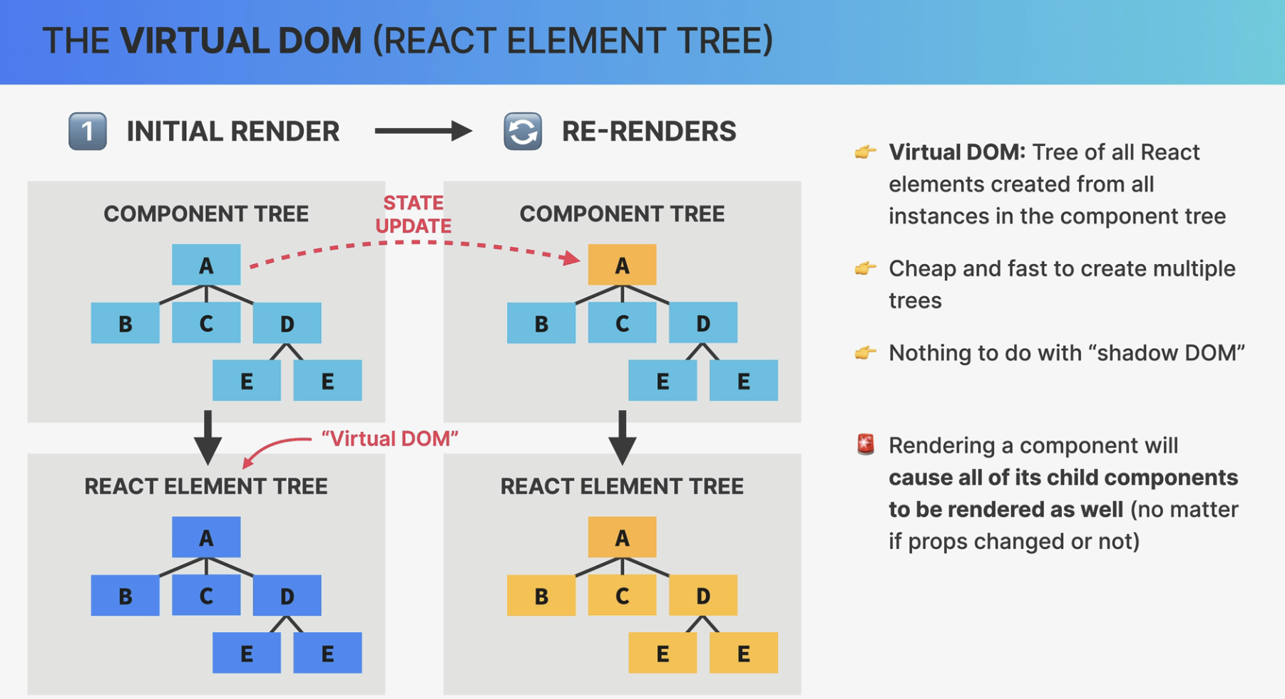

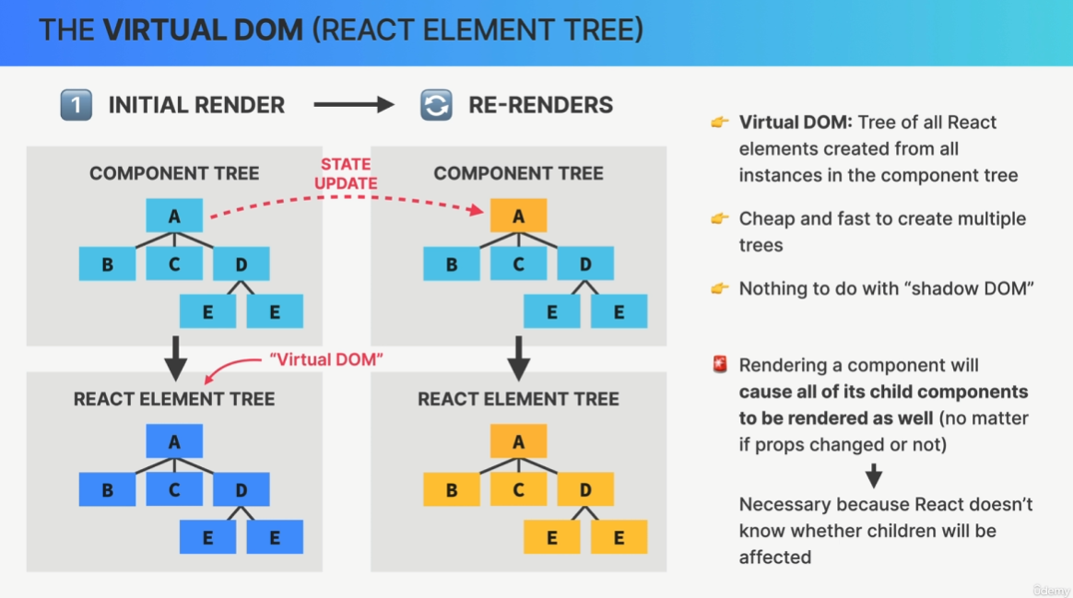

So again, if the updated components return one or more other components, those nested components will be re-rendered as well, all the way down the component tree.

This means that if you update the highest component in a component tree, in this example component A, then the entire application will be re-rendered.

Now, this may sound crazy, but React uses this strategy because it doesn't know beforehand whether an update in a component will affect the child components or not.

Also, keep in mind once again that this does not mean that the entire DOM is updated.

It's just a virtual DOM that will be recreated which is really not a big problem in small or medium-sized applications.

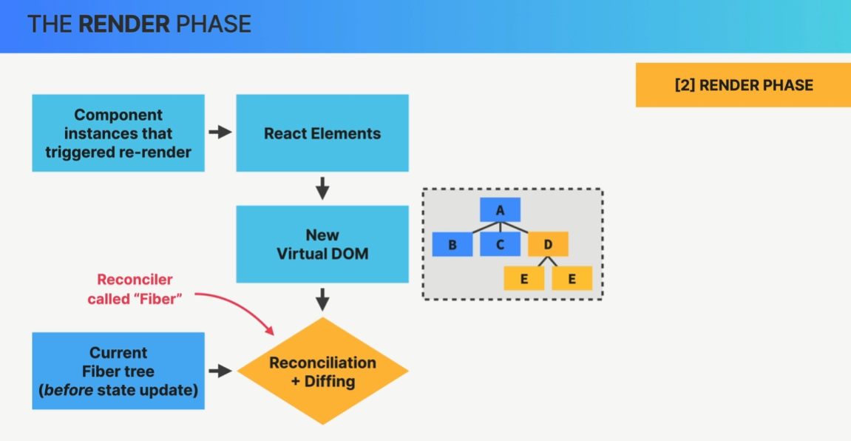

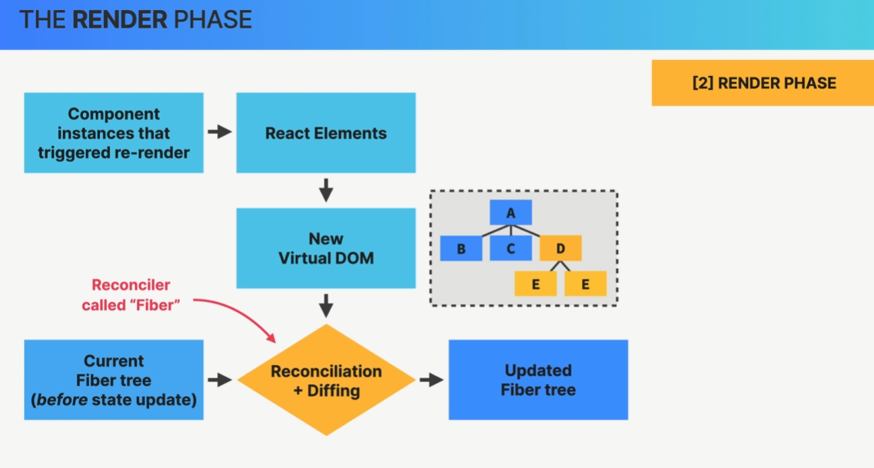

So what happens next is that this new virtual DOM that was created after the state update will get reconciled with the current so-called Fiber tree as it exists before the state update.

Now this reconciliation is done in React's reconciler which is called Fiber. Now that's why we have a Fiber tree.

Then the results of this reconciliation process is gonna be an updated Fiber tree, so a tree that will eventually be used to write to the DOM.

##### What is reconciliation and why do we need it?

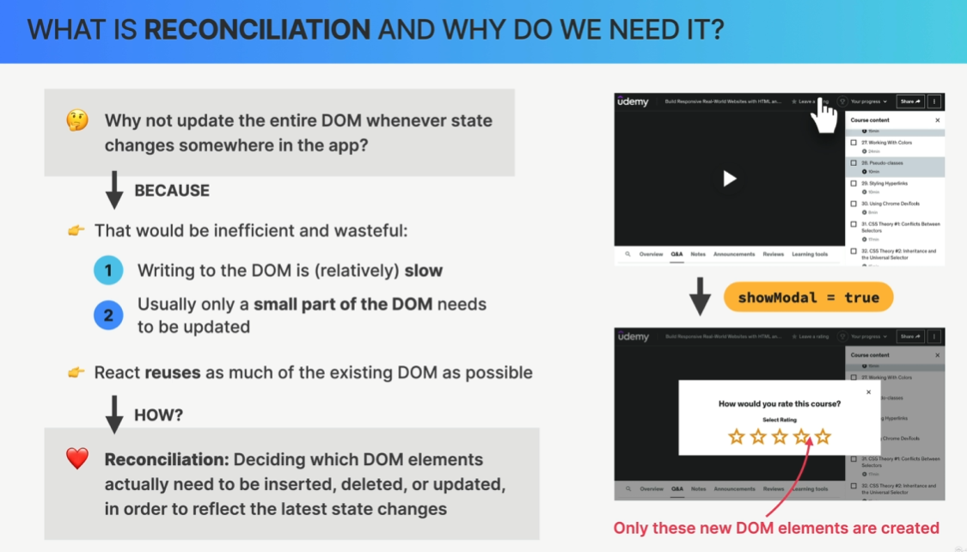

##### The Reconciler (called Fiber)

So, during the **initial render of the application Fiber takes the entire React element tree,**

**so the virtual DOM, based on it builds yet another tree which is the Fiber tree.**

The Fiber tree is a special internal tree where for each component instance and DOM element in the app, there is one so-called Fiber.

Now, what's **special about this tree is that, unlike React elements in the virtual DOM, Fibers are not recreated on every render. So the Fiber tree is never destroyed. Instead, it's a mutable data structure and once it has been created during the initial render, it's simply mutated over and over again in future reconciliation steps.**

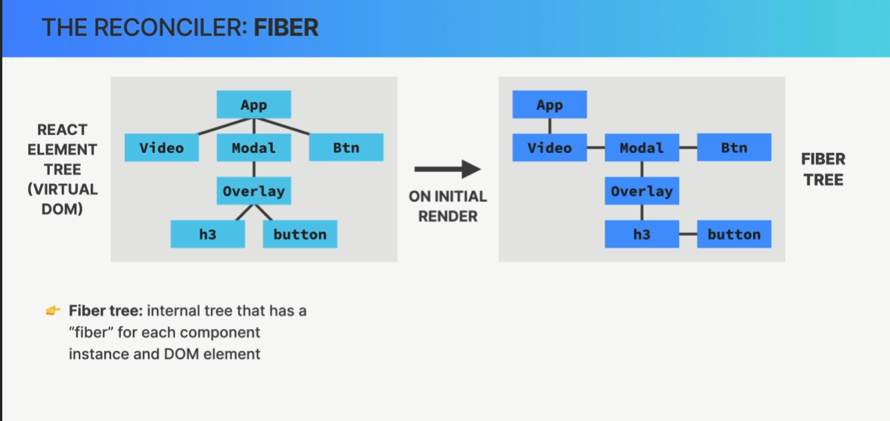

This makes Fibers the perfect place for keeping track of things like the current component state, props, side effects, list of used hooks, and more.

So the actual state and props of any component instance that we see on the screen are internally stored inside the corresponding Fiber in the Fiber tree.

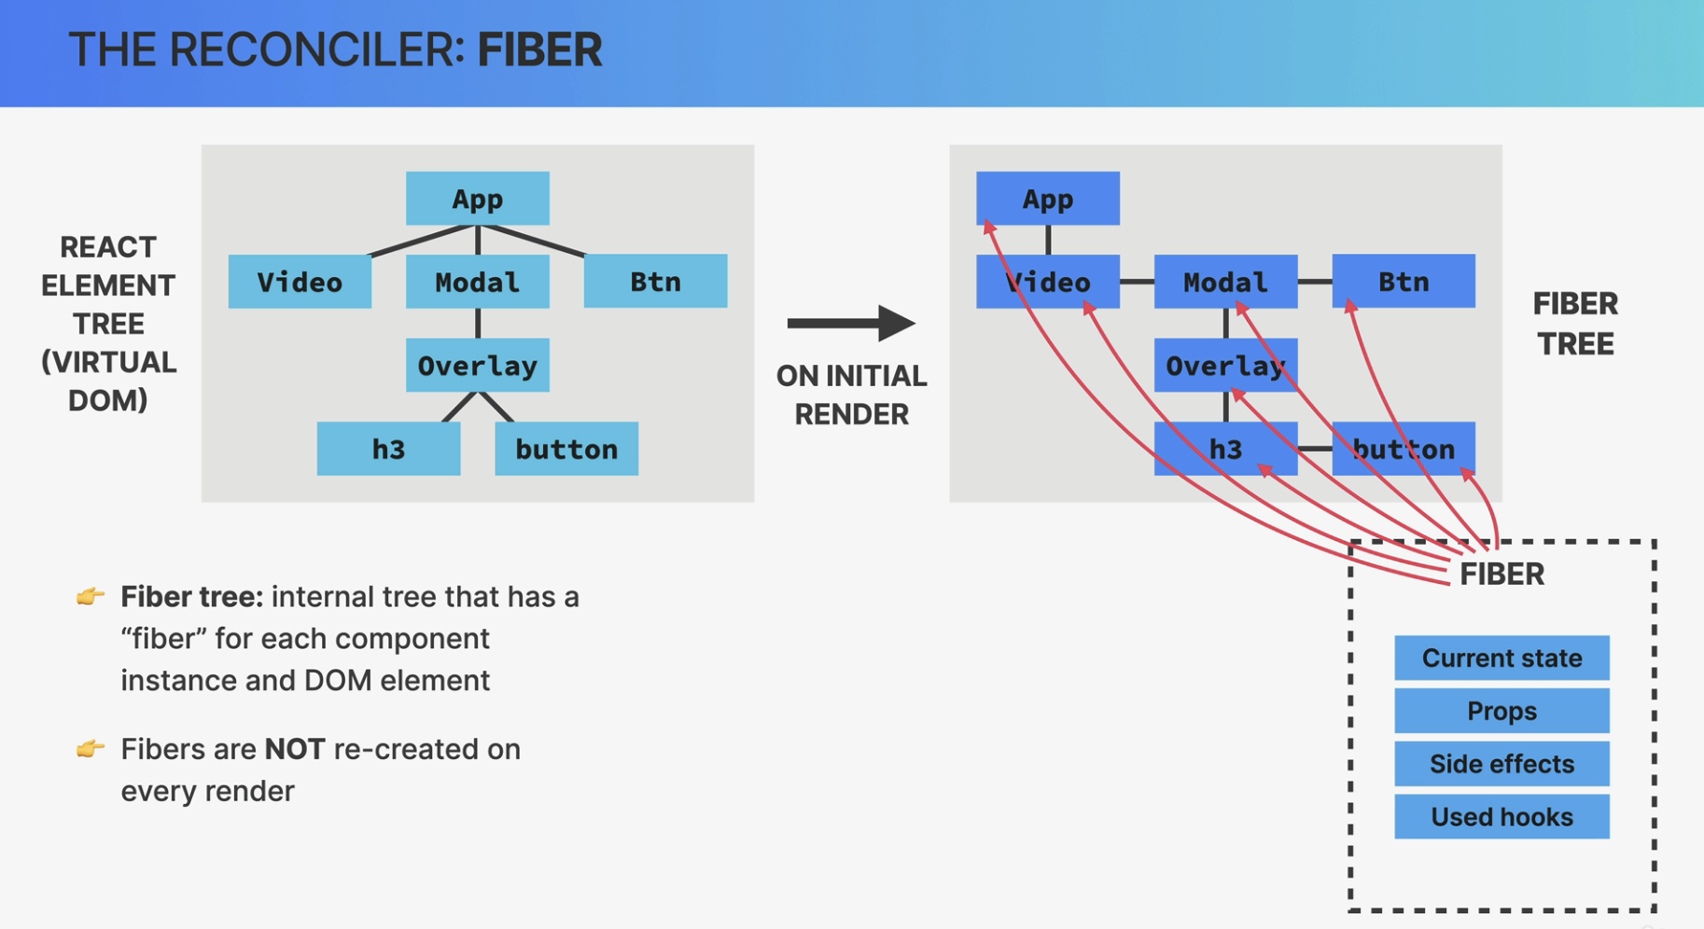

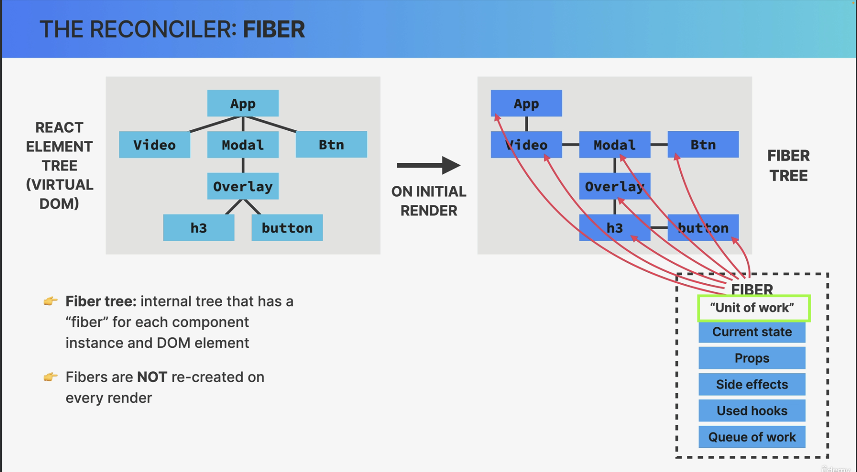

Now, each Fiber also contains a queue of work to do like updating state, updating refs, running registered side effects, performing DOM updates, and so on.

This is why a Fiber is also defined as a unit of work.

Now, if we take a quick look at the Fiber tree we will see that the Fibers are arranged in a different way than the elements in the React element tree.

So instead of a normal parent-child relationship, each first child has a link to its parent and all the other children then have a link to their previous sibling. This kind of structure is called a linked list and it makes it easier for React to process the work that is associated with each Fiber.

We also see that both trees include not only React elements or components but also regular DOM elements, such as the h3 and button elements in this example.

So both trees are a complete representation of the entire DOM structure, not just of React components.

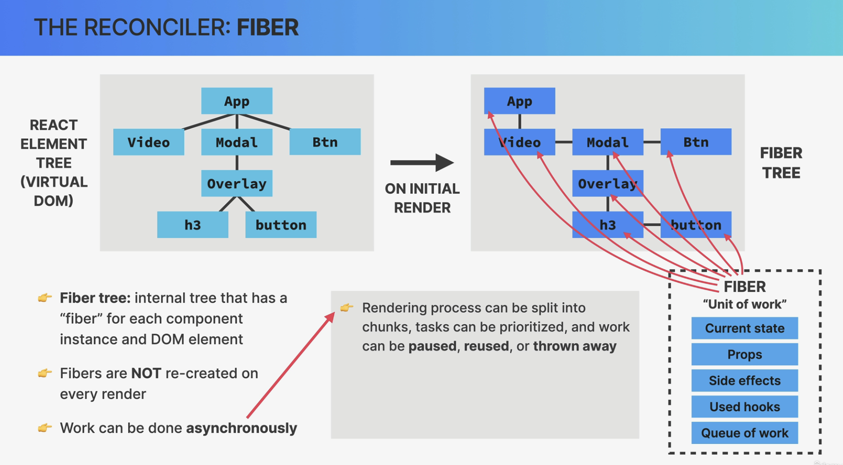

Now going back to the idea that Fibers are units of work, one extremely important characteristic of the Fiber reconciler is that work can be performed asynchronously.

This means that the rendering process which is what the reconciler does, can be split into chunks, some tasks can be prioritized over others and work can be paused, reused, or thrown away if not valid anymore.

Just keep in mind that all this happens automatically behind the scenes.

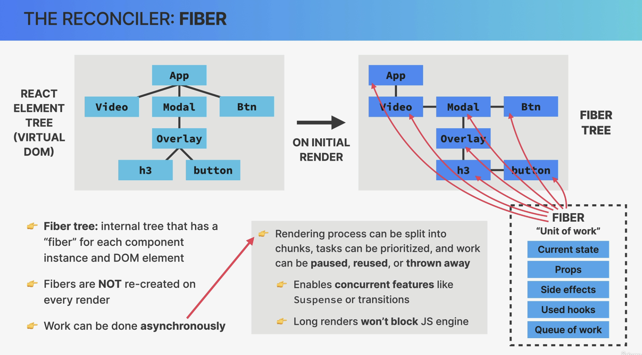

It's completely invisible to us developers. There are, however, also some practical uses of this asynchronous rendering because it enables modern so-called concurrent features like Suspense or transitions starting in React 18.

It also allows the rendering process to pause and resume later so that it won't block the browser's JavaScript engine with two long renders, which can be problematic for performance in large applications.

Again, this is only possible because the render phase does not produce any visible output to the DOM yet.

##### 

##### 

##### Reconciliation in action

